Home Learning Ideas for all
Wednesday 6th May 2020

E-Safety Home Learning packs
Think U Know have created Home Learning packs, which are updated fortnightly, for children at a time when they may be online more often. Each pack has simple 15 minute activities for your child to complete at home. There is also a parents and carers help sheet for you to read on this page too. https://www.thinkuknow.co.uk/parents/Support-tools/home-activity-worksheets/

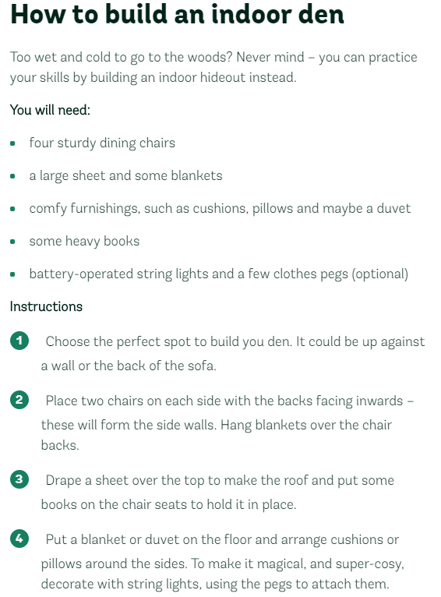
Make a den!
Dens are the perfect places to read stories together, imagine you are explorers discovering far-off lands, or have an impromptu sleepover!

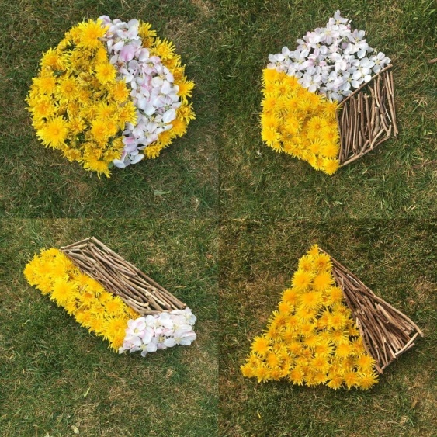
3D shapes
You will need 3 different items. You can use different colours of paper, or fruit on a plate. You could also use 3 different items you might find during your daily exercise. Can you create a 3D shape like the picture on the left?

