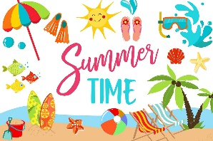
Summer Science Home Learning Challenges
Summer is the perfect time to take our Science learning outdoors! These investigations might be a little messier or use the outdoor environment.
Remember to ask an adult to help you before you investigate!

What melts in the sun?
You will need a very sunny day, different objects, a tray/container.
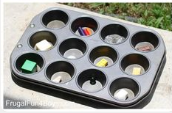
Choose different objects and make your predictions: will they melt in the sun?
You could try: butter, wax crayons, ice, Lego, sugar, stones, chocolate and anything else you are curious about!

Shadows:
- Build your own Lego tower. What do you think the shadow will look like? If it’s a sunny day, you could see if you predicted correctly outside!
- You could even ask a friend to use chalk to draw around your own shadow. See what happens to the shadow at different parts of the day! Can you explain why?
- Try making your own sundial!
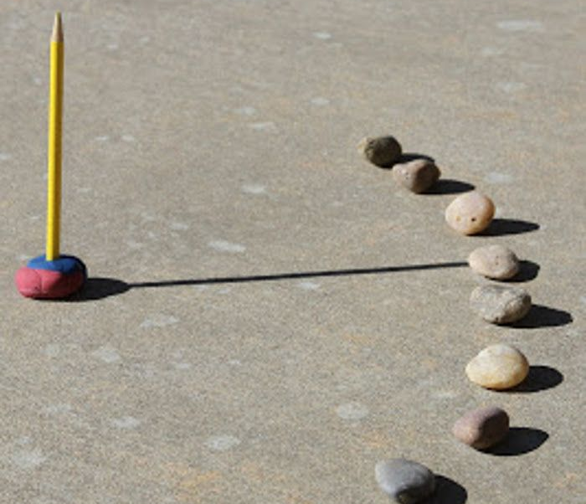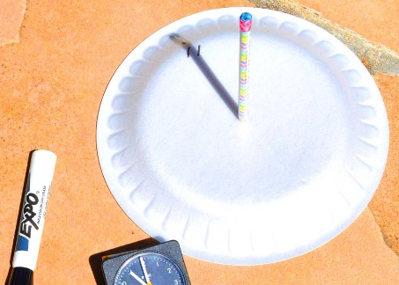

Sun cream research:
- Can you find out how sun cream works? Use your research skills to find out!
Brilliant Bubbles
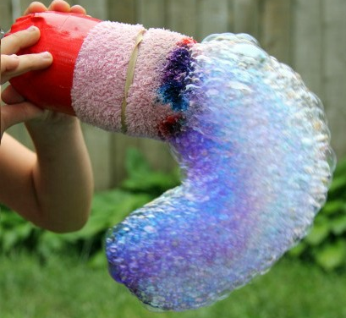
All you need is an empty water bottle, a sock and an elastic band or tape.
Start by cutting the bottom of the water bottle off.
Next slide the sock over the bottom of the bottle and secure it with an elastic band.
Pour some dish soap into a shallow container with a little bit of water and gently mix.
Dip the sock covered bubble blower into the solution and gently blow (do not inhale!!).

Leak-proof bag:
Can you push a pencil through a sandwich bag without it leaking?
You will just need some pencils, a sandwich bag and some water.
Can you research and explain what happens?

Indoor activities (in case it rains!):
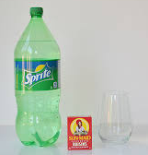
Dancing Raisins
Fill a cup with lemonade/ 7 up / Sprite etc.
Add a handful of raisins. Watch what happens!

Gummy Bears
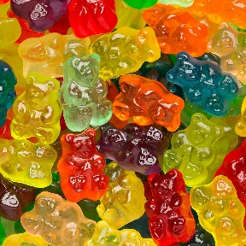
What happens if you leave gummy bears in different liquids overnight?
Some suggestions for your investigations: vinegar, salt water, sugar water, milk.
(Don’t eat the gummy bears after!)

