Home Learning Ideas for all
Wednesday 18th March 2020
Below are four hyperlinked ideas to some resources which you may find helpful to encourage some home learning.
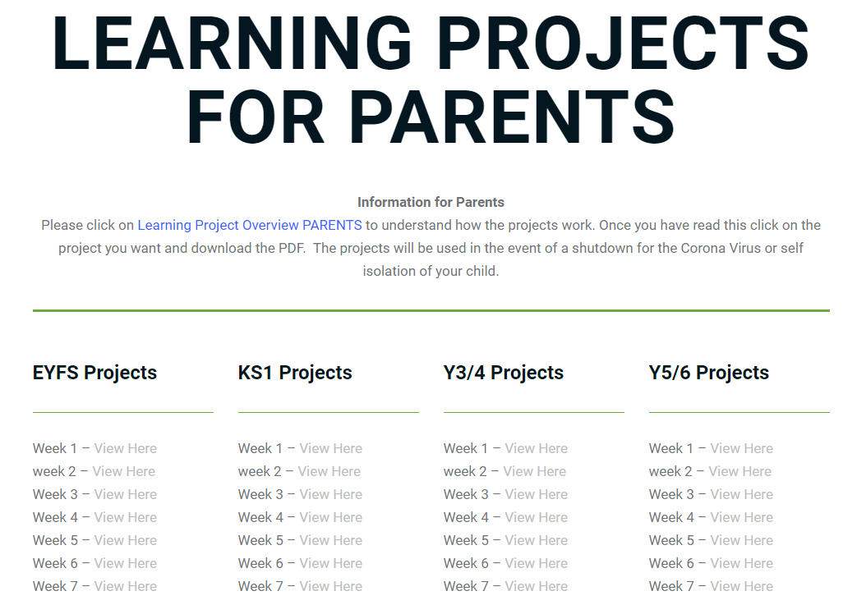  https://www.robinhoodmat.co.uk/learning-projects/  Great weekly resources in different subjects for Nursery to Y6 – click on the parent section. | 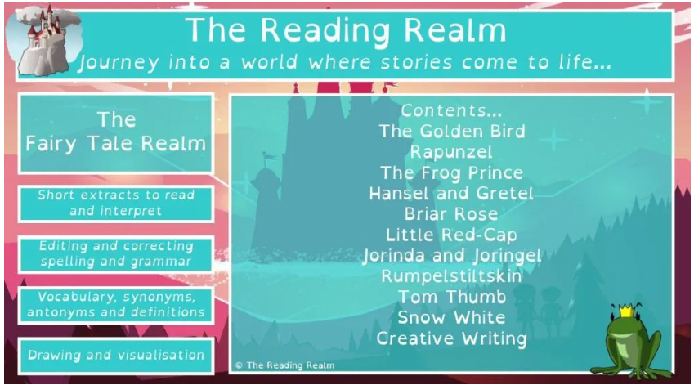  https://thereadingrealm.co.uk/2020/03/15/free-reading-realm-home-learning-pack-fairy-tales/amp/?__twitter_impression=true  A downloadable Home Learning Pack focusing upon reading.
moosekidcomics.com  Four online or downloadable comics for children to read – or for have read to them. | 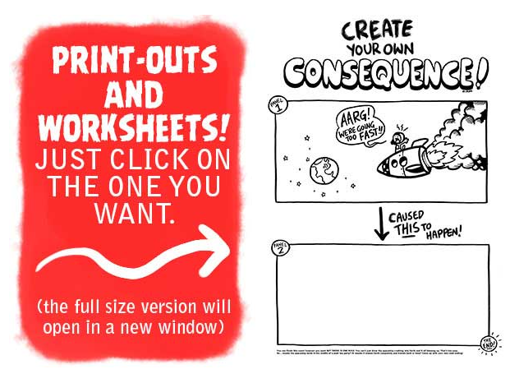  http://www.moosekidcomics.com/worksheets/  Downloadable worksheets to prompt your child’s imagination.

