Year 1 Home Learning – Monday 18th May

Below, you will find 6 home learning tasks. You may choose the tasks that you wish to complete and do them in any order. Please do not hesitate to contact us if you have any queries or would like to share the work you have been doing.
year1@highworthcombined.co.uk
Maths  Counting on and back in 2s, watch the videos and complete the activity sheets on BBC bite size about counting on and back in 2s.  https://www.bbc.co.uk/bitesize/articles/zkjv382  Remember to always use the internet with adult supervision and follow the school rules about internet safety.  - Challenge – Draw your own 1-50 grid. Colour in 2, 4 and 6 on the grid and then continue to count on in 2s and colour in that number on the grid. What do you notice?  Can you count in 2s? Do you know your two times table? Can you count in 2s from any given number? | Science  Keep a food diary for the week.  - Which plants have you been eating? And what part of the plants do they come from? (flower, stem, root, leaves) Can you write a few sentences to explain your answers?  The home learning matrix from Wednesday 29th April Science section helped us learn about the parts of a plant. If you have forgotten what they are please refer back to this previous matrix as it will help you with some of this task.  - What did the plants look like when they were on your plate? What would they have looked like when they had just been harvested? Would they have looked the same or different, can you write or draw about the similarities and differences?  - Do you know where the other foods you have eaten come from? Or what ingredients went into making them?
English
Mini location/ story setting
This is a speaking and listening focused task, and requires your imagination.

- First make your own farm. It could be on the floor, a table top or in a tray. This will be your setting for your story.
- Then make or find toy people and animals who will be the characters in your story.
- When you have created your farm act out stories perhaps you could ask a family member to take on a different character in your story or you could do this on your own.
- What happens at the start of your story? Who/what are the main characters? What happens in the middle? What is the problem? How does it get fixed? How does your story end?

You could get a big piece of paper and draw the landscape. What props will you have? Different cloths e.g. a clean duster could be a field. Will there be a farm house? You could make this from an old box. Where will the cows and horses go? Does the farm need fences to keep the animals safe? A little pond could be made from a circular, small tub, perhaps an empty margarine tub. This is where the ducks might like to be. You may have some toy farm animals but if not you could try and create your own. Draw and cut them out. Imagine a cotton wool sheep or a pom pom sheep!

- We want you to be as creative as you can and imaginative with your story as you like. Practise retelling your story lots, perhaps tell your story as many times as you can adding details and descriptions to captivate your audience.

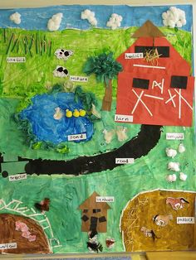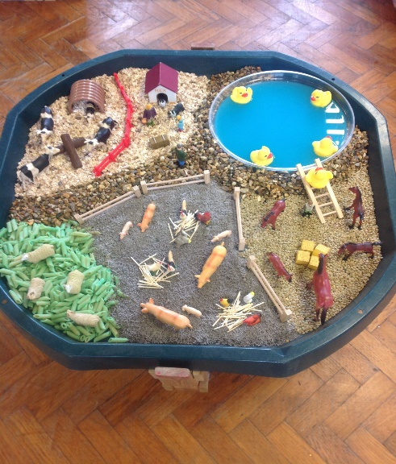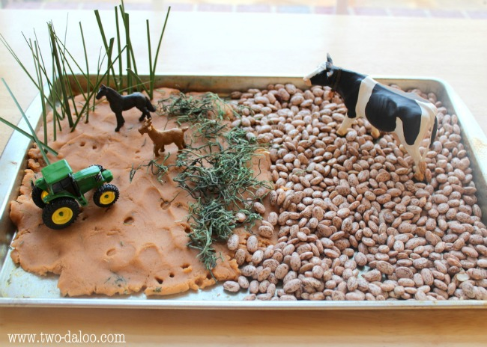

Challenge –
- Can you complete the Story Mountain below to explain what happens in your story? Use the story mountain to make notes on.
- Then use your notes from your story mountain to write your story in detail.

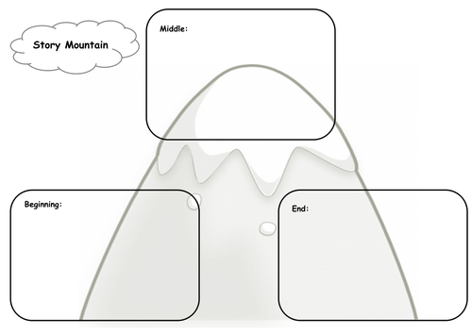

Design and Technology  Lots of fruits and vegetables are grown on farms. Today we would like you to prepare a vegetable or fruit based dish.  Help a grown up to make a vegetable or fruit based dish. If you aren’t sure what to make you could have a look in a recipe book you have at home or ask someone in your family what their favourite meal is. “I would make a salad or a fruit kebab”, but it is totally up to you, your adult and the ingredients you have available. Write the list of ingredients you will use, the method and maybe photograph or draw what your final dish looks like. Don’t forget about food hygiene, and the importance of helping to clear and tidy away at the end of your cooking session.  - Wear a clean apron.  - Wear closed-in shoes to protect your feet, in case of hot spills or breakages.  - Wash your hands before and after handling food.  - Keep food preparation surfaces clean.  - Tie back long hair.  - Wash vegetables and fruit under cold water before use.  - Do not run around the room where food is being prepared.  - Wipe up food spills immediately.  - Don’t use any cooking equipment or appliances without adult supervision.  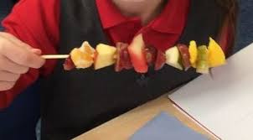  Challenge  Can you make a dish that uses the different parts of a plant? (flower, stem, root and leaves)  - Did you make a healthy meal? How do you know?  - Do you know where in the world the different ingredients you used have come from?  - Do you know how the different ingredients have been made?  - Which ingredients were grown?  - Can you find out about different food groups? | Art and Wellbeing  Make a fruit or vegetable picture. You can use any materials that you have at home and it’s up to you how you do it.  Please take a photograph and share your artwork with us.  Below are some ideas of what other children have done.  A still life drawing, using felt tips and colouring pencils.  Vegetable printing with paint.  A carrot made with tissue paper.  Pictures made with dried fruit.
History

Farming has changed over time, both the jobs people do and the machines that are used. Look at the THEN pictures (this shows farming from the past), what do you think is happening in each picture? Look at the NOW pictures what do you think the machines are doing /made to do in the pictures? Write a few sentences to compare farming from the past to farming now.

