Dear Y6 to be,
I am so excited about being your new teacher. I have heard lots of wonderful things about you all and am looking forward to meeting you all for real in September. I thought I’d write to you to tell you a little about myself.
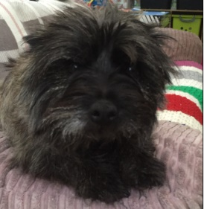
I’ve been a teacher for 20 years now. I’ve worked in 5 different schools in total but Highworth is my favourite by far. I have 3 children: 2 boys and a girl. Their names are Stephen, India and Lorcan. Since lockdown, I have been really busy home teaching my younger boy. He’s in Year 1 and loves to ask lots of questions.
I come from Ireland – all my family still live there. Whenever I get the chance, I try to visit them so we can all catch up on each other’s news. I have two sisters and one brother.
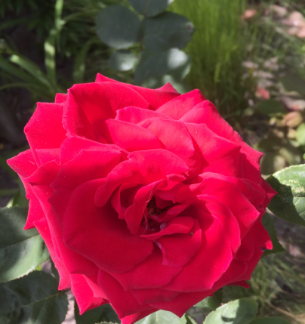
My most favourite things to do in my spare time are knitting, walking my beautiful dog (Bonnie) and gardening. I’ve been making lots of toys and clothes over the past few months.
If you were to ask me what my favourite subjects to teach were, I’m not sure I could choose. I love them all – Science, Maths, English, History, Geography and Art. I love learning new things and believe that we all have something to teach each other.
I hope that I have given you a little glimpse into the type of person I am. I hope that you find me to be a fun and creative teacher – that is what I aspire to be.
Once again, I can’t wait to see you all in September. Stay safe during the holidays and look after all those close to you.
Love from,

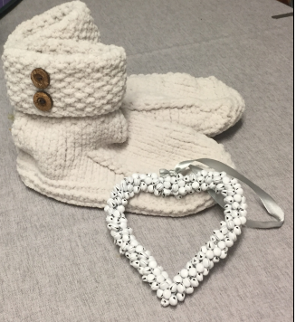
Mrs Smith xx

A pair of slippers that I have made x

