Year 5 Home Learning – Friday 10th July 2020
We’d love to see your work! Please send it to: Year5@highworthcombined.co.uk
ENGLISH:  The Game  We are going to think about the events that happened in the text a bit more.  Scroll down to read the text again. Answer the questions that follow.  Use this link https://soundcloud.com/talkforwriting/game/s-7MBlxRcz8zL  to listen to the story.  You could watch the trailer again (with adult permission) for movie Jumanji (1995) - https://www.youtube.com/watch?v=yLyXEQPuLJo  Why not draw some of the animals/plants that you would have wanted to see or would have had to run away from, if you had played the game! |  | MATHS:  You are going to be using your knowledge about Number and Place Value to solve some problems. Think about rounding and ordering numbers.  We have also included some Rapid Reasoning questions and a fun cross puzzle.  Scroll down and try to answer the questions.  The answers are included so, when you have finished, you can mark your work.  If you have any incorrect answers, re-read carefully to make sure you’ve understood the question, check your work and see if you can spot your mistake.
WONDERFUL WORDS
Look at the Year 5 & 6 Words List. You can find it as a link on our Coronavirus Closure, Home Learning Matrix, Year 5 tab: https://www.highworth.bucks.sch.uk/web/year_5/460996
Choose 4 or 5 words to practise at a time.
- Look up the definition in a dictionary to check the meaning of each word.
- Learn the correct spelling by using: Look, Say, Cover, Write, Check.
- Write a sentence which includes the word to show that you understand its meaning.
4. Challenge yourself to include speech in each of your sentences. Scroll down for a reminder
about accurate punctuation using the KNOWLEDGE ORGANISER: Writing Dialogue.
HISTORY  Medieval Monarchs  Use this link for the next lesson 6 in History.  We will be learning about the monarchs who preceded King Henry VIII.  https://classroom.thenational.academy/lessons/was-elizabeth-i-weak-and-feeble  You will need a pen, paper and your brain! | Wellbeing  We always feel better when we are kind to others.  Let’s make a poster to say ‘Thank you’ to the postman/postwoman or other delivery drivers that deliver food or other items to your home.  You can display outside your door where they can see it!  We can’t wait to see your posters! |  | DT:  Castle Storage Box  We are sure that extra storage is much needed for all your pens and pencils or arts and crafts materials, especially with all the home learning you have been doing!  Let’s make a storage box from an unused shoe box and some toilet paper/paper towel rolls.  Scroll down for the instructions and send us your pictures.  Have fun!

THE GAME
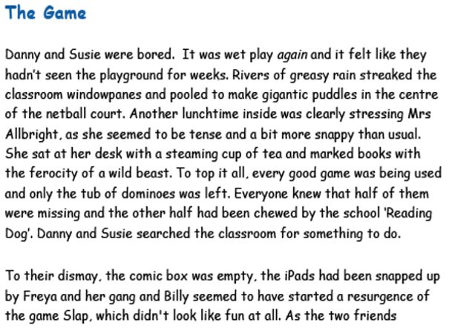
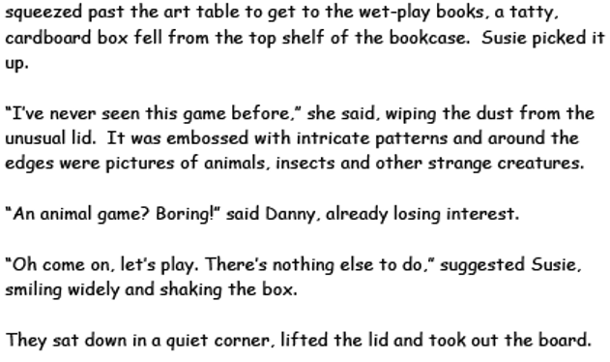

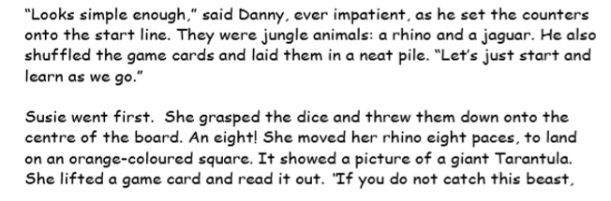
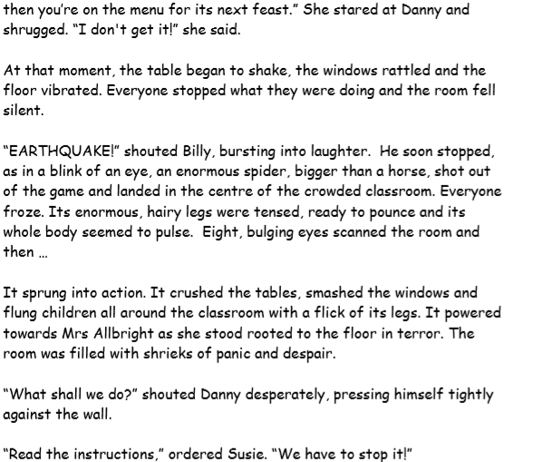

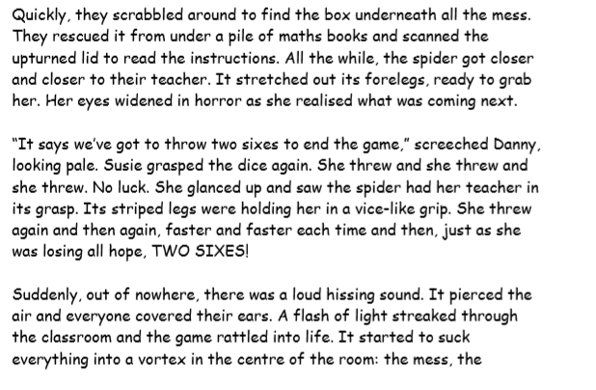
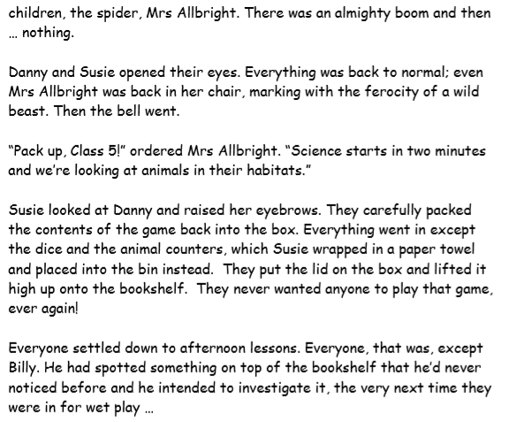

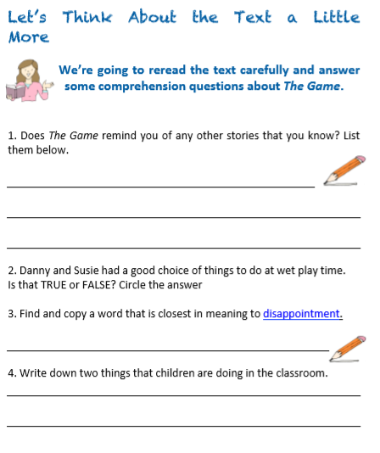
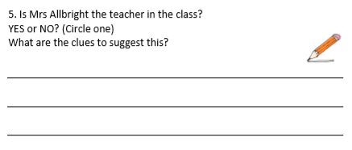

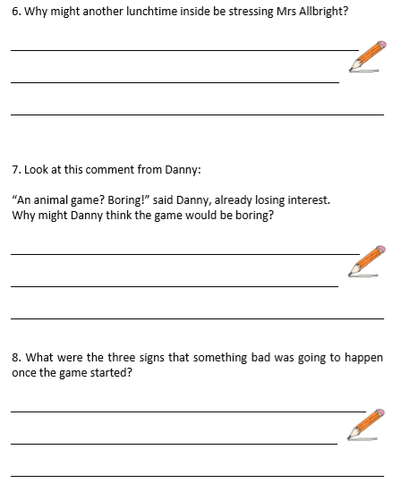
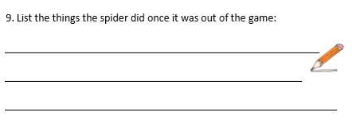
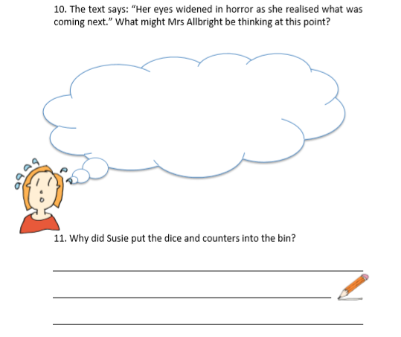

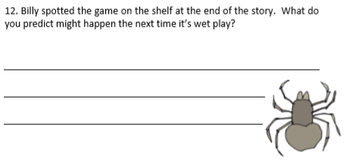

NUMBER AND PLACE VALUE
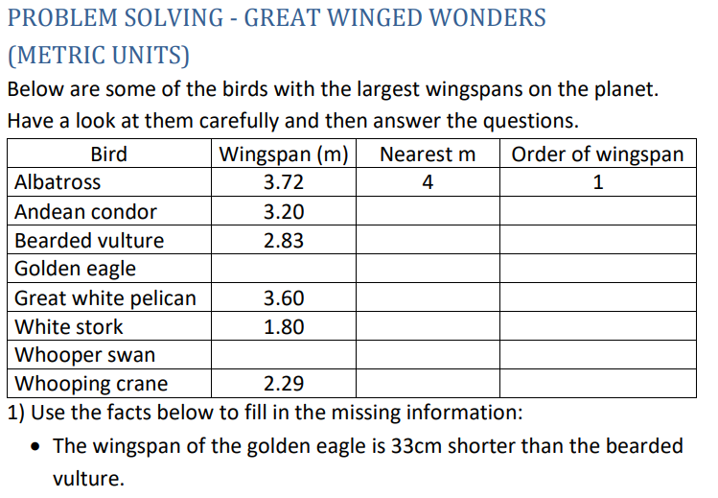
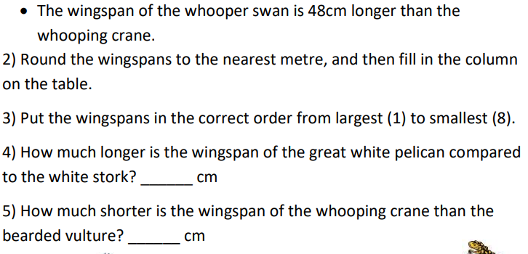

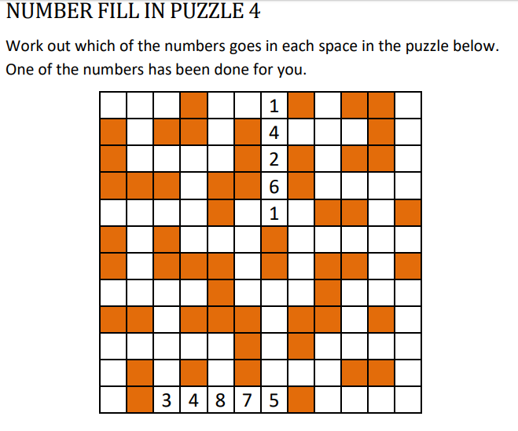
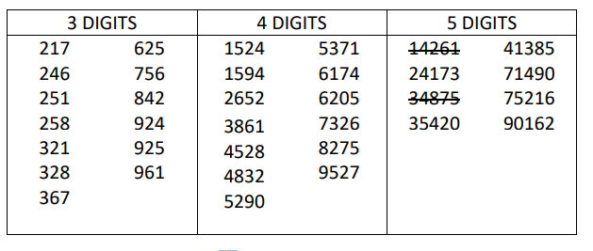

Answers
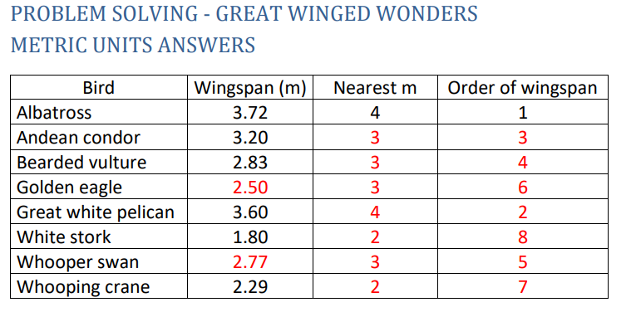
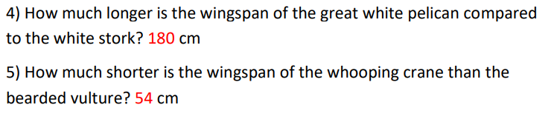
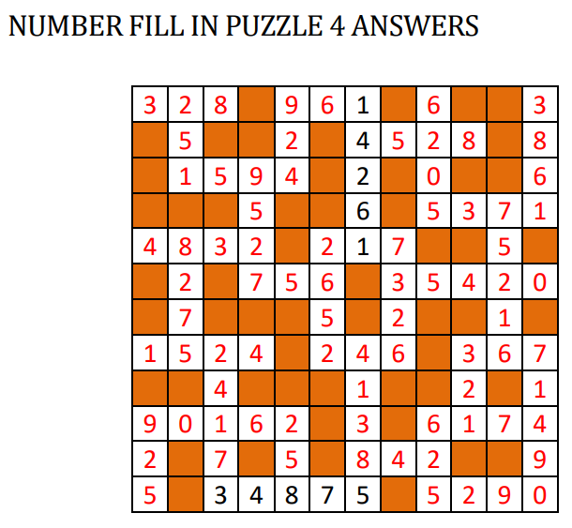
RAPID REASONING
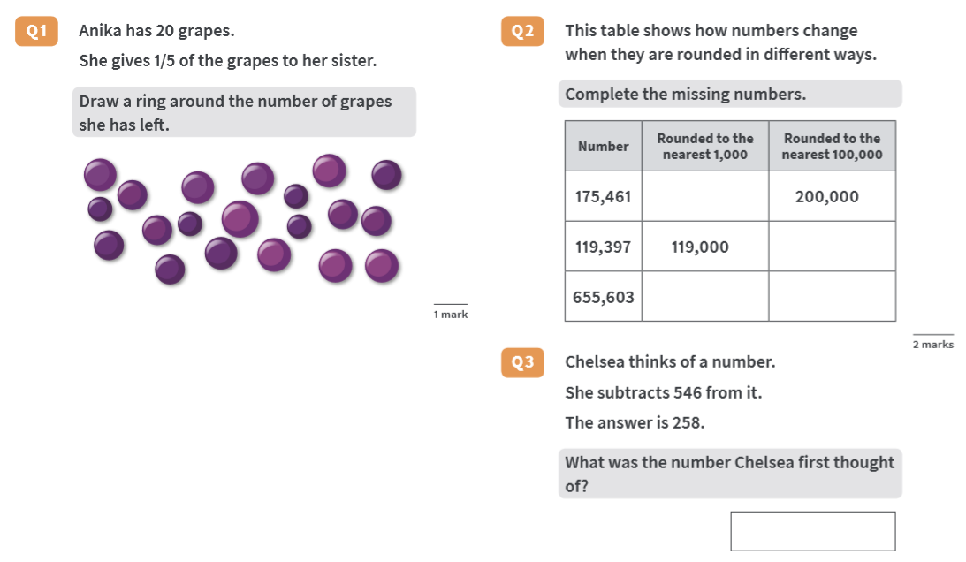

ANSWERS RAPID REASONING

