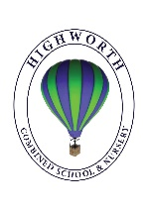
Home Learning Ideas for all
Friday 24th April 2020

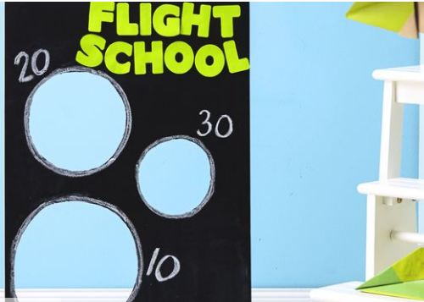
Paper Aeroplanes – Flight School!
Get ready for some all-ages play with this DIY target game: Cut holes in a piece of poster board and assign a point value to each. Prop up with bookends, then send paper airplanes soaring!
For ideas on making aerodynamic planes, click on the link: https://www.goodhousekeeping.com/home/craft-ideas/g3754/how-to-fold-a-paper-airplane/

Draw with Rob Biddulph
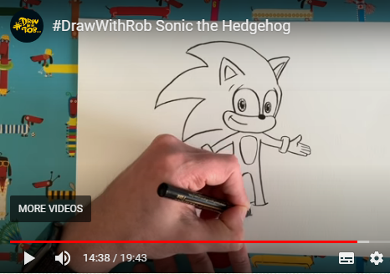
A reminder that the illustrator, Rob Biddulph is posting ‘draw-along’ videos twice weekly on Youtube. There is quite a range of characters to try drawing now, but how about trying to perfect Sonic the Hedgehog today?!
https://youtu.be/fj12BZE5FKw

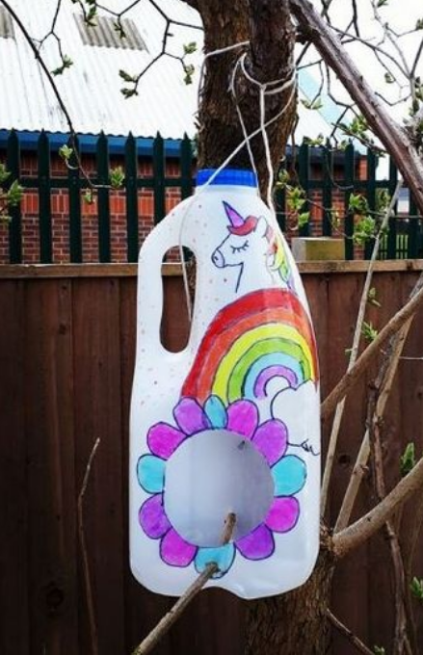
Make your own bird-box
Another recycling use for an empty milk container… all you need is an empty milk bottle, a stick, some string, some scissors and anything you wish to decorate it with. We would love to see photos of your own bird boxes!

