Year 5 Home Learning – Wednesday 29th April 2020
ENGLISH  Can you improve this paragraph:  It was a cloudy day. The balloon went up into the sky. The crew were scared. The crew were excited. Lots of people were cheering them on.  Try to use expanded noun phrases to make it more descriptive. You could challenge yourself to include a simile or metaphor.  Using a range of sentence structures and conjunctions will make your text flow. Try to start a sentence with a subordinate clause.  If you are enjoying this writing, why not continue the story? |  | MATHS  Use your skills in multiplying and dividing by 10, 100 and 1000 to complete the Multiplication and Division sheets below (scroll down). You could choose just one activity from each sheet, or you might like to really challenge yourself and do all 3 activities on each sheet.  Remember, if you get stuck, this will help you:  Move the digits to the left when you multiply a number.  Move the digits to the right when you divide a number.  The number of places that the digits move is determined by how many 0 place holders there are in the number that you are multiplying or dividing by.  So: to multiply or divide by 10 move one place; to multiply or divide by 100 move two places; to multiply or divide by 1000 move 3 places.  For example:  What is 64 multiplied by 10; by 100; by 1000?  64 64 64  Answer: 640; 6,400; 64,000  What is 572 divided by 10; by 100; by 1000?  572 572 572  Answer: 57.2; 5.72; 0.572.
WONDERFUL WORDS
Look at the Year 5 & 6 Words List. You can find it as a link on our Coronavirus Closure, Home Learning Matrix, Year 5 tab: https://www.highworth.bucks.sch.uk/web/year_5/460996
Choose 4 or 5 words to practise at a time:
- Look up the definition in a dictionary to check the meaning of each word.
- Learn the correct spelling by using: Look, Say, Cover, Write, Check.
- Write a sentence which includes the word to show that you understand its meaning.
4. Challenge yourself to include a CO-ORDINATING CONJUNCTION (for and nor but or yet so) in
each of your sentences.
SCIENCE  All living things have a life cycle. Look at this BBC website and do the activities:  https://www.bbc.co.uk/bitesize/topics/zgssgk7/articles/zwn6mnb  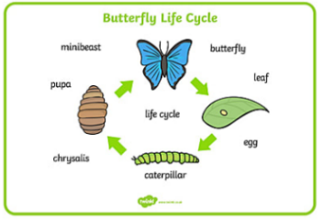  Can you draw the life cycle of a bird or an insect of your choice? Remember to label your diagram, like this one: | FRENCH  Time to impress your family with fluency in French!  Use this link to practise greetings in French. Join in with the footballers and learn the song and dance too!  https://www.bbc.co.uk/teach/supermovers/ks1--ks2-mfl-french-greetings-with-ben-shires/zdpdvk7 |  | P4C  Choose a question you would like to reflect on:  - Is good more powerful than evil?  - Is it worse to fail at something or never attempt it in the first place?  - Is it more important to be liked or respected?  What do you think? Can you give some real-life examples to justify your opinion?  Try writing a speech that you would make about your ideas.  Or you could have a family P4C style discussion. (You might need to teach your grown-ups the rules!)
In addition to the tasks above, please remember to spend 10 minutes reading every day!
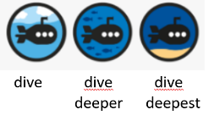
MULTIPLY BY 10, 100 and 1000
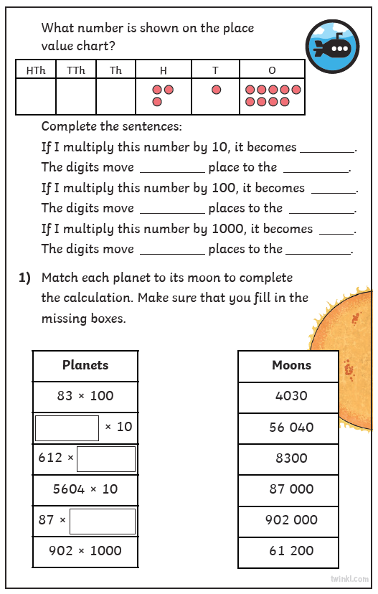
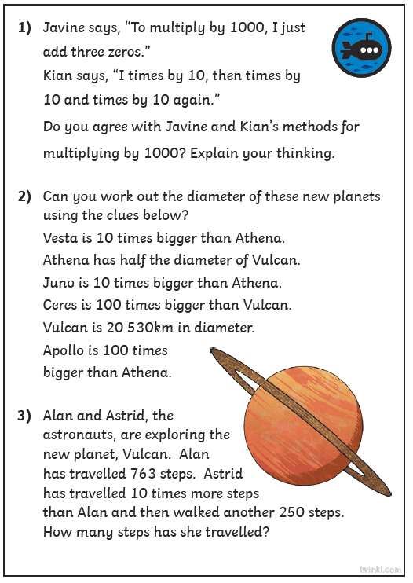

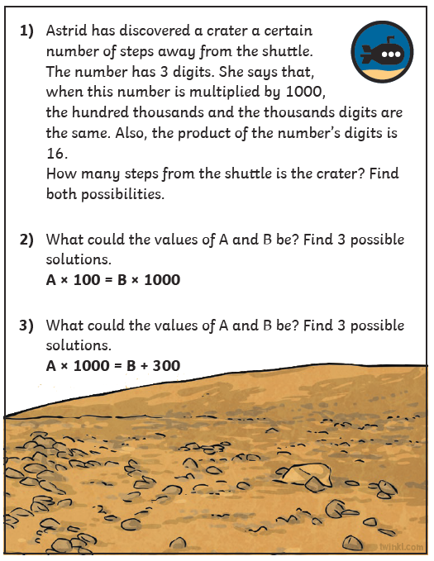

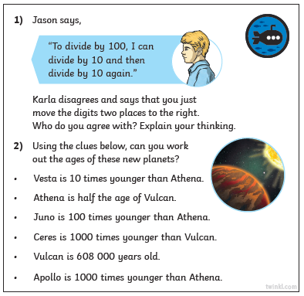
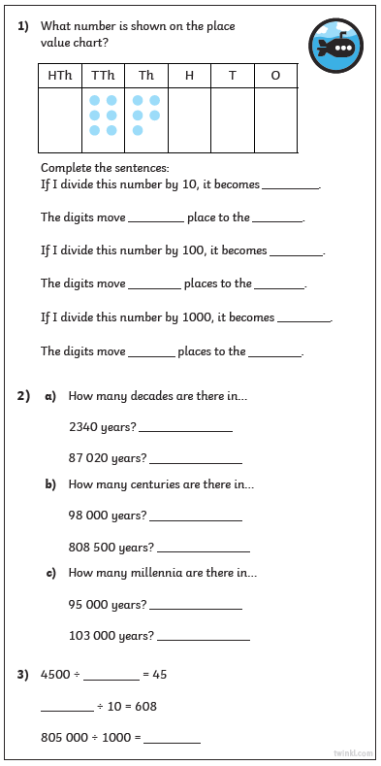
DIVIDE BY 10, 100 and 1000

