Home Learning Ideas for all
Friday 20th March 2020
Storyline Online is an excellent online audio book resource:
https://www.storylineonline.net/
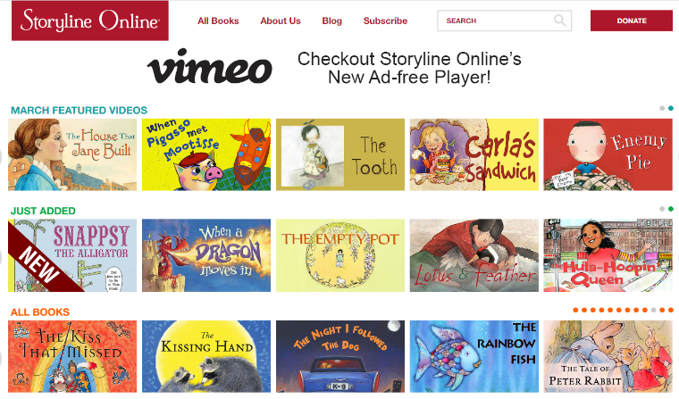
Go onto it and have a look at the many, many books – choose one and draw a picture of your favourite part of the story. If you did this quickly, feel free to write your own version of the story, or a book review. Would you like to recommend this book to others?

Also, remember to practise your number facts.
https://www.topmarks.co.uk/maths-games/hit-the-button
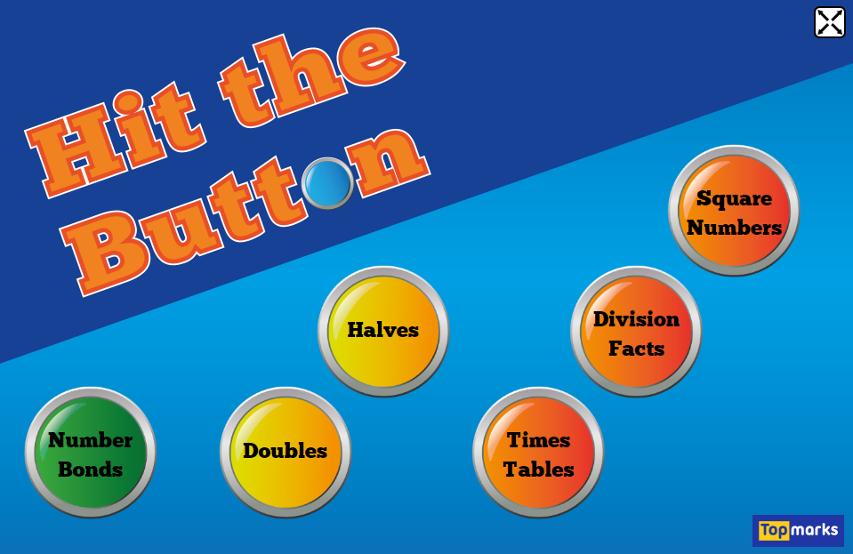
This is a great resource and you can make the task as easy or as difficult as needed. Can you set yourself a score to beat? Perhaps challenge another family member…

And finally, go into Espresso (log on details on the Home Learning Ideas) https://www.discoveryeducation.co.uk/what-we-offer/discovery-education-espresso and select the correct Key stage for you and complete the daily challenge… good luck!

