Year 5 Home Learning – Monday 4th May 2020
ENGLISH  Use your wonderful imagination, and your knowledge of writing poetry, to create a list poem of your wishes.  I wish …  You could use a character from a favourite story to inspire you. Scroll down to see an example to get you started. |  | MATHS  Practice your column addition and subtraction skills. (Hint: take care with aligning the digits in the correct place value)  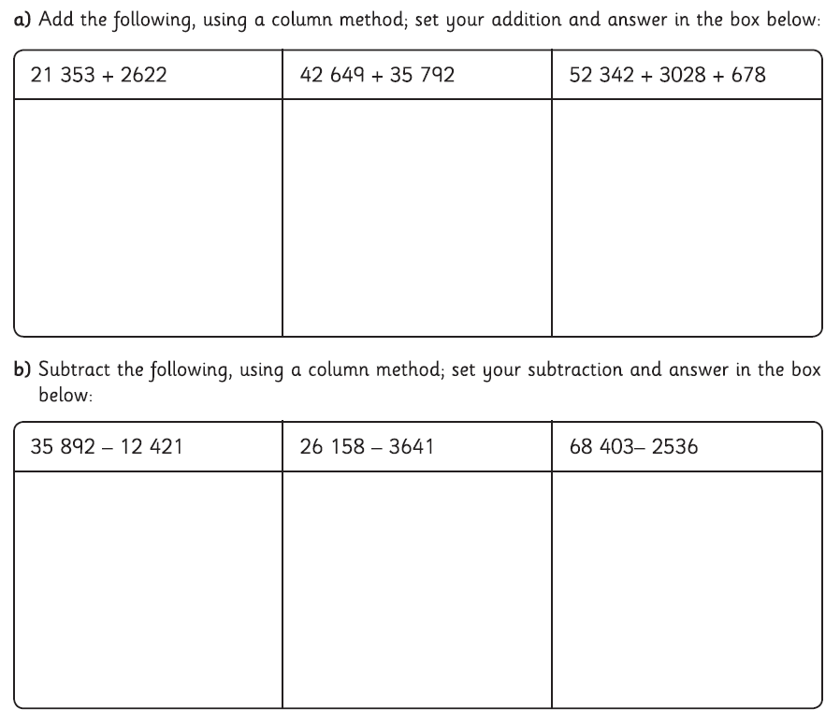
WONDERFUL WORDS
Look at the Year 5 & 6 Words List. You can find it as a link on our Coronavirus Closure, Home Learning Matrix, Year 5 tab: https://www.highworth.bucks.sch.uk/web/year_5/460996
Choose 4 or 5 words to practise at a time.
- Look up the definition in a dictionary to check the meaning of each word.
- Learn the correct spelling by using: Look, Say, Cover, Write, Check.
- Write a sentence which includes the word to show that you understand its meaning.
4. Challenge yourself to include PARENTHESIS (extra information) in brackets, or commas, in each
of your sentences.
SCIENCE  We know how much you all enjoy watching these science news update videos.  Use this link to watch the most recent one:  https://www.reachoutreporter.com/?category=news_update  You could try using the organiser below (scroll down) to jot down your thoughts and questions as you watch.  You might even want to do some further research about your favourite news item. | HISTORY  This Friday, 8th May, is the 75th anniversary of Victory in Europe (VE) day, which marked the end of Word War 2. We have attached some information which you can download.  Can you find out what people did to celebrate the day 75 years ago?  What did the two princesses, Margaret and Elizabeth (who is now Her Majesty the Queen), do to join in the celebrations?  We’ve also attached an idea for some bunting, if you’d like to make some for your own celebrations. |  | R.E.  As you know, this is the month of fasting for the Islamic religion, known as Ramadan.  You can learn about the Ramadan Lunar Calendar by reading the following text (scroll down) and then test your knowledge by answering the questions.  We’ve included the answers (no cheating!) to help you improve your learning. So try repeating the questions later in the week and see how much knowledge you can recall accurately.
In addition to the tasks above, please remember to spend 10 minutes reading every day!

