Year 2 Home Learning
Week Commencing 22 June 2020- Friday
Please send your work to- year2@highworthcombined.co.uk
We always look forward to seeing your work. Please let us know if you need any help or have any questions.
Book Review:  Did you like the book? Why?  What was the best part? Why?  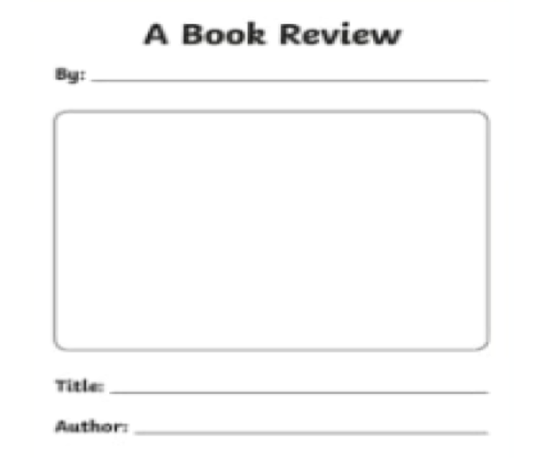  Who was your favourite character? Was there someone you didn’t like? Why? Would you recommend this book to someone else?  Can you invent a new character that would have worked well in this book? How would it fit onto the story?  Redesign the front cover. What would you put on the front cover? Can you draw a new version? | Maths  Mental Maths warm up:  1. 67 - 59 =  2. __ + 37 = 93  3. 4 x 11 = ___  4. 35 ÷ 5 = __  Multiplication:  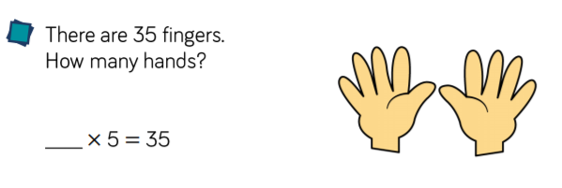  1.  2.  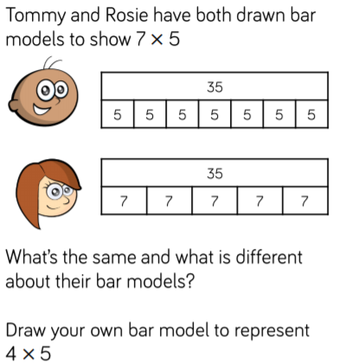  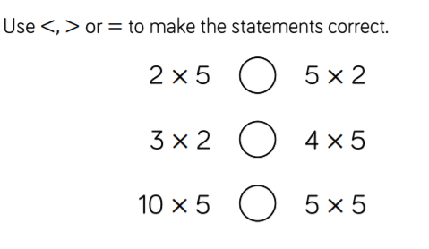  3. Prove your answers by shoeing your workings.  Challenge!  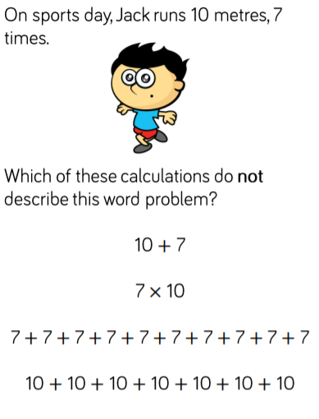  Explain why.
DT:  Watch: Bob the Builder – Spring City Wheel/Season 19 Episode 36 https://safeyoutube.net/w/5Aoe  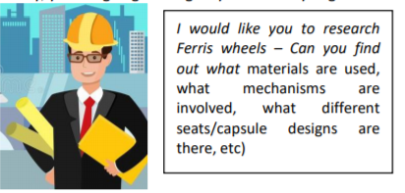  Today you are going to imagine that you are a City Engineer.  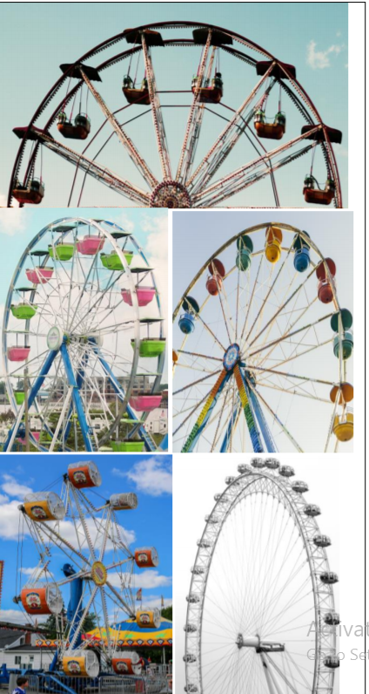  After you have made notes, have a look at these designs – which ones do you like/dislike and why? | 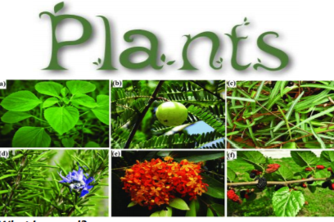  Science  What is a seed? What different types of seeds are there? What plants are grown from seeds that you know of?  Are seeds always visible? What do living things need to grow? How do we plant seeds?  Now watch: BBC Bitesize – The Lifecycle of Plants  https://vimeo.com/218127170  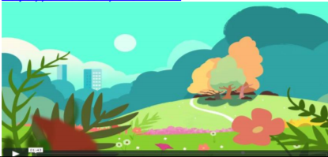  Create a poster to show the lifecycle of a plant? Can you explain what happens at each of the stages? For example:  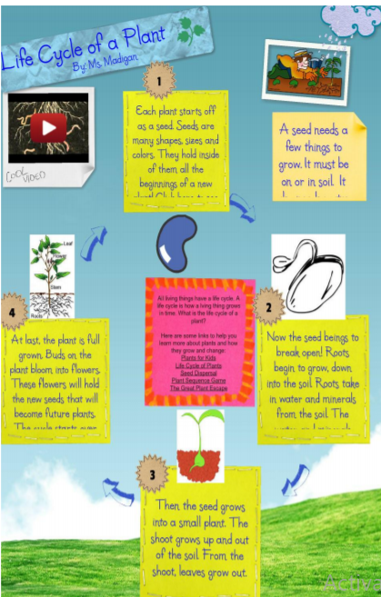
Reading  Bitesize Daily Book Club: The Night Box by Louise Greig  https://www.bbc.co.uk/bitesize/articles/zj6qmfr | Maths  https://www.topmarks.co.uk/learning-to-count/place-value-basketball  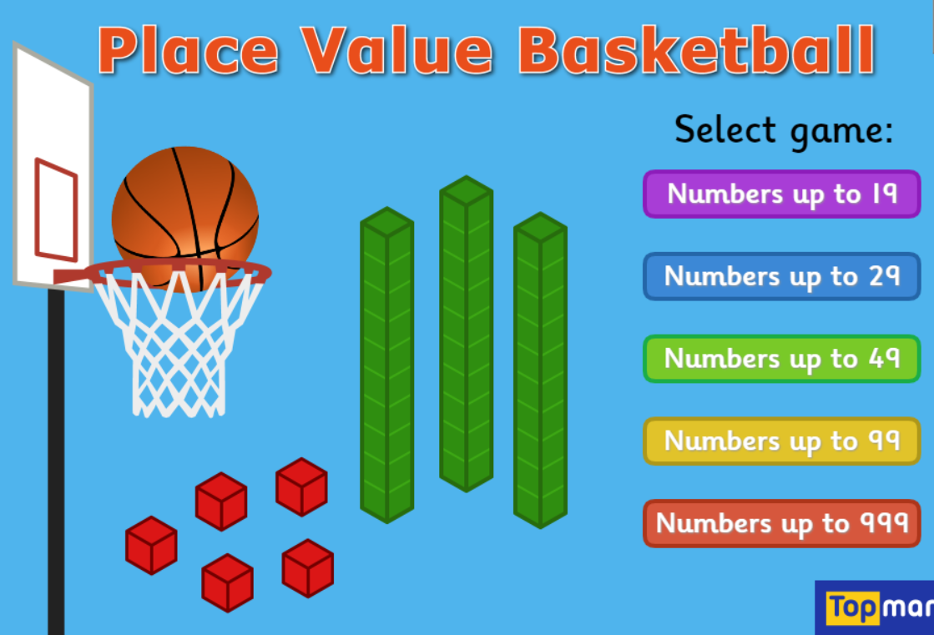  Challenge!  Choose numbers up to 999. How many did you score?  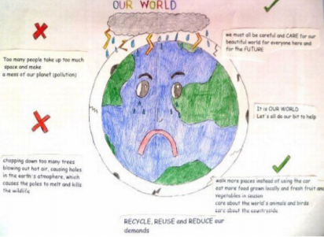

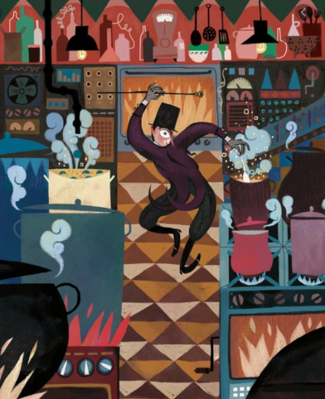

Charlie Bucket stared around the gigantic room in which he now found himself. The place was like a witch’s kitchen! All about him black metal pots were boiling and bubbling on huge stoves, and kettles were hissing and pans were sizzling, and strange iron machines were clanking and spluttering, and there were pipes running all over the ceiling and walls, and the whole place was filled with smoke and steam and delicious rich smells. Mr Wonka himself had suddenly become even more excited than usual, and anyone could see that this was the room he loved best of all. He was hopping about among the saucepans and the machines like a child among his Christmas presents, not knowing which thing to look at first. He lifted the lid from a huge pot and took a sniff; then he rushed over and dipped a finger into a barrel of sticky yellow stuff and had a taste; then he skipped across to one of the machines and turned half a dozen knobs this way and that; then he peered anxiously through the glass door of a gigantic oven, rubbing his hands and cackling with delight at what he saw inside. Then he ran over to another machine, a small shiny affair that kept going phut-phut-phut-phut-phut, and every time it went phut, a large green marble dropped out of it into a basket on the floor.

- Underline the verbs or write them down in your book.

- Highlight the similes or write them down in your book.

- How did Charlie feel when he was looking around the room?
How do you know this?
_____________________________________________

- What does anxiously mean?
_____________________________________________

- Which words tell you that the machines were noisy?
_____________________________________________

- How would you feel walking into that room? Explain your answer.
_____________________________________________
_____________________________________________

- Use a dictionary to find the definition of these words
delicious ________________________________
dozen ________________________________
gigantic ________________________________

- Using a thesaurus, could you find better words for
large _________________________
loved _________________________

- Why do you think the author used the simile?
_____________________________________________
_____________________________________________
_____________________________________________

- Could you change the simile?
‘He was hopping about among the saucepans and the machines like a _____________________________________________

