Year 3 Home Learning – Monday 1st June
We would love to see the work you have been doing. If you would like to take a picture of your work and send it to us for feedback, our email address is year3@highworthcombined.co.uk
Reading – make sure you spend some time reading every day, 10 minutes minimum.
Fractions  Remember to keep practising your times tables, learning both the multiplication and division facts by heart.  Learn how to find fractions of an amount. This is mainly revision of what you did in Year 2, with some different fractions added.  The top number in the fraction is called the ‘numerator’, the bottom number is called the ‘denominator’.  When we find a fraction of a number, we are dividing that number.  Look at the photograph below of the work that I’m setting for you. Practise reading the fraction (you may need help with this). The first one says ‘One quarter of 20’.  To find a quarter of 20, we need to divide 20 by the denominator, which is 4.  Get twenty small objects, e.g. buttons, coins, clothes pegs (I would use smarties, because you can eat them at the end!). Make sure you have counted carefully. Divide them by four. You could use four plates or bowls to help you. You could also use a picture instead, like I have drawn in the first photo. The amount you get in each group is the answer. | Geography – My local area  Make a map of your local area. An example done by a Year 3 child is shown below.  Don’t make your map cover to big an area, as this will be too difficult to do. Just include a few streets near to you. You could draw your route to school, including landmarks along the way. Remember to include some street names.  Here are some landmarks you could include, if they are near to your house:  - Your friend’s house  - A local shop  - A post box  - The school  - A park | English – Description of a sunny day  This week, practise writing longer sentences by using subordinating conjunctions.  We are having some wonderful sunny weather at the moment and are now allowed to go outside as much as we want, which is great.  Write a description of how it feels to be outside on a sunny day. Perhaps you might like to go outside and take some rough notes first to help you with your description. You might write about some of the following:  - What you can see around you  - What the sun feels like on your skin  - Any lovely fragrance of flowers you can smell  - Something you do outside when it’s sunny  - Do you buy an ice cream – describe what it’s like to eat it.
Science - Friction  Learn about the force of friction from BBC Bitesize.  https://www.bbc.co.uk/bitesize/articles/zb3ny9q  There is a really interesting toy car investigation that you can do. It’s one of the activities given underneath the video. | History – The Iron Age  A few weeks ago, we gave you some work to do on the Iron Age, but what was it actually like to be alive during the  Iron Age?  Watch these interesting videos on BBC Bitesize to find out:  https://www.bbc.co.uk/bitesize/articles/zb3ny9q  After you have done that, you could complete the Twinkl reading activity about the Iron Age linked on the same page. | Art – Self-Portrait  A portrait is a picture of a person. A self-portrait is when you draw a picture of yourself.  Use paints, pencils, felt tips or whatever you have.  Draw or paint a picture of yourself. You need to get a mirror and carefully observe what you see.  Below are some self-portraits by famous artists.

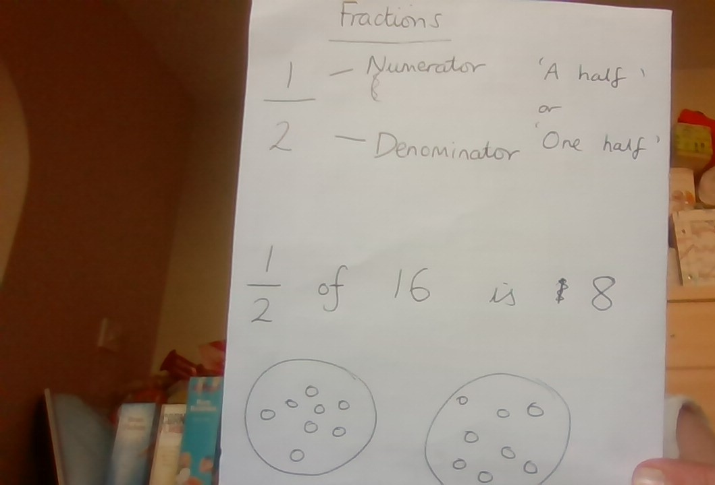

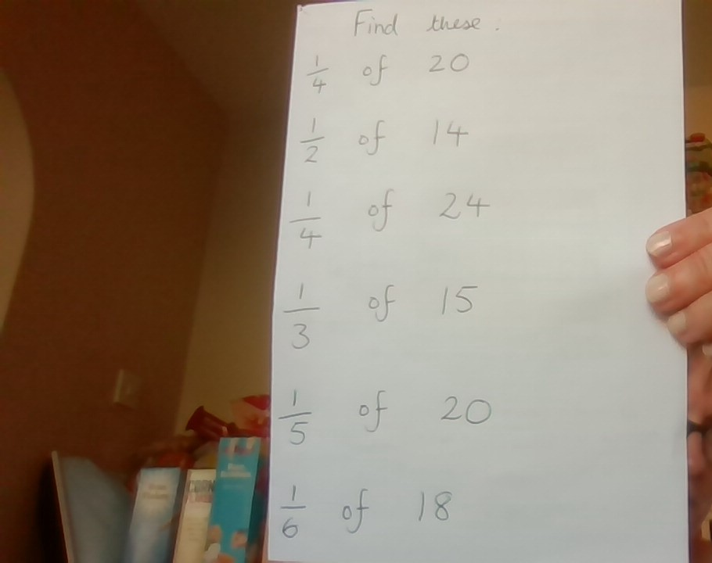

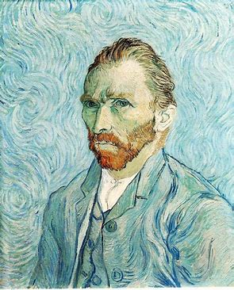 Vincent Van Gogh
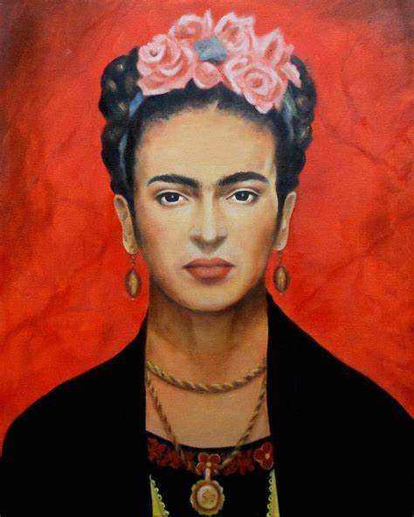 Frida Kahlo

