Home Learning Ideas for all
Friday 27th March 2020
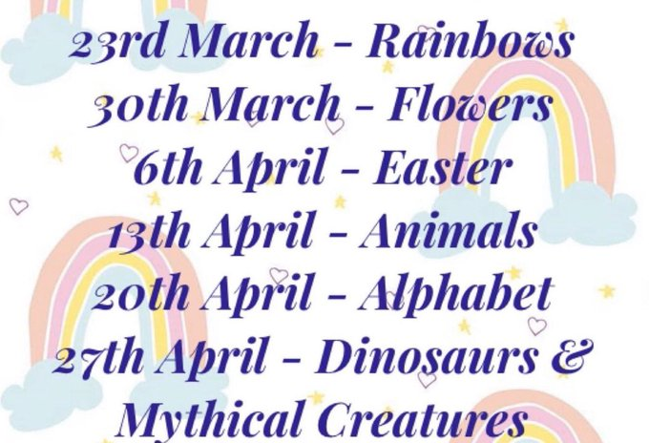
Get crafty and brighten up your neighbourhood:
Lots of people online are suggesting putting paintings up in your house windows to cheer everyone up. Look at the suggested list and have a go – we would love to see any pictures you have done!

Time to get inventing…
https://www.littleinventors.org/
Watch the 5-minute video with Chief Inventor, Dominic Wilcox. He will hopefully inspire you to draw your own invention today! If you do come up with an invention you are proud of, follow the links on the Little Inventors website to upload it – who knows… maybe your design will be chosen to be made properly?!

And finally, go into Espresso (log on details on the Home Learning Ideas) https://www.discoveryeducation.co.uk/what-we-offer/discovery-education-espresso and select the correct Key stage for you and complete the daily challenge… good luck!

