Year 3 Home Learning – Monday 29th June
We would love to see the work you have been doing. If you would like to take a picture of your work and send it to us for feedback, our email address is year3@highworthcombined.co.uk
Reading – make sure you spend some time reading every day, 10 minutes minimum.
Maths – Year 3 Maths Practise  Look at the work below, where you have two options.  Two sheets are labelled ‘easier’ and two sheets are labelled ‘harder’. Decide which would be best for you and complete the eight questions. | English – Correct the spellings  Look at the worksheet below that has incorrect spellings of Year 3 and 4 common exception words.  Correct the spelling mistakes. If you need help, check the correct spelling of the words in a dictionary. | English – Exploring Nonsense Poetry  Learn about nonsense poetry on BBC Bitesize. There is a brilliant video of the poet and comedian, Spike Milligan, performing his poem ‘On the Ning Nang Nong’.  https://www.bbc.co.uk/bitesize/articles/zv3v6g8  Complete the activities below and write your own nonsense poem. Remember to send yours in to year3@highworthcombined.co.uk so we can enjoy reading it.
French – Family and Hobbies  Learn how to talk about your family and hobbies in French using BBC Bitesize  https://www.bbc.co.uk/bitesize/articles/zgqp7yc  Watch the video and try to learn the words.  As an extra challenge, complete the linked worksheet on Twinkl. | Geography – Design your own island  Design your own island using the sheet below.  You need to include:  - A river  - An area of hills or mountains  - Small villages  - A large town  - A beach  - Any other locations you like | Art – Mosaic  Can you make a mosaic?  You will need to design a picture first, then you could use small pieces of coloured paper to build it up like a collage.  Some ideas could include:  Your name / initials.  Your favourite animal.  Your favourite flower/ plant.  If you really want to challenge yourself, you could try to make your mosaic symmetrical, like a picture of a butterfly or something similar.
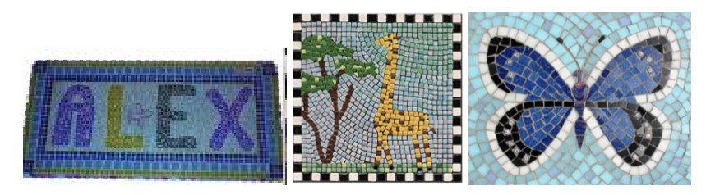

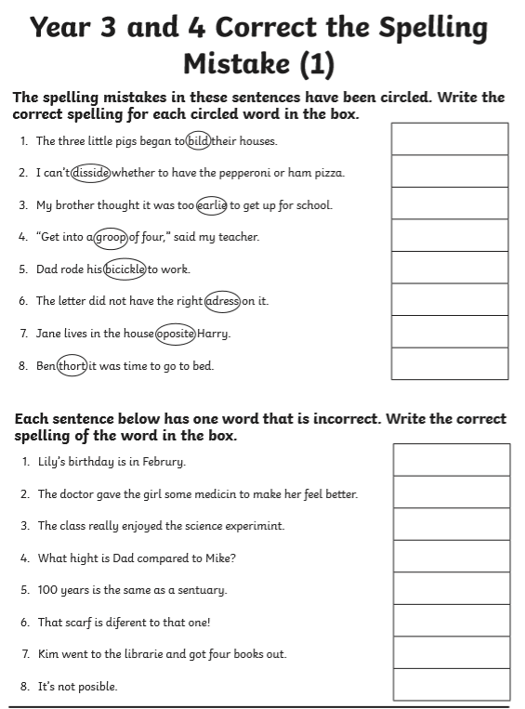

EASIER

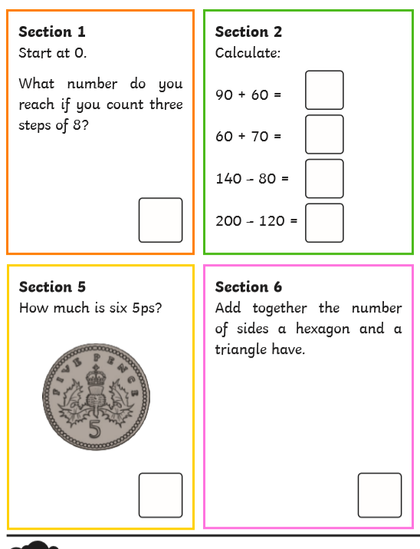

EASIER
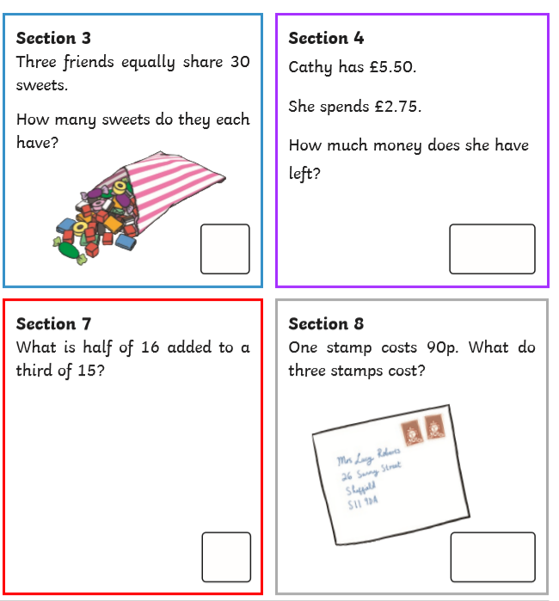

HARDER
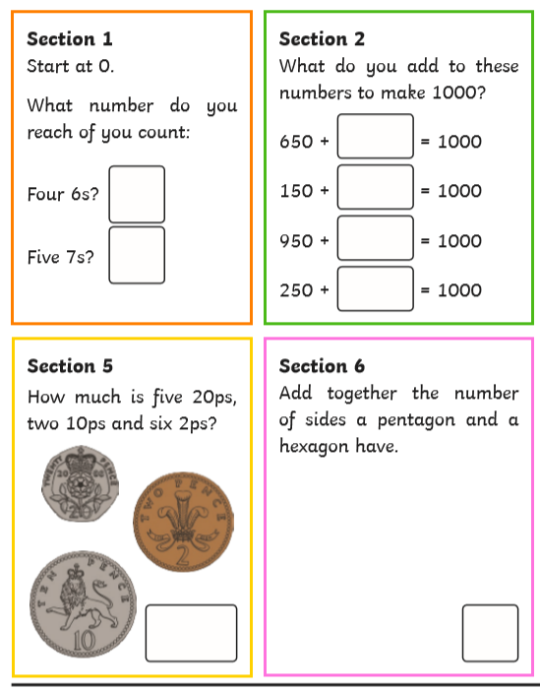

HARDER
