Nobles and priests were the only people who could read and write in the ancient Maya world.
Nobles did not go out in front of people without one of their slaves holding a cloth in front of their face so that people could not see their faces.
People could not speak to a noble. If a person wanted to speak to a noble, they had to speak to a noble's servant.

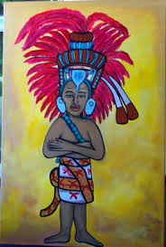
Education

Priests taught the children maths, science, astronomy, medicine, writing and other subjects.

Living conditions

The nobles lived inside the city in large palaces made from stone.

The nobles had slaves to do all their hard work for them.

Entertainment

Religious ceremonies were the main source of entertainment. They also played music, danced, and played ball games.

Job / Lifestyle

Most nobles did not have a job but if they wanted one they were given important jobs in government.

They had a great deal of free time and lived lives of luxury and were even carried from place to place by slaves.

Clothing

They wore colourful clothing made from animal skins, enormous hats or headdresses and wore loads of jewellery.

The more important the noble, the taller the hat or headdress they wore.
Only nobles could use feathers, and they used them on clothes, in their hair, on hats or headdresses and as jewellery.
Both men and women wore their hair long. They took time to plait their hair.

Food

The Maya ate lots of food. The most important food was maize. They made food from maize including tortillas,
porridge, and even drinks. They also ate beans, squash, and chilies. For meat the Maya ate fish, deer, ducks, and turkey.

Nobles liked a chocolate drink with chilli peppers.

