Dear Year One,

We’re setting you a few challenges so that we can now learn a bit more about you! Don’t forget to email them in for us to have a look at using this address: year1@highworthcombined.co.uk

We can’t wait to meet you! Have a wonderful summer holiday.

Take care,

Mrs Harris, Mrs Milner and Miss Hawes x

Have a go at drawing a self-portrait. First, draw your face using a pencil. Then use paint, crayons or felt tips to colour in your drawing using bright colours.  Miss Hawes created her own self-portrait but don’t worry she doesn’t really have purple hair! | 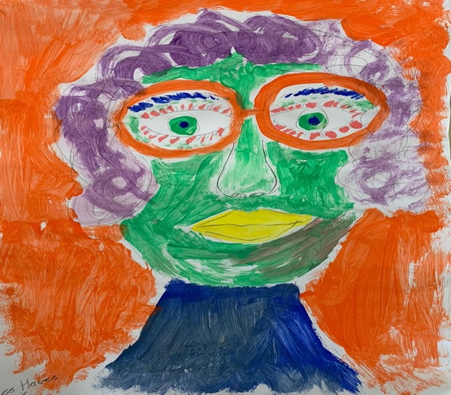
Draw some pictures to tell us a little bit about what you love to do!  Mrs Harris has drawn some of her favourite things. She’s looking forward to all our Art lessons and story times in September. Listen out for her as you may hear her before you see her as she sings her favourite tune! | 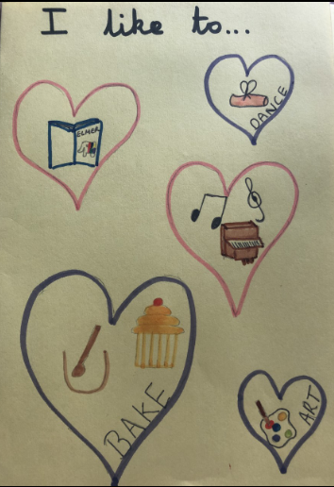
Draw a picture of your school friends. Ask a grown up to help you write their names and a sentence about what you like to play with them.  Mrs Milner has drawn her friends at school and has written about how brilliant they are! | 