Year 5 Home Learning – Monday 18th May 2020
ENGLISH  We thought you’d enjoy creating your very own virtual time capsule of your experiences of the lockdown.  We have attached a Time Capsule document, which has lots of templates and fun ideas to help you with this.  Take a look and have a go at completing Monday's comic strip and Tuesday's collage. |  | MATHS  Practice your problem solving skills using addition and subtraction (scroll down).  HINT: take care with aligning the decimal point and the digits in the correct place value.
WONDERFUL WORDS
Look at the Year 5 & 6 Words List. You can find it as a link on our Coronavirus Closure, Home Learning Matrix, Year 5 tab: https://www.highworth.bucks.sch.uk/web/year_5/460996

Choose 4 or 5 words to practise at a time.
- Look up the definition in a dictionary to check the meaning of each word.
- Learn the correct spelling by using: Look, Say, Cover, Write, Check.
- Write a sentence which includes the word to show that you understand its meaning.
4. Challenge yourself to include a PLURAL word which requires a POSSESSIVE APOSTROPHE
in each of your sentences but BE CAREFUL because both of these are correct:
The teachers’ muscles were aching after their run. The children’s muscles were aching after their run.
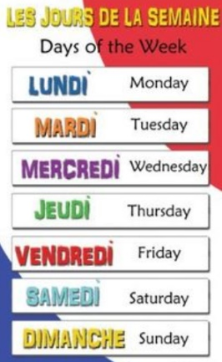  FRENCH  Challenge  yourself to  write as  many days  of the week  in French  as possible,  from memory  Can you get  the spellings right too?  Watch this video for a fun way to help you remember them in the right order:  https://www.bbc.co.uk/teach/class-clips-video/french-ks2-days-of-the-week/zv2jmfr  You could even practise and perform the chorus for your family!  We know how much you love a Wordsearch, so we’ve included one of those too! (scroll down). | R.E.  This is the month of Ramadan (an Islamic festival) which is a time of prayer and fasting.  You can learn more about the festival of breaking the fast, Eid al-Fitr (which will be celebrated on Saturday) by reading the attached text and then test your knowledge by answering the questions.  There are three levels to choose from. Make sure that your questions have the same number of stars as the comprehension you have chosen. The answers are included but don’t look at them until you are sure that you have tried your best!  Try repeating the questions later in the week and see how much knowledge you can recall accurately. |  | Planning a Celebration  Plan a celebration event of your choice and design an invitation. You could do it on a computer.  It could be a birthday party, an Eid celebration, or anything else you wish to plan.  Imagine that you have £150 to spend and 25 guests will be attending. What will you spend the money on?  Plan the celebration considering the location of the event, how you will decorate the venue, what your guests will eat and drink and how you will entertain your guests. Detail the timings of your event.  Remember to include all the details in your invitation.
In addition to the tasks above, please remember to spend 10 minutes reading every day!
