Extra Home Learning – HID Children No 10 - Monday 22th June

To replace some of the tasks in the class home learning you may wish to try some of these. Parents, please simplify or extend depending on needs and age of children. There’s more signing from Mrs Mills and another story from the Royal
Association of Deaf People at this link: https://m.youtube.com/watch?v=XWcDpDT7Y2o&list=PL7zNl2HpED2imeU0ZDV3W6BF4DilSUAEg&index=42&t=0s
Don’t forget to email me your child’s learning to hid@highworthcombined.co.uk

Signed Story and Book from Mrs Mills –  ‘The Cabin in the Hills‘  Watch the signed story and  then read the story on the  Power Point.  There are activities to do  Below and at the end of  The power point | Scientific Wordsearches:  Some fun word searches related to the science topics you have been learning. See below for:  - Yr2 – Geography – Asia/China  - Yr3 – Science – Food Chains  - Yr4 – Science – Water Cycle  Can you remember the signs for the words on the word searches?
Signed Story ‘Mog the Forgetful Cat’:  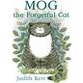  Watch the signed story by going  To the link below:  Click (and press control) to go to  the link:  https://m.youtube.com/watch?v=XWcDpDT7Y2o&list=PL7zNl2HpED2imeU0ZDV3W6BF4DilSUAEg&index=42&t=0s  What things does Mog keep forgetting? | Looking and Thinking Activity – ‘The Castle’  Look carefully at the picture below of a castle.  There are 2 quizzes below, A and B. Start with A and if you can, you can do B as well.
HID Afternoon Activity: - Worries 2
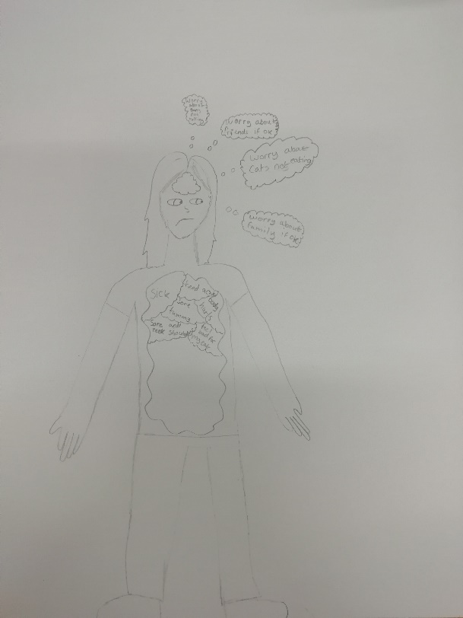
This week you will add to your picture you did last week.

Think about what things make you worry.
Around the picture of you make a map of the things that worry you
and you can’t stop thinking about.
You can draw or write them.

Here is one already started by one of the HID children.
You can add to your picture every week:

See 7 more pages below:
- Activities for story, ‘The Cabin in the Hills’
- Asia/China Word search
- Food Chains Word search
- Water Cycle Word search
- Looking and Thinking picture for ‘The Castle’
- Questions A for ‘The Castle’
- Questions B for ‘The Castle’
Activities for ‘The Cabin in the Hills’ – see Power Point
Questions:
- Where did Ben and Mitch go on holiday?
- What animal did they find in the cabin?
- How did they get rid of the possum?
- Why did Mitch shut the door at the end?
- Where do you think possums live?
Use these sentence starters to start your answers:
They went ...........................................................................................................
They found .........................................................................................................
They got rid of the possum by.......................................................................
They shut the door to......................................................................................
They live ...............................................................................................................

Cut up these words and make sentences from the story The Cabin in the Hills’
Sentences for ‘The Cabin in the Hills’
Ben got to the cabin first and opened the door.
Dad opened the door slowly and went inside the cabin.
Dad stopped the car at the end of the road.
He ran up the steps to the cabin.
He ran back to help Mitch with his bags.

Task: Can you find out about possums? Where do they live and what
do they eat?

2 – Geography- Asia/China

a s i a m x b f q c

s r t o b s c v w o

h a e s d a e d s n

a x h j h l u h g t

n t w i g t x f z i

g r e a t w a l l n

h j s n i a r t q e

a z o i w t k y m n

i t z h x e s n k t

k o i c a r p x o n

z b u i l d i n g s

asia continent
china shanghai
dead sea saltwater
great wall buildings
trains koi carp

3 – Science- Food Chains

h e r b i v o r e x

p r e d a t o r s r

x e b g m w a f e q

z r c p r e y c z e

f o o d x g u h y r

p v f s u d t a b o

l i b w o e l i n v

a n t r a m d n e i

n r p u g c x f v n

t a n i m a l s r m

s c o n s u m e r o

food chain
plants animals
producer consumer
predators prey
herbivore carnivore
omnivore

4- Science- water cycle

try the experiment on yr4 matrix

p c l i n g f i l m x r

d y f o j t e a r t h e

g c h e b f c n g e r c

z l q j o v g s b m l y

r e t a w s n h I u e c

a f u s l x i f k g f l

k n o i t a r o p a v e

d i b e h p t e d f c x

c o n d e n s a t i o n

n u s c h o u t s i d e

water earth
cycle recycle
evaporation
condensation
mug string
bowl clingfilm
outside sun

Picture for Looking and Thinking Activity: ‘The Castle’
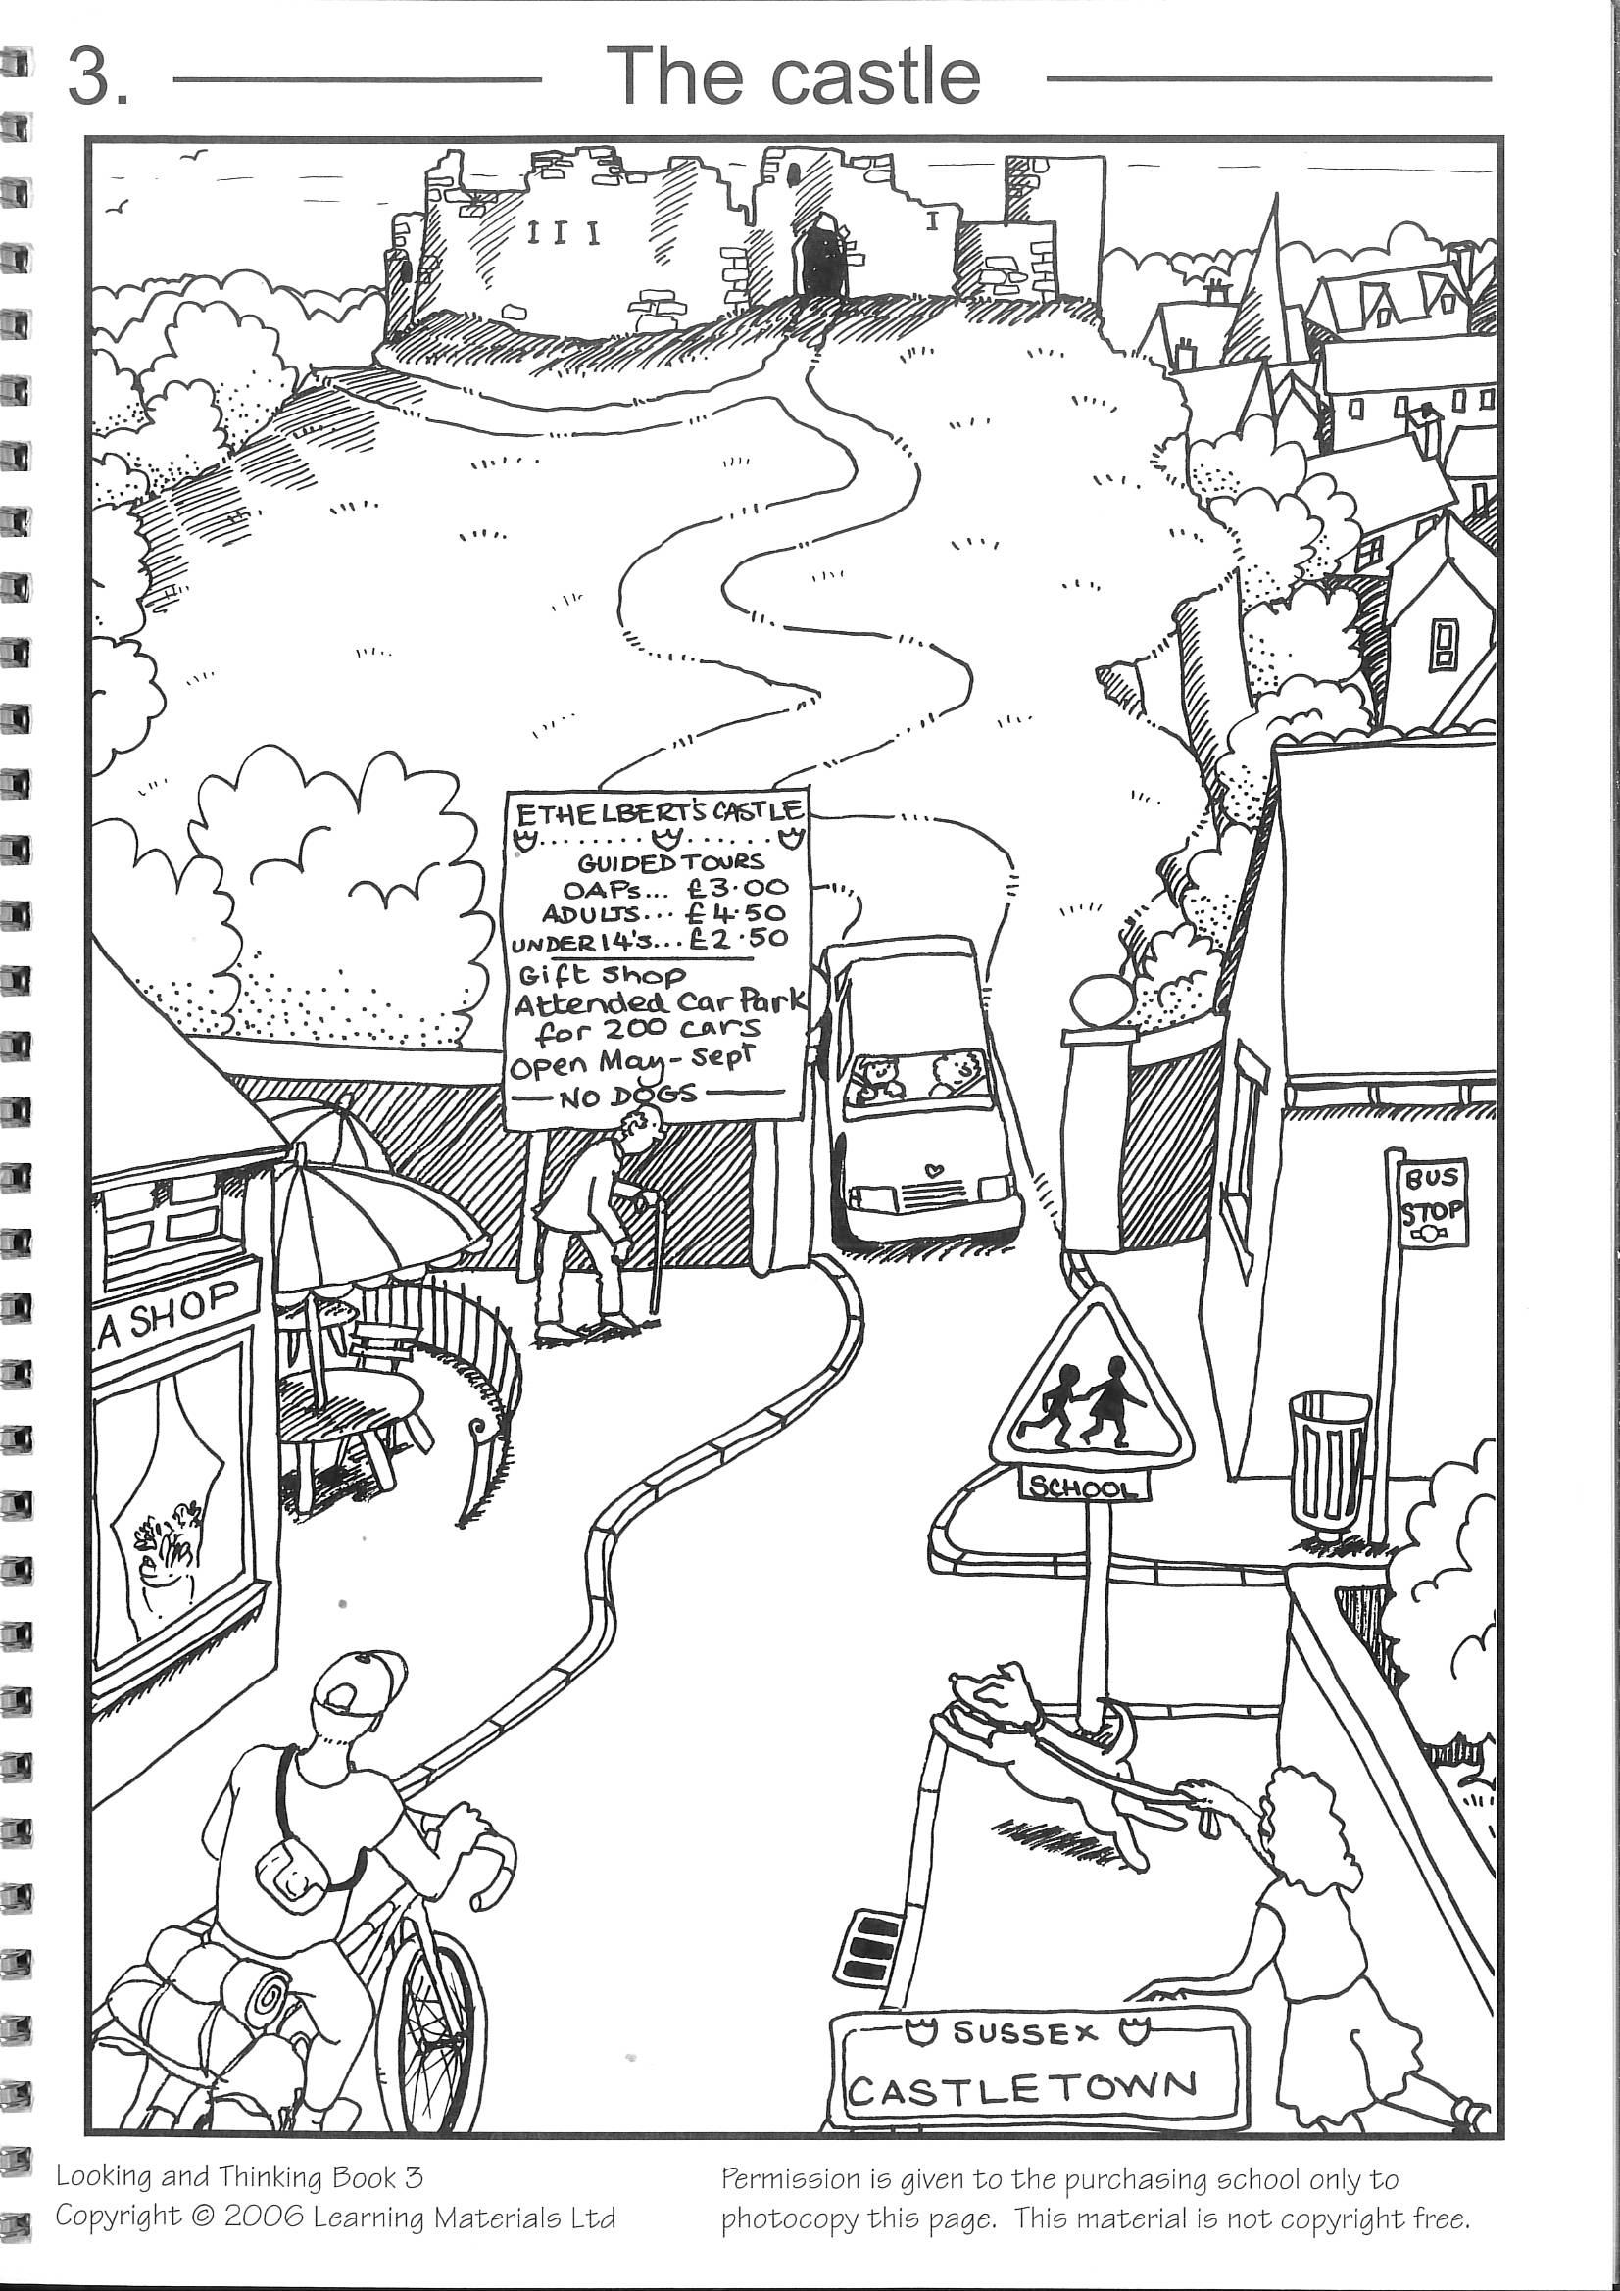

See below for Questions A then Questions B for ‘The Castle’

Questions A for ‘The Castle’
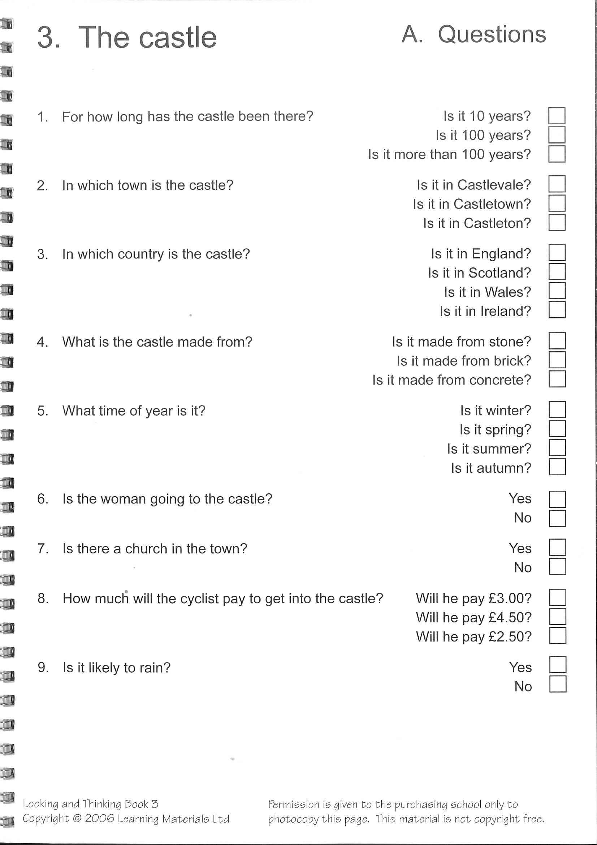

Questions B for ‘The Castle’
