Home Learning Ideas for all
Monday 27th April 2020

Make you own TV show!
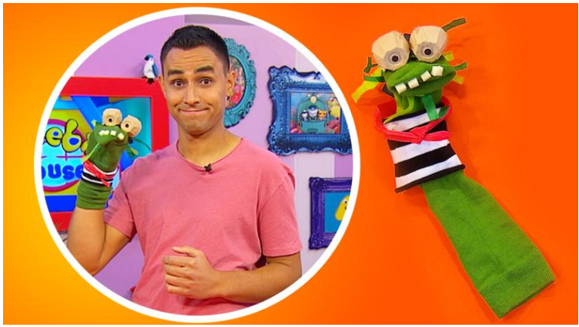
Get all of your kids favourite toys together and make your own TV show. You could film it on your phone and then enjoy watching it back. You could even make your own characters just like Ben from CBeebies has with his sock puppet! Click here if you want to see how Ben made his sock puppet… https://www.bbc.co.uk/cbeebies/makes/swashbuckle-make-your-own-wally-the-welly-puppet

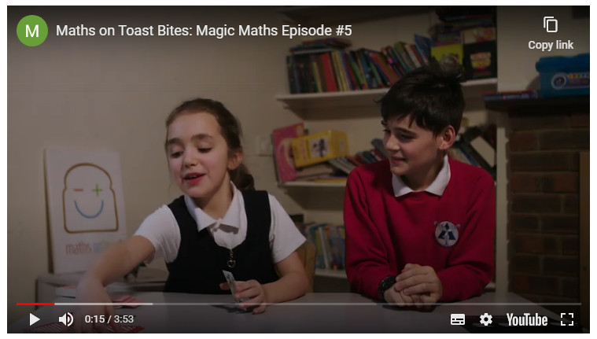
Magic Maths – Step through a playing card
Challenge your children to step through a playing card today! All you need is a playing card (or piece of card that size) and scissors. Watch the clip from Maths of Toast to find out how…
https://youtu.be/hruqv905TuI

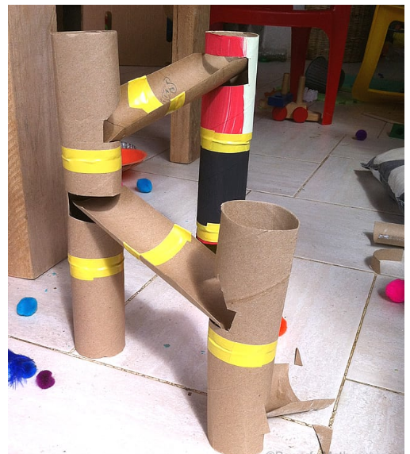
DIY Cardboard Marble Run
All you need is lots of left over toilet roll and kitchen rolls, plus glue/tape to create your very own marble run. You don’t even need marbles to run down at the end – you could use any small spherical objects – such as small playdoh balls. Who can create the longest marble run? We would love to see photos of your finished products!

