Year 2 Home Learning
Week Commencing 18 May 2020- Monday

Maths Task  Five in 5  We have done many of these challenges in class. Can you complete the 5 different questions below?  - 23 + 45 = __  - 42 – 37 = ___  - 5 x 6 = ___  - 40 10 = ___  - What is ½ of 12 | English Task  Describe the Scene- Use the picture and keywords to describe the scene. Imagine yourself in the picture and use your senses to describe what you can see, hear, feel, smell and taste.  Try to write in the present tense.  Ex- I can see an enormous grey elephant raising his trunk.  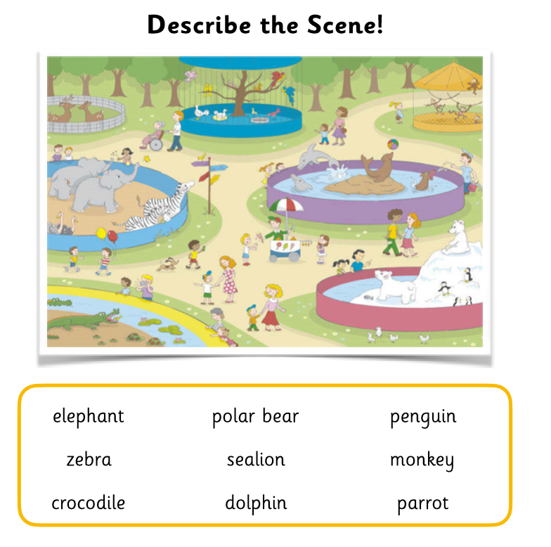
Reading  The Dragon Machine  Follow the link to read the online sorry about the boy who starts to see dragons. Can you remember when we saw a dragon at our school?  Turn the volume off and see if you can read it on your own.  *This website has lots of free books for you to read online. Have a look and see if there are any other books that look interesting.  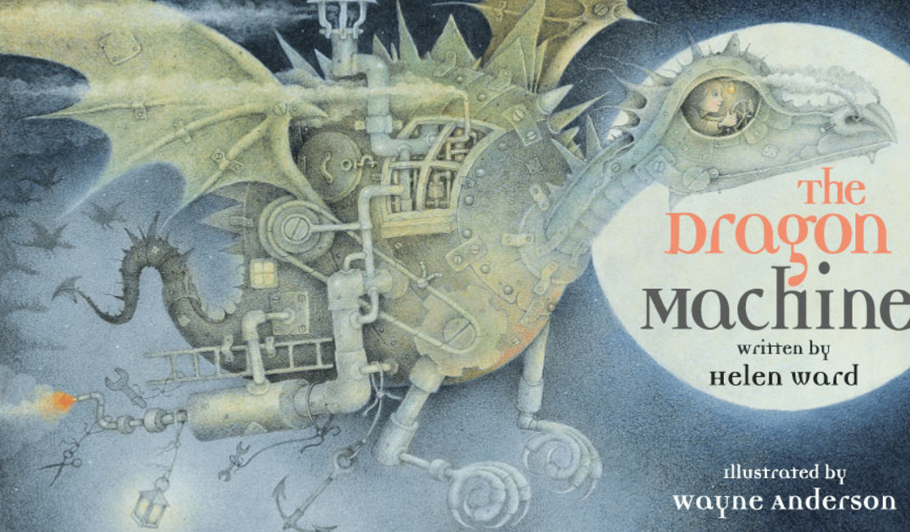  https://www.booktrust.org.uk/books-and-reading/have-some-fun/storybooks-and-games/the-dragon-machine/ | Vocabulary  In today’s book there were some great vocabulary words. Can you match these words to their definitions?  *Challenge- can you use each word in a sentence?  noticed ignored perched havoc consulted  Definitions  - To destroy, to damage  - To pay attention to, to see or to be seen  - to rest in a high place  - to ask advice from others  - to not see or recognise something
Science  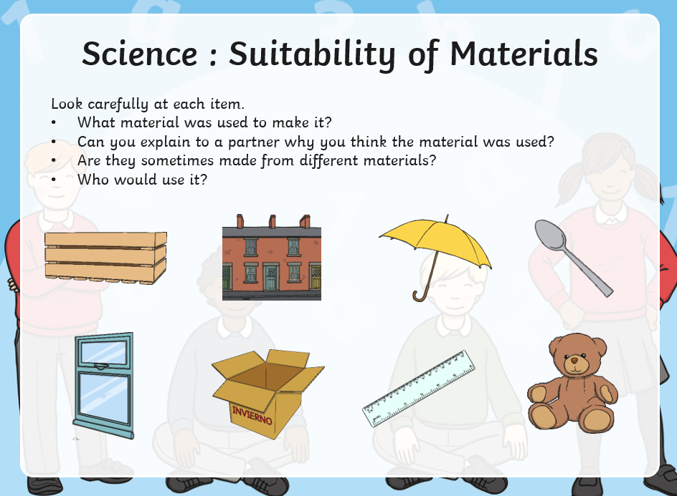 | App/ game  Free Rice  Freerice is a free-to-play website and mobile app that allows players to donate rice to families in need by playing a multiple-choice quiz game. For every question the user answers correctly, 10 grains of rice are donated via the World Food Programme.  https://freerice.com/categories/english-vocabulary  