Welcome to Reception!

Dear Reception Superhero,
Firstly, I just want to say how excited I am to meet you properly in September and I am so sorry that it can’t be sooner. I feel so lucky that I are going to be your teacher.
I have made you a video that tells you a little bit about me and what your classroom will look like. I hope you enjoy it.
I have set you a few challenges to help me to learn a little bit more about you! Please complete them at home and then send a photo of your masterpieces in for me to have a look at using this address: yearr@highworthcombined.co.uk
I hope you have a wonderful summer and I can’t wait to hear all about it on your first day.

Take care,
Mrs Cox

Transition Day activities
Activity | Example/ Top Tips
We love to read and listen to stories in Reception. Read ‘Jake’s First Day’ with an adult. When you have finished the story you could make your own pirate hat. Follow the steps on the instruction sheet to help you. | In the story Jake has lots of fun on his first day; meeting his new teacher and making new friends. Talk about what you think your first day at school will be like. Who do you think you’ll meet? What do you think you will do? What do you think you will learn about?  TOP TIP  * If possible use A3 paper when making your pirate hat.
Draw a self-portrait of yourself.  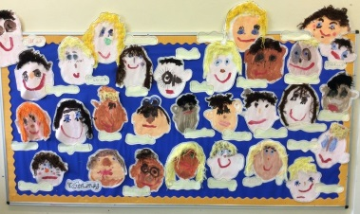  You can use colouring pencils, felt-tip pens, paint, chalk or even collage! | Use one of the frames provided or if you do not have access to a printer A4 paper will be great too. Maybe you could draw your own frame?  TOP TIP  *If you can use a mirror to help you.  *SMILE
We can’t wait to build a great year together!  Can you build us something? It could be a building, a place, an animal or a character. Use your imagination… | You could build with all different types of materials. Look at our list below for some ideas:  *lego  *duplo  *wooden blocks  *junk modelling  *playdough  *natural materials such as sticks, pine cones, flowers, leaves, stones  *sand  *mud  *clay

Don’t forget to take a photo and send it to us!

