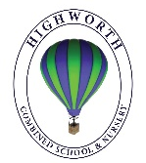
Year 1 Home Learning – Wednesday 13th May 2020
Below you will find 6 home learning tasks, you can choose which and how many you do. A number of the activities use internet links please remember the importance of only using the internet with an adult and our school internet rules to help keep you safe https://www.highworth.bucks.sch.uk/web/children/295423

Please do not hesitate to contact us if you have any queries or would like to send the work the children have been doing at home:
year1@highworthcombined.co.uk
English  Today we are going to do some writing using question marks. When we ask a question in our writing we use a question mark.  First practise writing question marks so that you know the shape of them when you come to use them in your writing. Make a colourful question mark page like the one below.  These questions are missing question marks. Can you add them in the correct place? Then write the question with the question mark in the correct place and perhaps have a go at answering them.  - What do you like to eat at a picnic  - When do you see a rainbow  - Who has long ears and hops  - Where do birds build nests  - Why do people plant seeds  - How do birds get up to their nests  - Would you rather be a fish or a frog  - Would you rather have a bath in baked beans or jump in a swimming pool of spaghetti  Can you write your own ‘would you rather’ question using a question mark? Share it with a family member and ask them for their answer.  Below are some pictures! Write a list of all the questions that the pictures make you think of. Don’t forget to use question marks.  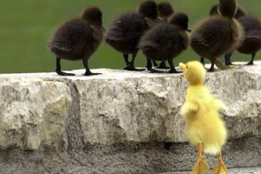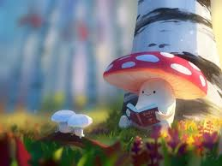  Challenge  - With an adult as you will need to use the internet go to this link https://www.bbc.co.uk/bitesize/articles/z7hc47h  - Watch the videos and complete the tasks, writing question marks in the air for the first video. Watch the second video about ‘The Magic Faraway Tree’ and write a question for the four children using the words, what, when and how and using question marks. | Maths  You will need adult supervision at all times with these activities as it involves playing with water and they need to be with you to keep you safe.  This activity is going to be wet, so might be best done outside or in the bath.  Capacity is the measure of how much a container can hold, measuring spoons and measuring jugs can be used to measure capacity. We usually measure capacity in millilitres and litres.  We are learning about capacity and volume. You will need to find a selection of containers of different sizes, two containers that are the same size, some water to fill them up and bath/bucket/paddling pool etc. to pour the water into.  - Using your water and containers show your adult a full container, an empty container, a half full container, and an almost empty container of water.  - Using your two containers that are the same size pour some water into both of them, then use the words MORE and LESS to compare the two amounts of water in each container.  - Now select your smallest container and a medium sized one. How many small containers does it take to fill your medium sized one? Repeat this with other containers and then place all your containers in order of how much they hold (order the containers from smallest to largest capacity).  - Can you use a measuring jug to measure how much each container holds?  Challenge  - You will need a family member to play this with you outside.  - Place a bucket of water at one end of your garden and two buckets at the other end.  - Then using the containers you have been working with you need to race to transport the water from the start bucket to your end bucket (please be careful not to spill the water or slip).  - When all the water has gone from the start bucket see who has managed to transport the most water to their end bucket.  - The person with the most water in the end bucket is the winner.  - Which containers were the best to transport the most water?  - You could try this game again this time using sponges to transport the water!  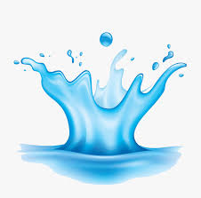
Art
Today we are thinking about famous artists. Below is a selection of paintings made by famous artists.
Make your own version of one of the pictures based on the images below.
Claude Monet  A pathway in Monet’s garden | Paul Klee  A red balloon | Vincent Van Gogh  Sunflowers | Pablo Picasso  Peace

Science  Your five senses are taste, sound, touch, sight and smell. Draw a picture of your favourite tastes, now think about your other senses and go on a senses scavenger hunt:  Can you record what you found?  - Challenge - can you complete these sentences?  One thing I like to taste is……………….because……………………………  One thing I like to hear is………………….because………………………….  One thing I like touch is……………………because …………………………  One thing I like to see is…………….because………………………………..  One thing I like to smell is…………….because …………………………… | Wellbeing and COVID 19 explained for year 1  What’s in the bag?  Ask an adult to put something in a bag, but to not tell you what is inside. Then ask your adult questions to find out what is inside.  Talk to your adult about your feelings and emotions during the game. How do you feel about not knowing what’s inside? Are you curious? Excited? Frustrated? It doesn’t matter what you feel, only that you are mindfully acknowledging what those feelings are.  Then ask the adult to leave the bag on the side for 5 minutes before they empty the contents, you mustn’t touch the bag. This is just time to think about what it is going to be. How do you feel now? Even more excited? Worried? Relieved? Again, spend some time thinking about and communicating your emotions.  Then ask the adult to tip everything out. What’s your reaction? Surprise? Disappointment? Where did the excitement go? Has it gone away? Spend some time talking about how the activity made you feel. Remember all emotions and feelings are important, and it is important to be able to talk about them. Now draw a picture to represent the different emotions you felt.  Below is a link for a story that has been written to explain what Covid -19 is for 5-7 year olds and to help them express their emotions about it, if you choose to look at the book with your child it is important that you allow them time to talk about their feelings and maybe return to the story once they have had time to think about it in case they have any questions.  https://660919d3-b85b-43c3-a3ad-3de6a9d37099.filesusr.com/ugd/64c685_0a595408de2e4bfcbf1539dcf6ba4b89.pdf
Design and Technology

Today we would like you to design and make a windmill. We have made lots of objects over the past few weeks, but today we would like you to make a windmill with moving sails.

Design what you want your windmill to look like. Think about the materials you will use, the size of your windmill, what you will use as the base and how you will make the sails move. Use materials from around your home to make a windmill.

Below are some images of ideas to help you. Please remember that resilience is one of our school values, don’t worry and remember to persevere if this is a tricky challenge. However successful it is it will help you make better decisions in the future and attempting new things is important.

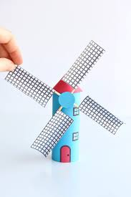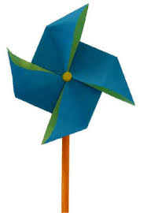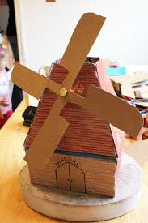

Challenge
- When you have made your windmill, please write a sentence to evaluate your design.
- What is good about your windmill? What would you do differently next time to improve your design?

