Year 6 Home Learning Week Commencing 15.6.20
Please email your work into us using the Year 6 email address – year6@highworthcombined.co.uk
We love hearing from you and seeing everything you’ve been up to! Take care Year 6.
Writing  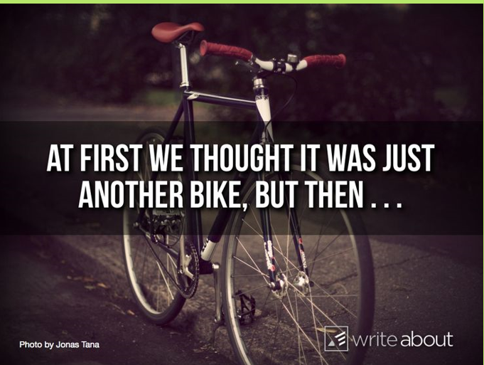  Use this starter to write a short story.  How soon did you notice it was not a normal bike? What made you realise it was different?  What did it do? Did it have some superpowers? Where did you find it? Who did it belong to? What happened once you realised it was not a normal bike? Were you on your own or with somebody else? Did you keep the bike? How does your story end?  Try to challenge yourself to use some dialogue, similes or metaphors and a range of punctuation. | Maths  Remember that you can use the Daily 10 website to complete mental arithmetic challenges. You can choose the level, the concept and the time. Can you challenge yourself to answer the 10 questions in the minimum time of 3 seconds?  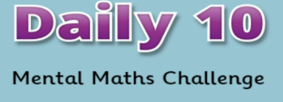  https://www.topmarks.co.uk/maths-games/daily10  This week there are 3 number problems to be solved. Can you remember what the word product means?  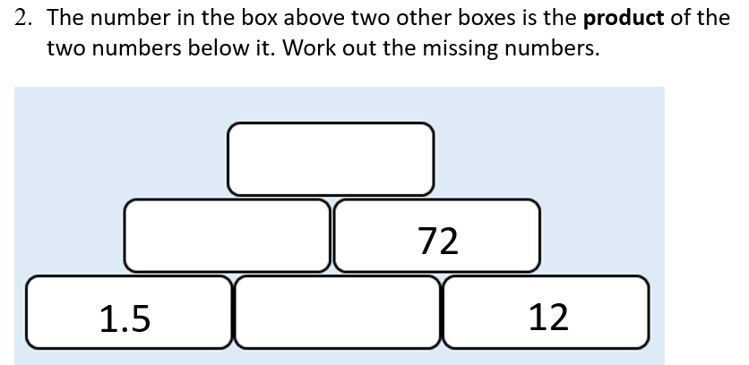  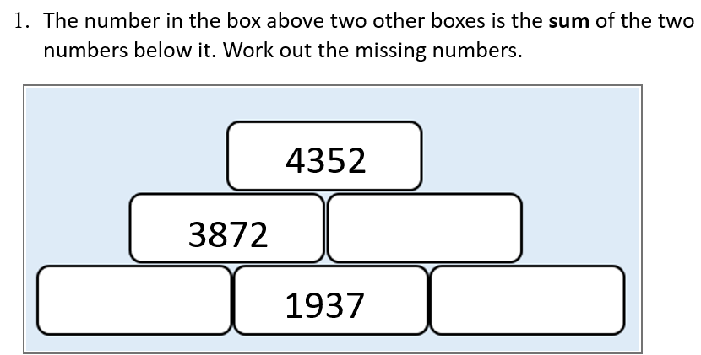  We have also attached a larger version with some hints and tips to help you.  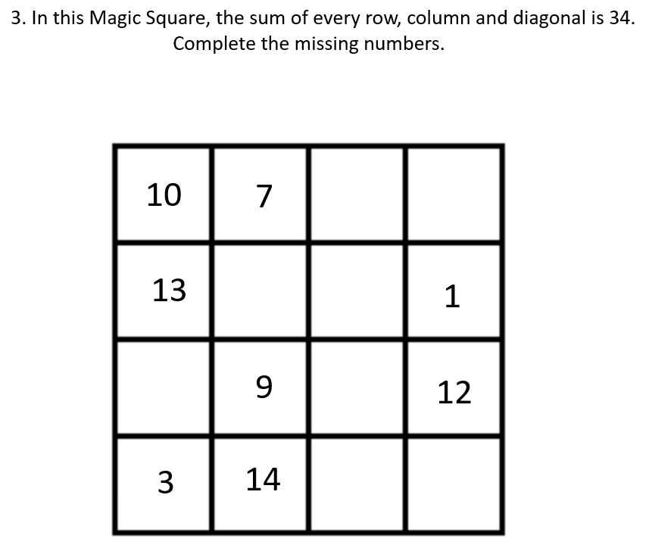  Maths Challenge  This week there are 2 challenges!  The first one involves converting between fractions and percentages and the second one looks at the equivalence between fractions, decimals and percentages. There are some problem solving and reasoning problems to complete too.  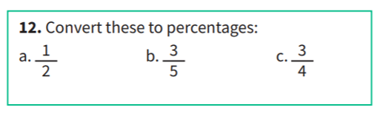  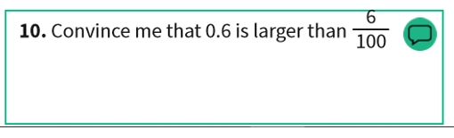
Reading

We have attached a reading comprehension for you this week.
Remember to read the questions carefully!

Spellings

Last week we gave you a spelling wordsearch and crossword with words with double consonants.
This week we have another wordsearch and crossword for you, this time with spellings with tricky endings.
Please ask your adults to only give you the crossword to start with. Once you have completed as much as possible then you can have the answers sheet and mark your own work. Good luck!

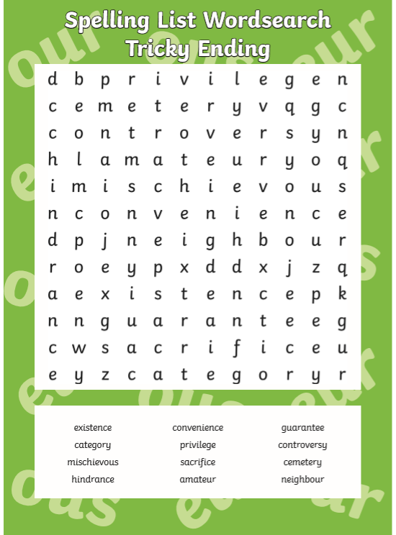

Topic

Continue to use the oak national website. Have you learnt anything in addition to what you already knew? We’d love to see or hear about this!

https://www.thenational.academy/online-classroom/year-6/
Mindfulness and Wellbeing

Have a look at this YouTube video. It shows you lots of ways to help you cope with your feelings and gives some fantastic ideas – with all the letters of the alphabet!
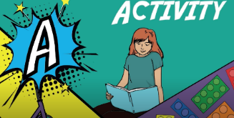
https://www.youtube.com/watch?v=5EXpkVw3fh0
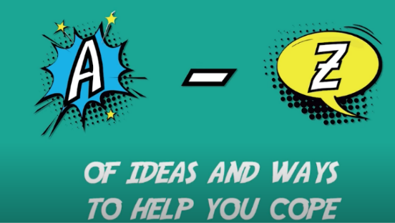

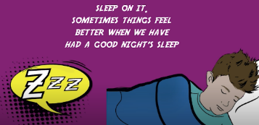

Which is your favourite idea? How many new ideas did you find?
Maybe you could share the video with your family.

Online Safety
We have attached some screen shots from a PowerPoint on cyberbullying that we will be sharing with the children in school this week. We would like you to read through it carefully as it gives lots of information about what cyberbullying is, some examples of how to deal with it and details of websites where you can get help and advice.

Maths Week Commencing 15.6.20
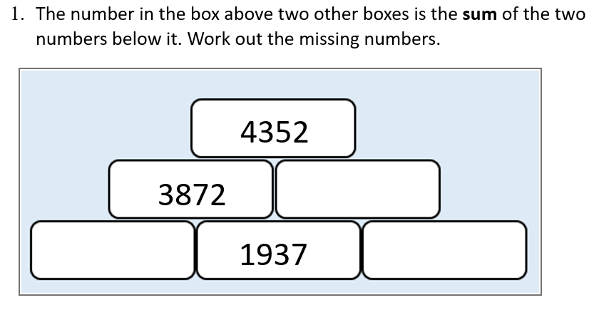

Remember you will need to add any two adjacent numbers and write the answer in the box above.
Think about which box you can complete first. Can you complete the box on the bottom left? What about the bottom right? At this point you cannot complete the bottom right box as there is not enough information but you can complete the bottom left by using subtraction.
WARNING! One of the answers will be a negative number!
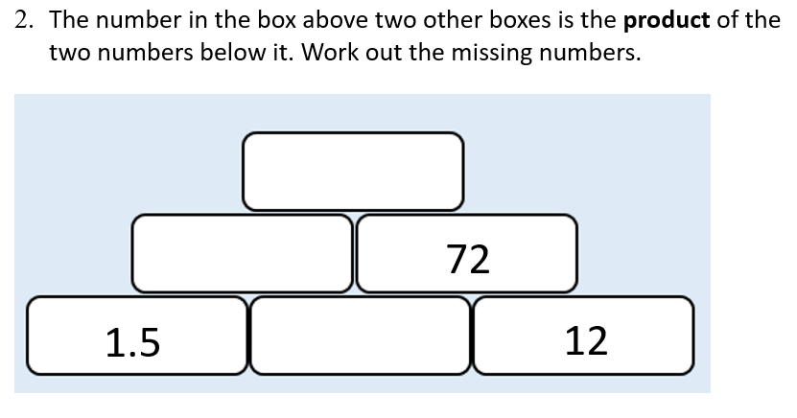

What does the word product mean?
Product means multiplication so here you need to multiply the two adjacent numbers and complete the box above. Think about which box you can complete first and how.

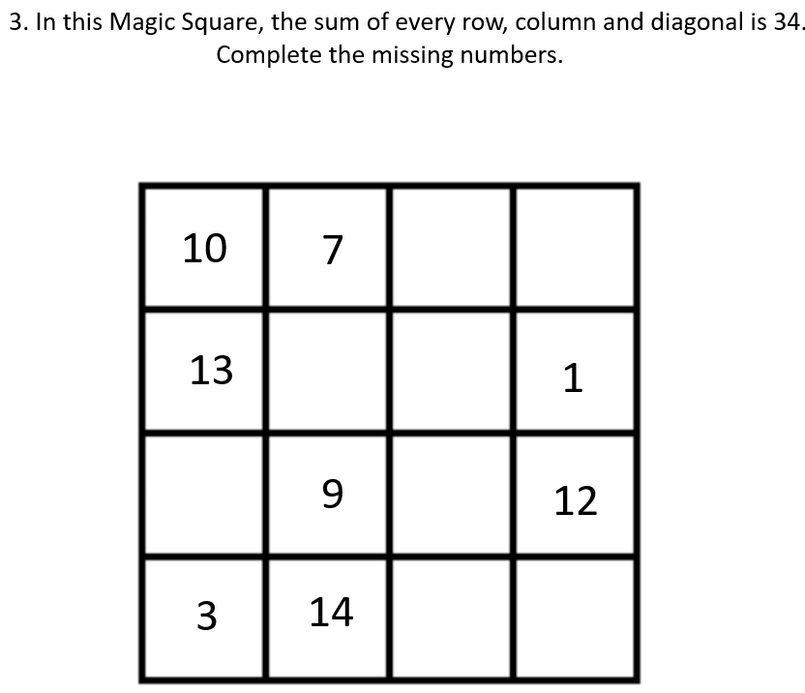

Think about which boxes you can complete first with the information that you have been given.

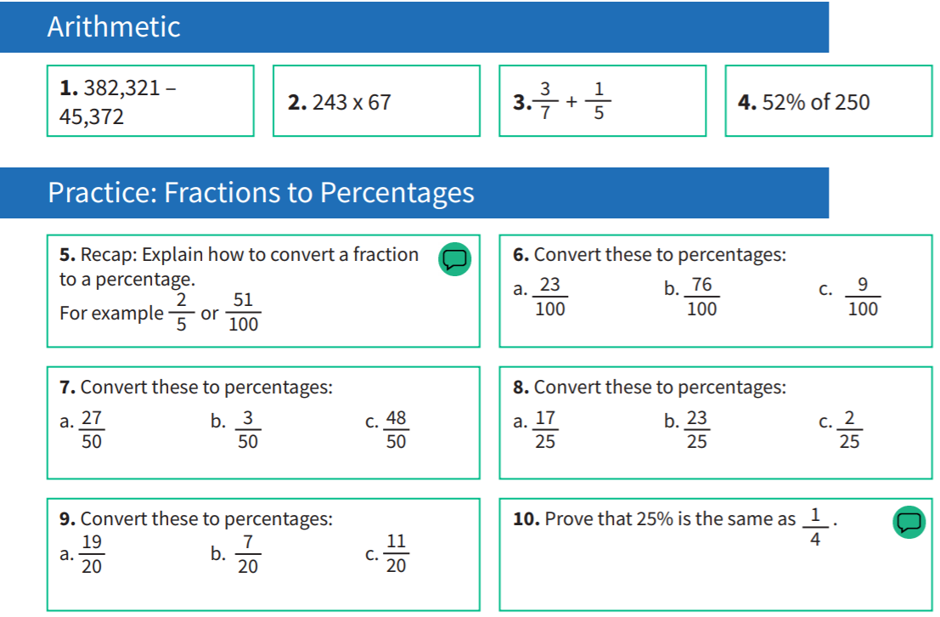
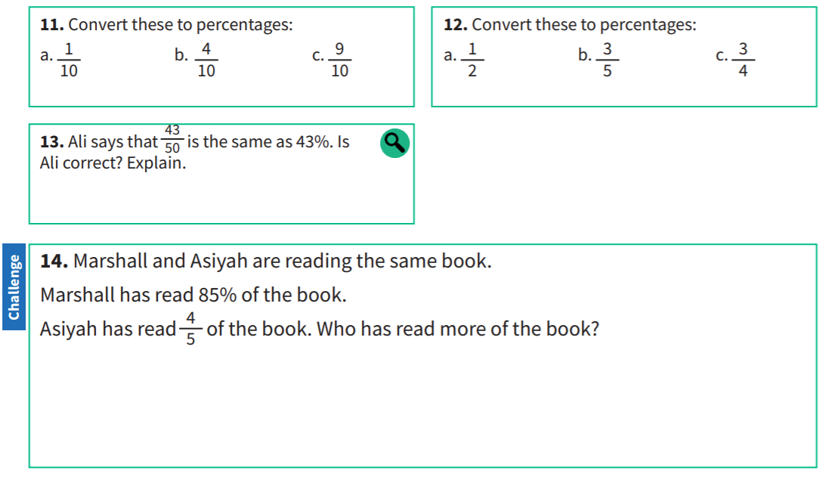
Maths Challenge 1

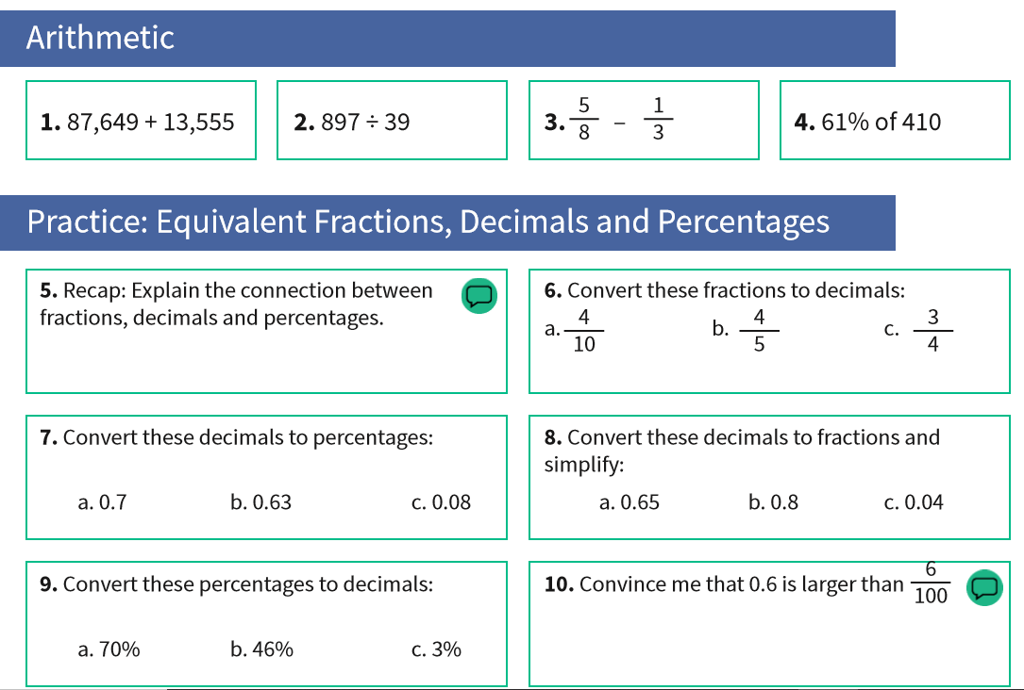
Maths Challenge 2
