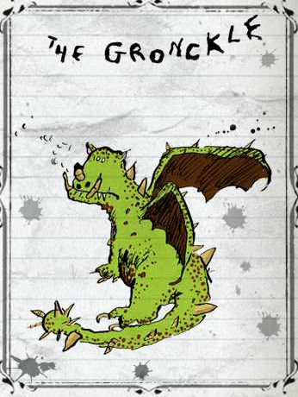 | Hiccup and Fishlegs were comparing 12 different dragons. They were talking about what they looked like.  - 6 of them were black, the rest were green.  - 4 of them had spiky tails.  - Only 3 were black and had spiky tails.  How many dragons were green with no spikes on their tail? | 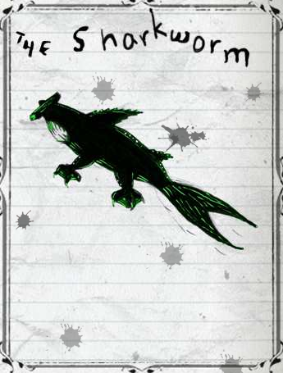
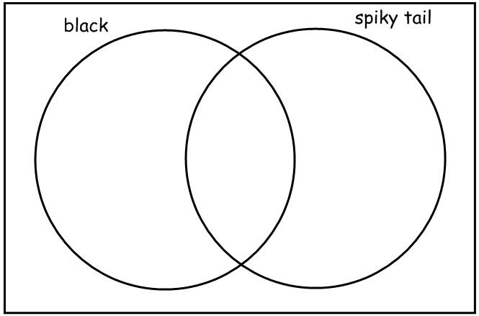
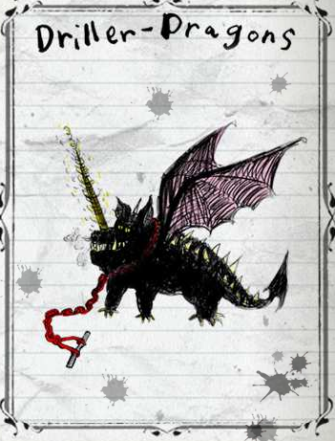 | Speedifist and Wartihog compared 15 different dragons to find out how they hunted and caught their prey.  - 8 of the dragons had a super sensitive sense of smell.  - 4 of the dragons used echo location to help them find their prey.  - Only 1 dragon had a super sensitive sense of smell and echo location.  - The rest had to rely only on their eyesight.  How many dragons had to rely only on their eyesight? | 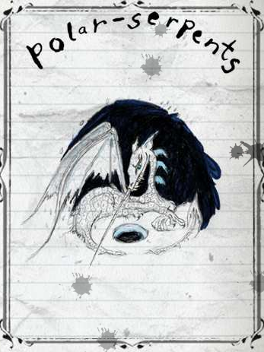
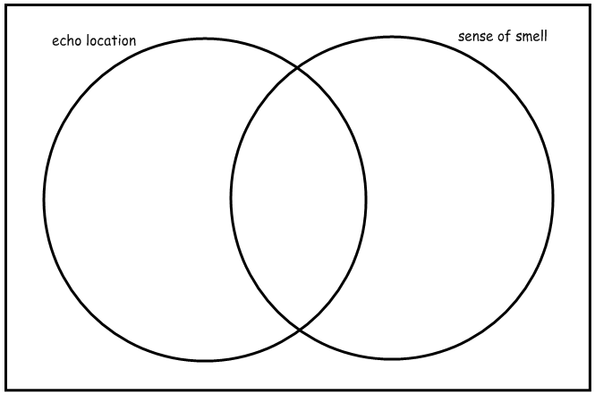
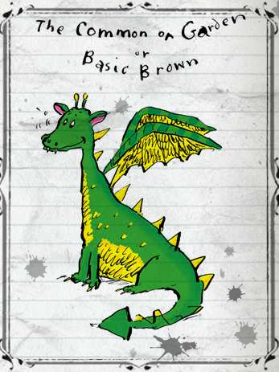 | Snotlout and Dogsbreath-the-Duhbrain were trying to work out which dragons were the worst hunters. They compared 20 different dragons.  - They agreed that 11 of the dragons were totally terrifying.  - They agreed that 9 of the dragons were lightning quick.  - They both agreed that only 3 were totally terrifying and lightning quick.  - They agreed that the remaining dragons were utterly useless.  How many useless dragons did they find? | 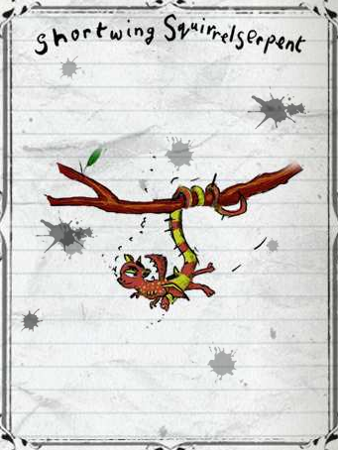
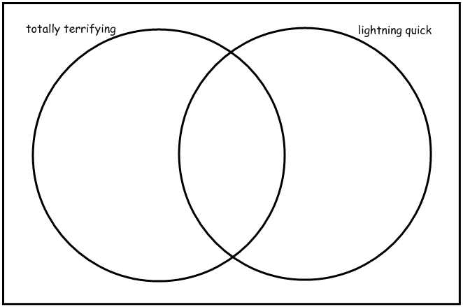
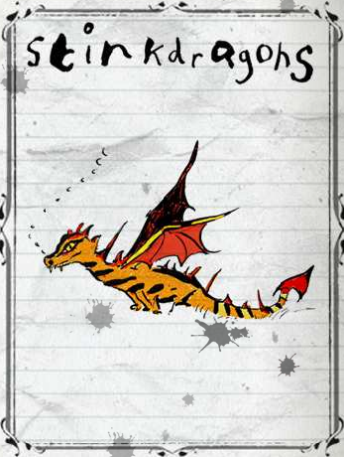 | Toughnut Junior and Clueless were discussing dragon defences. They compared 24 different dragons that could all breathe fire.  - They found that 10 of the dragons could change colour to match their surroundings.  - They found that 13 of the dragons used poison.  - They found that 6 of the dragons used fire, poison and camouflage to defend themselves.  - The remaining dragons could give off a disgusting smell.  How many smelly dragons were there? | 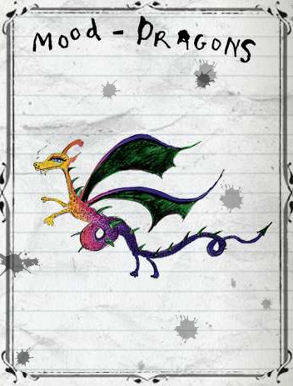
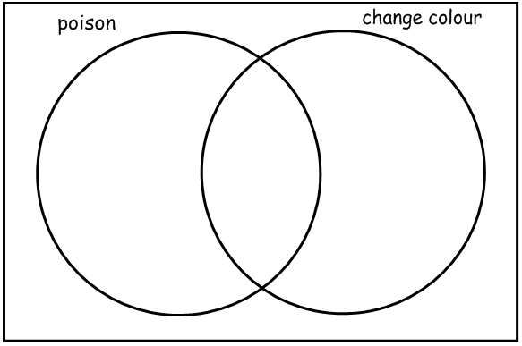
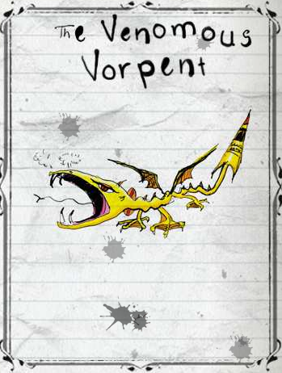 | 45 Hairy Hooligan children were asked which dragon they feared the most.  - 27 children were afraid of the Monstrous Nightmare.  - 19 children were afraid of the Exterminator Dragon.  - 11 children were terrified by both the Exterminator Dragon and the Monstrous Nightmare.  - The remaining children were most afraid of the Venomous Vorpent.  How many children had nightmares about the Venomous Vorpent? | 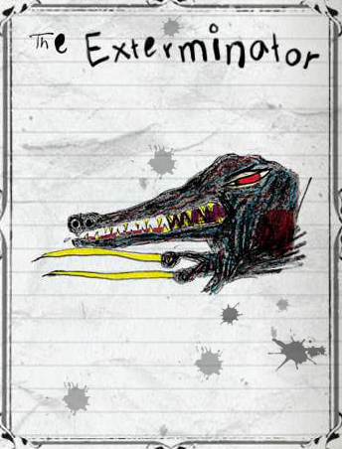
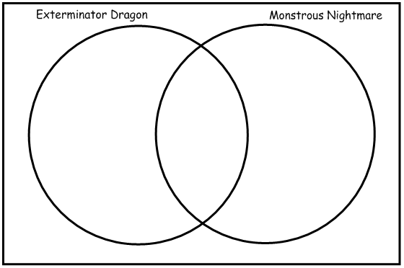
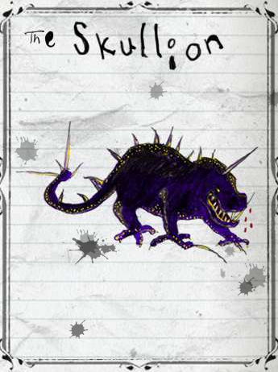 | Hiccup and Fishlegs carried out a survey to find out if the Gronckle, the Sabre Tooth Driver Dragon or the Skullion is the most popular dragon with the Hairy Hooligan children. The results of the survey of 58 boys and 63 girls showed that:  - 30 boys and 38 girls liked the Polar Serpent.  - 27 boys and 29 girls liked the Sabre Tooth Driver Dragons.  - 19 boys and 15 girls liked both the Polar Serpent and the Sabre Tooth Driver Dragons.  - The remaining children liked the Skullion the most.  How many girls and how many boys preferred the Skullion? | 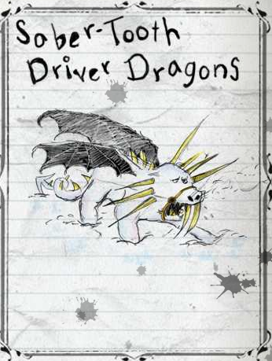
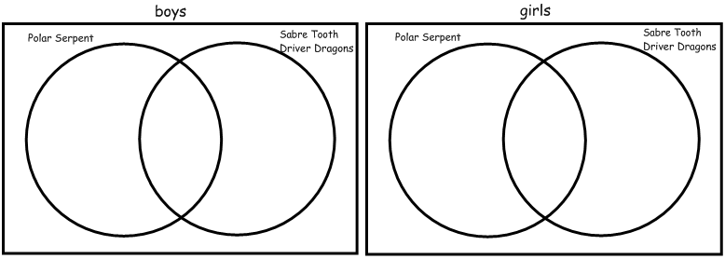

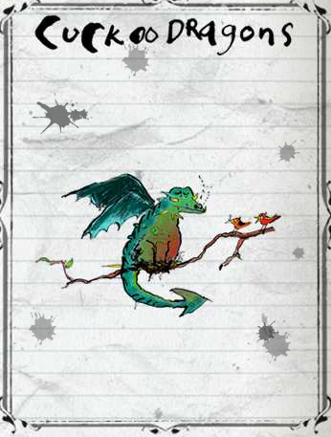 | The results of a survey of 344 male and 316 female Hairy Hooligans show that the three dragons that are most difficult to spot are the Stealth Dragon, the Cuckoo Dragon and the Raptortongue:  - 156 females and 190 males have never seen a Stealth Dragon.  - 178 females and 140 males have never seen a Cuckoo Dragon.  - 106 females and 94 males have never seen either the Stealth Dragon or the Cuckoo Dragon.  - The remaining people have never seen a Raptortongue.  How many more males than females have never seen a Raptortongue? | 

