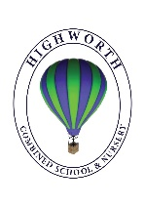
Home Learning Ideas for all
Monday 18th May 2020

International Museum Day
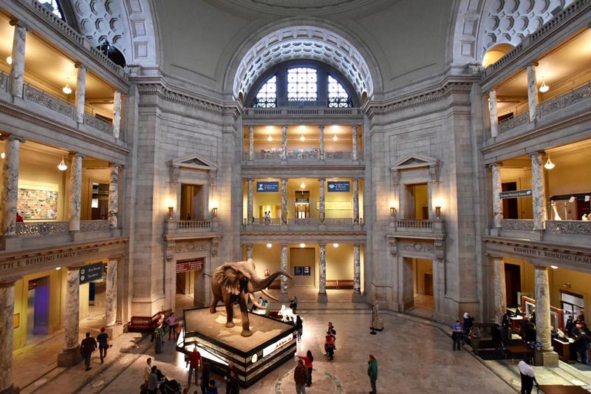
Did you know that today is International Museum Day? Have a look at the virtual tour of a museum very far away! https://naturalhistory2.si.edu/vt3/NMNH/ This museum is called the Smithsonian Museum of Natural History and it is in Washington D.C. in America. In the Sant Ocean Hall, you can get up close and personal with a blue whale like you’ve never seen before!

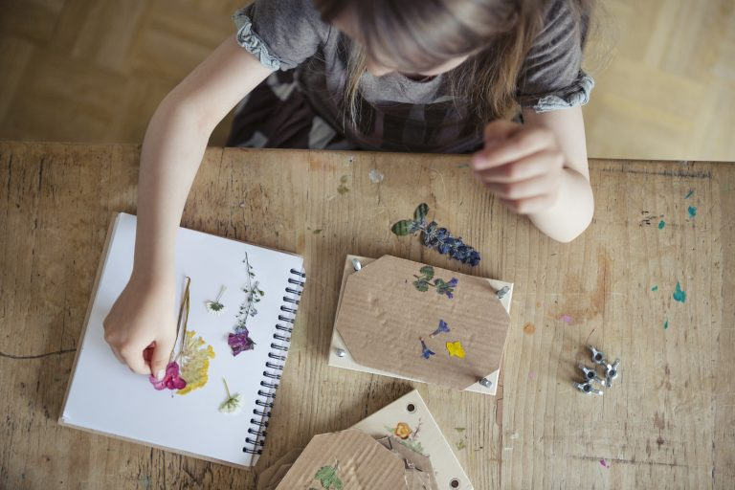
Pressing Flowers
Whilst the weather is so beautiful this week, pick some wild flowers during your daily exercise and see if you can ‘press’ them. Once the flowers have been chosen and picked, simply place them between sheets of baking parchment or tissue paper, ensuring the full flower is covered, and then place inside the pages of a big heavy book and leave to press for 2-3 weeks.
Jammie Dodgers

