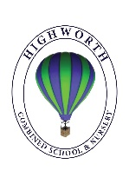
Home Learning Ideas for all
Friday 15th May 2020
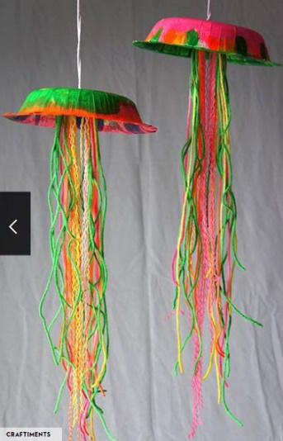
DIY Jelly Fish!:
Using a paper plate, some paint and any wool you can find, can you create your own jelly fish today?

Book Review
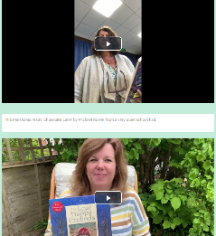
Have a look on our school website at the Story Time with Highworth Staff! section: https://highworth.eschools.co.uk/web/story_time_with_highworth_staff/478292
Listen to a few of the stories and choose which story is your favourite and why? Can you write a book review about the book, or video yourself talking about the book and send it in to us? Suggestions of stories to be read for our website gratefully received too!

And finally, go into Espresso (log on details on the Home Learning Ideas) https://www.discoveryeducation.co.uk/what-we-offer/discovery-education-espresso and select the correct Key stage for you and complete the daily challenge… good luck!

