Year 4 Home Learning – Friday 27th March 2020
We hope you enjoy completing these activities. If you wish to present the information in a different way, or to extend the activity, we would be delighted to see what you produce.

Remarkable Writing!  Complete your play script and carefully edit it.  Red: check for sense, capital letters and all punctuation  Blue: spelling  Green: uplevelling | Sensible SPaG!  Time to practice editing! Complete the activity on the sheet below.  Alternatively: write out a short passage (could be copied from a book). Then write it again including some mistakes that need editing. You must also create an answer sheet. Ask someone in your home to have a go, or send it to us to have a go!
Super Science!  Using recyclable materials found around the house, make an instrument. Explain how you will change either the pitch or the volume of the sound produced by your instrument. | Terrific Topic!  Investigate the effect of eruptions on the environment, both positive and negative. Write a paragraph or create a poster about your findings.  http://primaryhomeworkhelp.co.uk/mountains/volcanoeruptions.html  https://www.riddlelife.com/what-are-the-effects-of-volcanoes-on-the-environment/
Marvellous Maths!  Times Tables and division practice for quick recall.  Without internet: You could write them out, ask someone to quiz you or create your own beat the clock grid. Or you can use this link:  https://www.topmarks.co.uk/maths-games/daily10  Use Level 4 multiplication and division.  Practice short multiplication. e.g. 35 x 6 or 237 x 8. What do you need to remember?  Challenge: Create some of your own word problems and make sure you include an answer sheet. | Wonderful Wellbeing!  This week’s winning way to wellbeing is:  KEEP LEARNING (for example try something new, set yourself goals, read a book)  Note down 3 things you are grateful for.  Find a piece of happy news, or think about your own happy news, and share it with somebody.

Editing activity 27th March 2020
- Read the extract below.

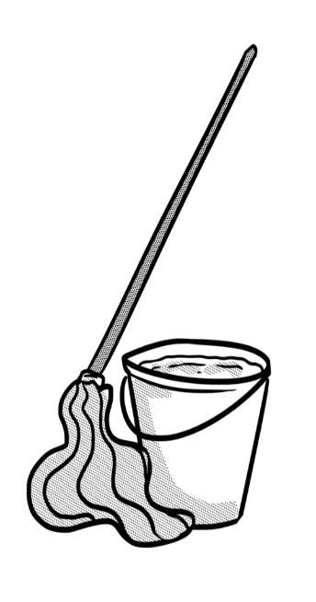
When Dad got home, he will be greeted by a peculiar site. What was going on. All of them were busy the floor or scrubbing down the surfaces in the kitchen. Abdul was washing the food blender in the sink. A banana skin was poking out of the bin looking up, Dad noticed what looked like a piece of mango from the ceiling.

“Let me guess,” he smiled, “you were trying to surprise me by making my favourite smoothie for a treat.” His family all nods slowly. “However, you tried switched on the blender but you had not remembered in time to put the lid back on to the blender before you switched it on.”

2. After reading the extract, check for the following aspects and underline them:
- Check if there are any missing words.
- Check if there is any missing punctuation.
- Check if there are any problems with the tense.
- Find at least one part that could be improved.

3. Complete the grid below.
List any missing words.
List any missing punctuation.
List any problems with the tense.
Write a sentence which could be improved.

