Year 1 Home Learning – Friday 24th April 2020
Below, you will find 6 home learning tasks. You may choose the tasks that you wish to complete and do them in any order. Please do not hesitate to contact us if you have any queries or would like to share the work you have been doing.
year1@highworthcombined.co.uk
English  At school this year we have been working really hard on learning the correct letter formation of both capital letters and pre cursive lower case letters.  We are going to use your knowledge of letter formation today to make an alphabet book.  Make a small book using folded paper. Split each page up into different sections or divide the pages in your work book up ( to help save paper)  At the top of each section of your book write the capital letter and pre cursive lower case letter next to each other. Think carefully about where each letter starts (all of the lower case pre cursive letters start on the line)  Then draw and write as many exciting words you can think of for that letter. E.g. if you draw  an alligator write alligator next to it on the Aa page. | Science  In the spring term we were learning about materials and their properties.  Today we are finding out about magnetic and non-magnetic materials and have a chance to explore magnets.  Magnets stick to some things and not to others. Use a fridge magnet and take it around your house to find the things that it does and doesn’t stick to.  Record your results in a table like the one below e.g.  Object Magnetic (Sticks) Non-magnetic (Does not stick)  Mug  Tin Foil  Key  Ring  For fun can you make a magnetic game?  - Put paper clips on cut out fish and attach a magnet to the end of a pencil with a piece of string to make your own fishing game.  - Or can you think of another game or craft you could do using magnets.  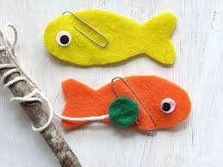
Maths
Cut up a selection of 2D shapes out of paper in any colours that you like, if you don’t have coloured paper colour in paper once you have cut them out, these are going to be toppings for a pretend 2D shape pizza. These could include: circle, square, triangle, rectangle, heart, kite, pentagon, hexagon, octagon and any other 2D shapes that you know etc.

Talk with an adult or older sibling about the properties of these shapes e.g. Circles only have one side and no corners, rectangles have 4 sides and 4 corners they have 2 long sides and 2 short sides, a square is a regular shape it has 4 sides that are all the same length and 4 corners.

Then draw around a plate, and stick your 2D shape pizza toppings down.
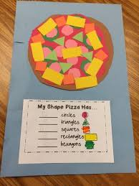

When you have stuck them down can you talk about your 2D shape pizza and record the answers to these questions.
- How many of each shape have you used?
- Have you placed your toppings in a pattern?
- Is your pizza symmetrical?

This link gives you some information about 2D shape properties https://www.twinkl.co.uk/resource/t-n-7105-2d-shape-properties-word-cards

PSHE and RE  Ramadan is a special month for Muslims all over the world. It begins at the first sight of the new moon of the 9th month of the Islamic calendar. During this month Muslims would usually go to mosque regularly, read the Qur’an, pray, give up bad habits and give to charity and help others and many Muslim adults will be fasting during this time.  Today we are going to think about the importance of helping others and doing good deeds. This can be being kind, giving your time and sharing what you have.  Make a table with 30 squares in it, and try and fill the squares with 30 acts of kindness e.g. tidy your room, make a thank you card for someone, draw a picture and put it in your window to make someone else smile, share your toys with a sibling etc.  Tick off the acts of kindness when you have done them.  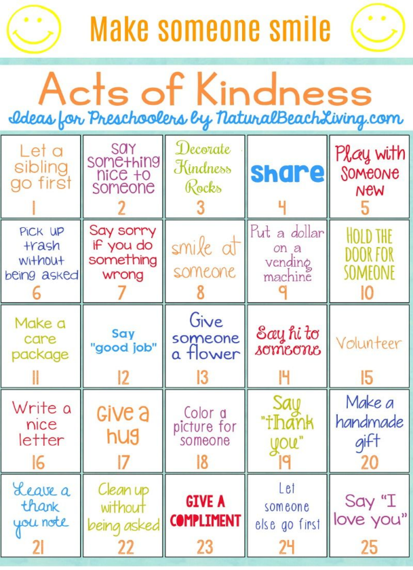  We would love to see some of the things that you are doing to be kind.  If you are taking part in Ramadan maybe you could also let us know what you have been up to at this special time. | Art and Maths  Today we are going to think about geometric art!  This means you will make artwork using shapes to make a pattern rather than a picture of an object.  Make some artwork using shapes e.g. Squares, rectangles, circles, triangles and use them to make repeating patterns. Perhaps you could also think about symmetry and make your artwork symmetrical (if you placed a mirror down the middle would it be the same on both sides?).  You could draw around a glue stick lid or something similar to draw a circle shape. Or use a ruler to make your squares and rectangles the same size each time.  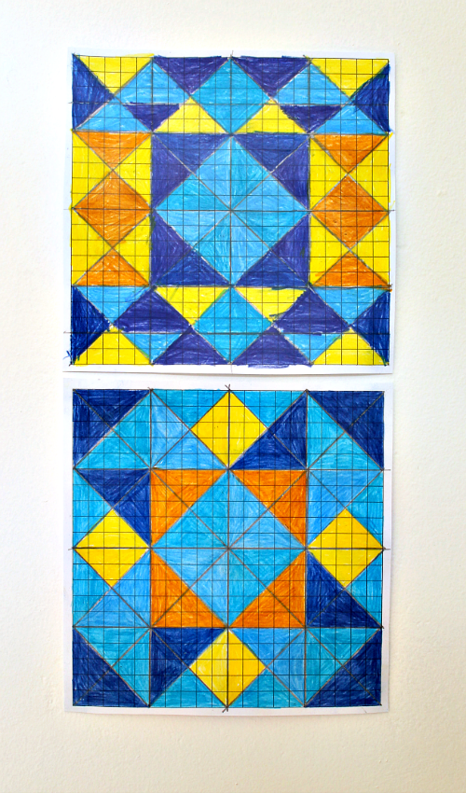  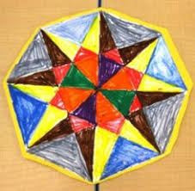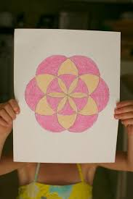  Don’t forget to send us a picture of your art if you can!
History
We are going to think about how toys have changed over time, and what is different about toys we play with today and those in the past.

Get two pieces of paper on one write ‘THEN’ on the other write ‘NOW’

On the paper with NOW on draw and label your favourite toys that you like to play with. On the paper with THEN on ask an older family member what they used to like playing with as a child, draw and label the toys that they used to play with.

- Are any of the toys the same, what is the difference between the toys they liked to play with and what you play with now? e.g. “I liked to play with marbles, Rubik’s cubes, skate boards, an etch-a sketch and cabbage patch dolls. Do you play with any of those now?”

Write a sentence about the similarities and differences between the toys in the past and toys now.

