Extra Home Learning – HID Children No 4 - Monday 4th May

To replace some of the tasks in the class home learning you may wish to try some of these. Parents, please simplify or extend depending on needs and age of children. Have fun! There is an email address prepared for you to use. Go to Signed Stories and use the arrows to find the story ‘The Monkey Puzzle.’
There is a signed version of the letter I have written below. If your child choses to
video a BSL reply, email me and I will tell you how to do this. It must be less than 2
minutes. Email hid@highworthcombined.co.uk

Signed Story ‘The Monkey Puzzle’  Watch the signed story of ‘The Monkey Puzzle’  1. Can you sign the animals in the story?  2. Why was it hard for the butterfly to find  the monkey’s mother?  Draw 5 animals from the story and their babies. Draw where they live. Can you teach your family the signs for the animals? Write a sentence about where each animal lives and sign it. You can record it and send it to me. | The Stay At Home Superheroes  Watch this  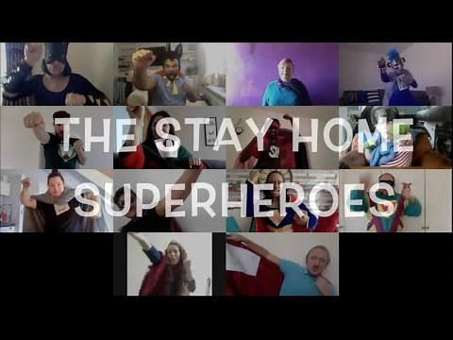  story:  Follow the link below to access the superhero story told in BSL:  https://www.youtube.com/watch?v=HuOKIZL-ny8
Weather Presenter  Be the weather presenter in your home each day. Go outside or watch the weather on TV and present the weather for the day. You can:  - Sign it and have pictures to point at  - Write a description each day  - Draw a map and draw the sun, clouds, rain and the temperature  - Record it and send  it to me  Record the weather for  every day of the week | Deaf Awareness Week  This week is Deaf Awareness Week. As we are not in school, we need to remind our hearing friends of the things they need to remember when communicating with Deaf people.  Design and create a poster with tips and ideas on how to communicate with deaf people. Think of things that people need to do to make it easier to communicate with deaf people.  Make your poster clear with large captions.  I will share it with everyone.
Write me a Letter  As I have missed you all, I have sent you a letter in BSL and written one. I would very much like you to write one or sign one back. I have asked some questions in my letter that you need to answer.  I would like some lovely pictures as well.  Happy signing and writing! | Looking and Thinking Activity Elm Road  Look carefully at the picture below about Elm Road and answer the quiz. There are 2 quizzes, A and B. Start with A and if you can you can do B as well.  See below for the activities

4 more pages below:

Follow the link below to access the superhero story told in BSL:
https://www.youtube.com/watch?v=HuOKIZL-ny8
The Stay Home Superheroes - written by Sophie Marsh in British Sign Language (BSL)
The Stay Home Superheroes story is special. It is designed to encourage children to understand the coronavirus pandemic. You are all Stay Home Superheroes! Told in British Sign Language by Deaf Performers with English subtitles. Written by Sophie Marsh - https://www.sophiesstories.co.uk/ https://www.facebook.com/SophiesStori... https://www ...
www.youtube.com

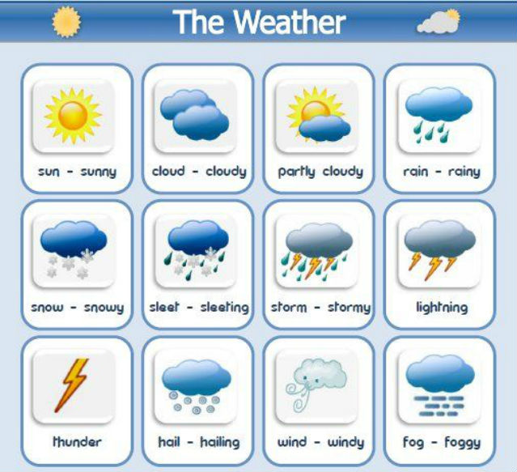

Monday 4th May 2020
Dear Children in HID,
How are you all. I hope you are busy doing lots of different things with your families. My favourite time of the day is walking in King’s wood and I was very pleased to see the bluebells flowering. What is your favourite time of the day?
In the first week of the Easter holidays, I planted some seeds. I am very excited that some of them have started to grow. I have some pictures. Can you guess what I am growing? To help you it’s something you can eat. I have planted three different seeds. See if you can guess what these seedlings are!

A B C
I miss you all and I know you miss your friends too. What I have found really difficult is the computer! I know this will make some of you laugh as you know that I am not good with computers. I have to work all day on it and I would rather be at school. What has been the hardest thing for you?
Something I do look forward to on the computer, is your work and that is what I check first thing in the morning even before I have breakfast. So, please send me lots of your fun activities and learning and if you have any questions, I would be very pleased to answer them too.
Take care,
From
Ms Pereira

Go to the website to see the BSL version of this letter

Looking and Thinking Activity:
Elm Road
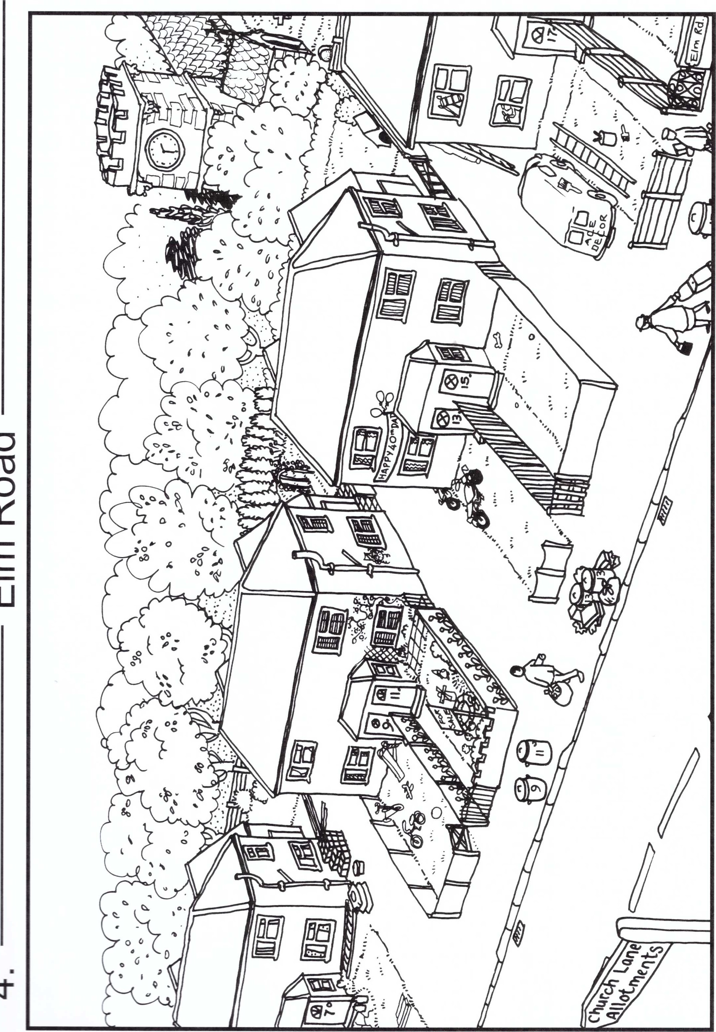

People living in the houses on Elm Road are:
House Number | People
No. 7 | The Gupta family
No. 9 | The Todd family
No.11 | Mr Wilson
No.13 | The Weekes family
No. 15 | Mr and Mrs Nolan
No. 17 | Mrs Cooper

See below for Quiz A then Quiz B for Elm Road

Quiz A for Elm Road
A | Questions | Tick the right answer
1 | Who keeps a dog? | Is it the Todds family?
 |  | Is it the Weekes family?
 |  | Is it Mr and Mrs Nolan?
2 | Who has young children? | Is it the Todds family?
 |  | Is it the Weekes family?
 |  | Is it Mr and Mrs Nolan?
3 | Who is going to move house? | Is it Mrs Wilson?
 |  | Is it Mrs Cooper?
 |  | Is it the Gupta family?
4 | Who is having the house decorated? | Is it the Gupta family?
 |  | Is it Mrs Wilson?
 |  | Is it Mrs Cooper?
5 | Who is away on holiday? | Is it Mr and Mrs Nolan?
 |  | Is it Mrs Wilson?
 |  | Is it the Gupta family?
6 | Who is having a garage built? | Is it the Weekes family?
 |  | Is it Mrs Cooper?
 |  | Is it the Gupta family?
7 | Who has grown up children? | Is it the Todds family?
 |  | Is it the Gupta family?
 |  | Is it the Weekes family?
8 | Who likes gardening? | Is it Mrs Cooper?
 |  | Is it Mr and Mrs Nolan?
 |  | Is it Mrs Wilson?
9 | Where will there be a birthday party? | At the Weekes family’s house?
 |  | At Mr and Mrs Nolan’s house?
 |  | At the Gupta family’s house?

Quiz B for Elm Road
The shops nearby are closed every Wednesday afternoon. Rubbish is collected on Wednesdays except in weeks when there has been a bank holiday. When there is a bank holiday, the rubbish is collected on Thursdays.
Answer these questions in your book:
- Why would anyone walking down Elm Road be able to see the time?
- How can you decide whether the shops nearby are open or closed?
- What day do you think it is and why?
- If Mr and Mrs Nolan are on holiday, where do you think the dog is?
- Which way will Mrs Cooper turn at her gate, if she goes to the shops? How do you know?
- Which way will Mr Wilson (No 11) turn at his gate to go to the allotments? How do you know?
- How many houses will Mr Wilson pass before he reaches the end of Elm road?
- Which house has the most people in it? Why?
- Who do you think is having a birthday? Why?

