Home Learning Ideas for all
Monday 23rd March 2020
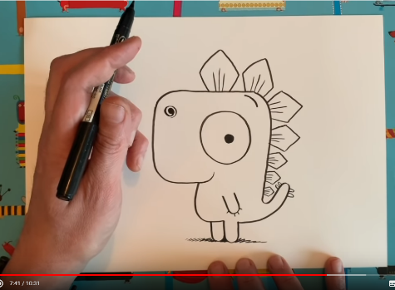
Fancy yourself as an illustrator? The author and illustrator, Rob Biddulph can show you, step by step, how to draw a Gregosaurus:
https://www.youtube.com/watch?v=bhyCxVPb1qU&safe=active

Have a go playing your own made up version of “Countdown”
You will need 4 ‘large number’ cards with the numbers 25, 50, 75 and 100 on them and a set of cards with the digits 1-10 on them, with at least two cards for each number. Watch the clip on Youtube to show you how to play:
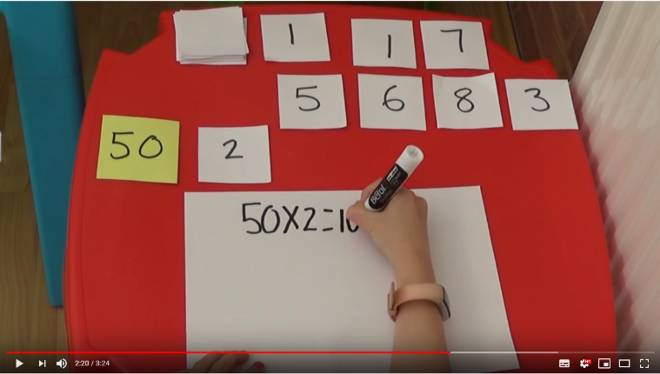

https://youtu.be/RZgkr5_Xn58

And finally, go into Espresso (log on details on the Home Learning Ideas) https://www.discoveryeducation.co.uk/what-we-offer/discovery-education-espresso and select the correct Key stage for you and complete the daily challenge.

