Year 5 Home Learning – Wednesday 6th May 2020
ENGLISH  Write us a letter about what you’ve been doing at home. Tell us about how you’ve been relaxing, what games you’ve been playing, what learning you’ve been doing and how you’ve been helping out at home with chores.  (For those of you who have already written to us, give us an update. Or you could be outrageously inventive and make it all up! What’s that? You learnt how to tame grizzly bears?!)  We’d really love to hear from you and know how you are. |  | MATHS  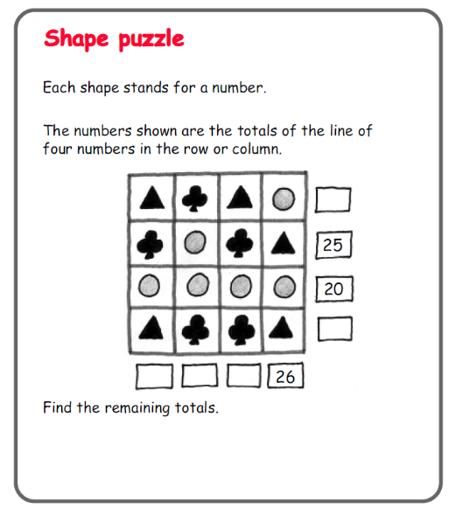  Practice your mental addition and subtraction skills to solve  this:  Can you  make up  your own  Shape Puzzle  using different  numbers?  You could try  it out on  someone at  home.
WONDERFUL WORDS
Look at the Year 5 & 6 Words List. You can find it as a link on our Coronavirus Closure, Home Learning Matrix, Year 5 tab: https://www.highworth.bucks.sch.uk/web/year_5/460996
Choose 4 or 5 words to practise at a time.
- Look up the definition in a dictionary to check the meaning of each word.
- Learn the correct spelling by using: Look, Say, Cover, Write, Check.
- Write a sentence which includes the word to show that you understand its meaning.
4. Challenge yourself to include PARENTHESIS (extra information) in brackets, or commas, in each
of your sentences.
FOOD TECHNOLOGY  This Friday, 8th May, is the 75th anniversary of Victory in Europe (VE) day, which marked the end of World War 2. During that era, some foods were in short supply (a bit like flour at the moment!). So wartime recipes for delicious food had to be creative with available, tasty ingredients.  We know how much lots of you have been enjoying cooking. So you might like to have a go at the following recipe for Cheese and Potato Dumplings (scroll down).  Or, you could tell us what you’ve been cooking at home and send us photos and recipes.  Has anyone been creative in making cakes without flour? The best we’ve come up with is Cheesecake (which is delicious!). | HISTORY  We remember how much you enjoyed working out a secret message in hieroglyphs, when we learnt about Ancient Egypt. So we thought you’d like to have a go at this activity.  During World War 2, coded messages were sent using Morse Code. We have attached a document with the code (p.4 of the document) and activity sheets for you to work out some messages. We’ve included the answers too (p.3) but try not to peak until you’ve finished!  Or, you could try doing your own research into Morse Code and write your own message. |  | WELLBEING  Write down three things that you are grateful for, each day.  After a few days, look back at what you have written and you will surely have a smile on face!  You could even draw a picture about one of the things that you are grateful for OR write a note to thank someone for being in your life!
In addition to the tasks above, please remember to spend 10 minutes reading every day!
