Extra Home Learning – HID Children No 12 - Monday 6th July

To replace some of the tasks in the class home learning you may wish to try some of these. Parents, please simplify or extend depending on needs and age of children. There’s more signing from Mrs Mills and on Celerity Supply Teacher’ on CBBC i-player features Maise Sly, a Deaf Actress from the film ‘Silent Child.’ Worth a look!
Don’t forget to email me your child’s learning to hid@highworthcombined.co.uk

Signed Story and Book from Mrs Mills –  ‘First Flight‘  Watch the signed story and  then read the story on the  Power Point.  There are activities to do  Below and at the end of  The power point | Topic Wordsearches:  Some fun word searches related to the science topics you have been learning. See below for:  - Yr2 – Geography- Australia  - Yr3 – Science – Forces and Magnets  - Yr4 – Science - Natural Materials  Can you remember the signs for the words on the word searches?
Signing for the Whole Family from Deaf Actress:  Teach your whole family to sign with this programme as an introduction available on i-player:  CBBCs ‘Celerity Supply Teacher’ Series 1, 19  Rachel Shenton and Deaf actress Maise Sly will explain and teach BSL.  Have fun signing with the whole family. | Looking and Thinking Activity – ‘The Buffet’  Look carefully at the picture below of a buffet which is like a café or restaurant. A buffet is where you can choose your own food to eat.  There are 2 quizzes below, A and B. Start with A and if you can, you can do B as well.
HID Afternoon Activity: - Looking Ahead
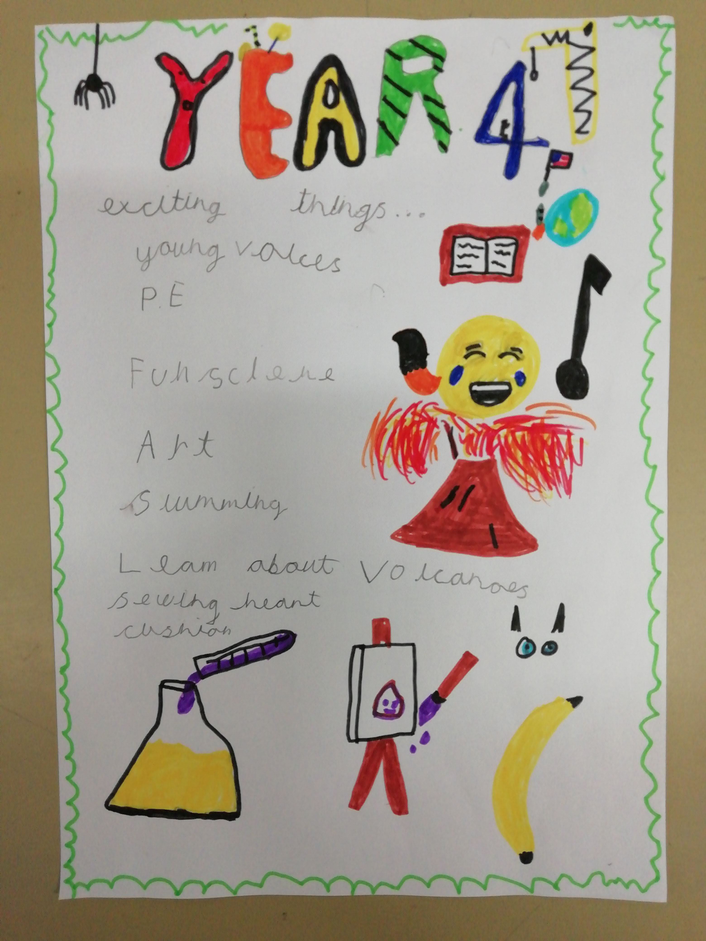

Think of all the wonderful things you enjoyed at school this year and
Create a poster about it.
Include top tips you can tell others who will be moving up to your
Year group. Think of the things you had to remember to do in class.

It would be nice to send me a picture of your poster so I can show
it to others so they know all about it and look forward to next year.

Next week is Transition Week and it would be nice to share your
poster with others. Here is one a Year 4 child made:

See 7 more pages below:
- Activities for story, ‘First Flight’
- Australia Word search
- Forces and Magnets Word search
- Natural Materials Word search
- Looking and Thinking picture for ‘The Buffet Bar’
- Questions A for ‘The Buffet Bar’
- Questions B for ‘The Buffet Bar’

Activities for ‘First Flight’ – see Power Point
Questions:

How did Kel feel about going on a plane? Why?

How did Kel feel when the plane took off?

Who did Kel meet when he arrived?

How did Kel feel about flying after the flight?

How do you think Kel will feel about flying when he goes back home?

What do you know about Kel and his family?

Activity:
Can you think of a time when you did something for the first time? How did you feel? Draw a picture and describe what you did and what it felt like. Write about it and say how you felt at the start and how you felt at the end.

Year 2 – Geography- Australia

u t a i l a r t s u A

l x i b a j m o s v l

u t n x r w x p t y i

r s a p o u t n w l c

u z e m c q e v o y e

o f c r z n d r y r s

u h o t i y p x u a p

t p u t w f o u l q r

b q n o s n d a r m i

a o v r m t o l v p n

c w p y s k x q i m g

k a n g a r o o s w s

Australia koalas dry
continent Alice Springs wildfires
oceania outback coral
kangaroos hot uluru

Year 3 – Science- Force and Magnets

m e t a l h x y a

d a k n r u l g n

r i g o l d b m o

c e f n h r q z n

y o x t e n g a m

s p p p s t q d a

g o e e o c i e g

m l u x r a o c n

w e h t l r v r e

z s a c h t u o t

n c e h j t e f i

n o r t h a k j c

p a p e r c l i p

copper south magnet
paperclip north force
non magnetic metal gold
poles attract magnetic
repel

Year 4- Science- Natural Materials

y h t r o w s d l o G

d c h e k b r o f n e

n s l a i r e t a m r

A w g b c m w k h c u

f h a w s t o n e s t

n a t u r a l o p t p

e d i o n h f x d i l

l k r a b q i u e c u

s a n d m o m g b k c

g z f j l e a v e s s

sticks leaves natural
flowers sand Andy
mud bark Goldsworthy
materials stones sculpture

Picture for Looking and Thinking Activity: ‘The Buffet Bar’
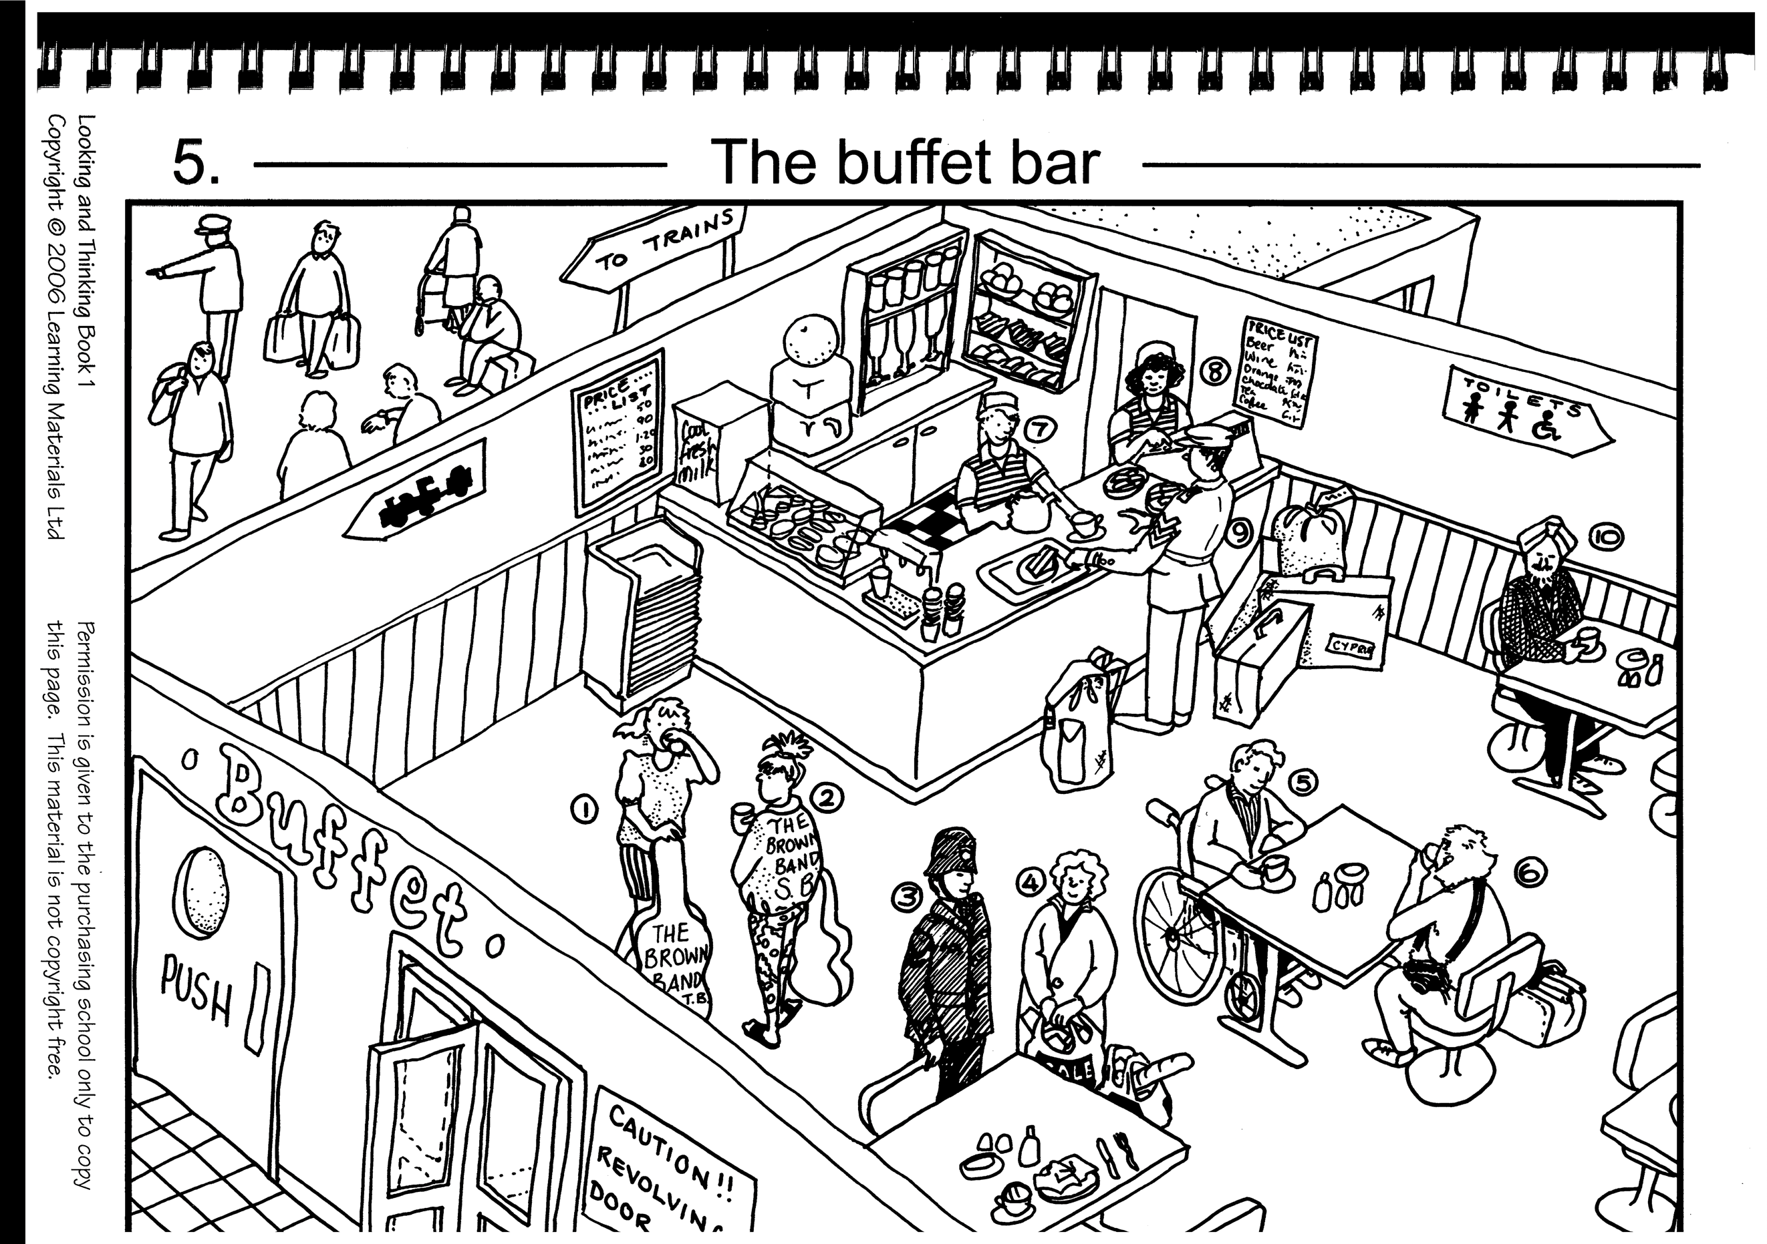

See below for Questions A then Questions B for ‘The Buffet Bar’

Questions A for ‘The Buffet’
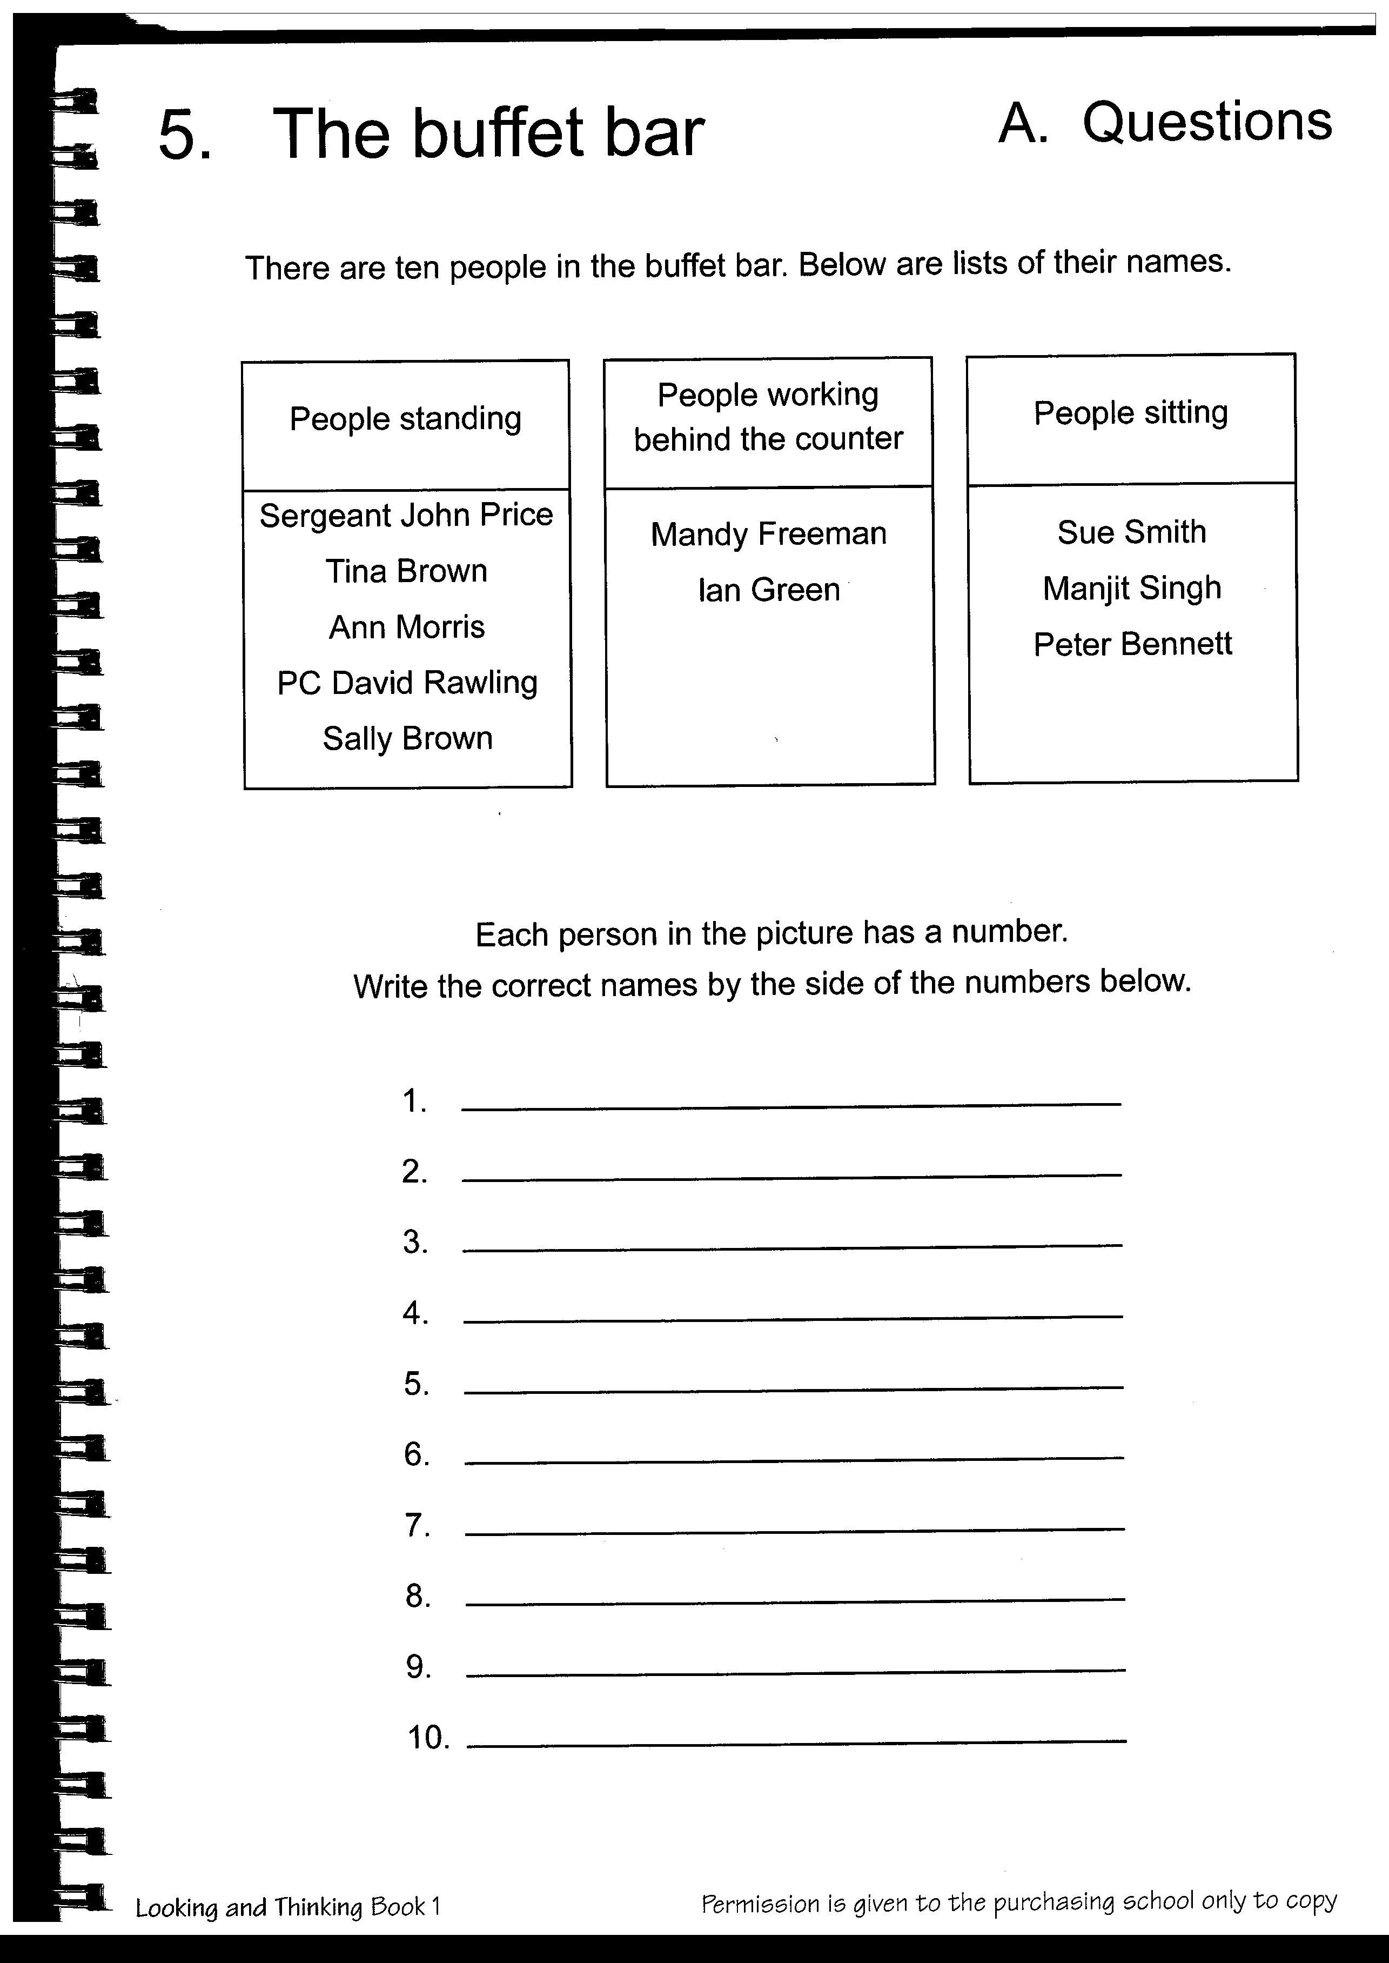

Questions B for ‘The Buffet Bar’
