Year 3 Home Learning – Friday 5th June 2020
X means that no internet access is needed. We would love for you to share any home learning and we look forward to seeing what you chose to do. Take a photograph and send it to - year3@highworthcombined.co.uk
X  Introduction to Roman Numerals  Roman Numerals can still be found in many  places today including clocks, watches, buildings  and on coins.  Have a look at home or when you are out  to see if you can spot any.  If you can, watch the powerpoint to find out  more.  On the next page you will find a clock face  with Roman Numerals. Use it to draw your  own clock face showing the Roman  Numerals. Write the numbers 1 to 12  around the clock on the outside.  Write the following in Roman Numerals -  1.Today’s date  2. Your age  3. Your Year group  4. The number of people in your family.  See if you can draw the clock from memory. | Science – Space  Last Saturday, 30th May 2020 saw  the historic launch of the first  commercial space rocket into  space. Did you watch it?  Click on the link to read about it  and watch the launch.  https://www.bbc.co.uk/newsround/52526849  Questions  Where was the rocket launched?  Can you name the two  organisations who worked together  to launch the rocket?  Where was the rocket travelling to?  What were the names of the two  American astronauts?  At what speed did they travel?  Why is the Falcon 9 rocket unique?  What did the astronauts name the  spacecraft?  Would you like to become an  astronaut? Why? | X  English – 10 minute writing.  Choose one of the writing prompts  and write as much as you can in ten  minutes. Ask an adult to time you.  Describe what you see.  - You have discovered a new planet.  - Outside your window you see  something you don’t believe.  - An island rose from the sea.  Write using long and short sentences.  Use capital letters and full stops.  Try and include commas, a ? and !  Use adjectives and adverbs.  Include a simile or two.  Now, go back and read your writing  out loud. Correct spellings and  punctuation using a different pen.  Finally, edit your writing. How could  you make improvements?  Re-write 2 or 3 sentences and underline what you have changed.
X  Art – Dot painting  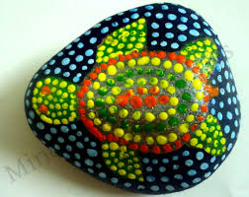  Art has always been part of Aboriginal life.  Aboriginal people are native Australians and their art expresses their relationship with the land and animals. It has been used for story telling for thousands of years.  Use paper, cardboard or a large stone to create your own dot painting.  Draw an outline of your animal or design in pencil. Use cotton buds to apply the paint. Test your technique out on some scrap paper first.  Use bright and vibrant colours.  If you do not have paint at home, you can draw your dots on paper using felt pens or colouring pencils.  https://www.youtube.com/watch?v=zp_vYfEiuGU | X  Super Spelling  Y3 and 4 Common Exception words  Here is the next group of spelling. Write  a list using neat joined handwriting.  famous  favourite  forwards  fruit  guard  guide  Activity 1  Practise your spelling by making a  pyramid, adding one more letter on  each line.  f  fa  fam  famo  famou  famous  Activity 2  Write a silly sentence for each word.  Include adjectives and adverbs in each  sentence. | X  Wellbeing  Enjoy music - sing or dance.  Think of your favourite music or songs.  Play music and sing a long or make up  a dance. You could do both!  Dancing is great fun and gets your  heart beating a little faster. It is a fun  way to exercise. It helps with balance,  coordination and stamina. You can do  it indoors or outdoors.  Ask your family to join in too.  Have fun!
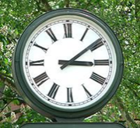
Roman Numerals
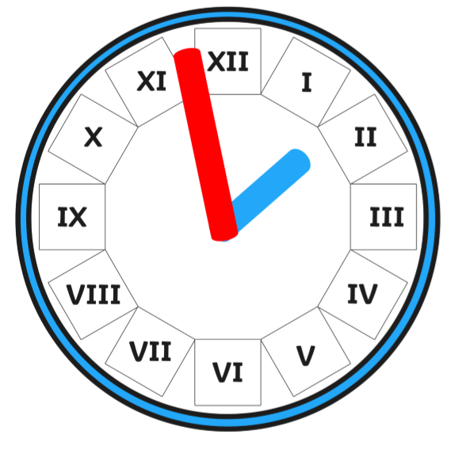

Draw 6 smaller clock faces and show the following times.
- 3 o’clock. 2. 6 o’clock 3. 9 o’clock 4. 9.30
- 8.15 6. 11.25

Choose a time of your own and show it on a clock.

Remember! The long hand is the minute hand and the short hand the hour hand.
There are 60 minutes in one hour. From X11, count clockwise in 5s.

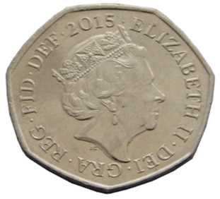
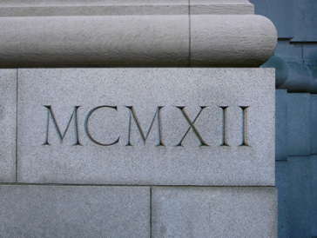
More Roman Numerals to learn
20 XX 100 C
30 XXX 500 D
50 L 1000 M
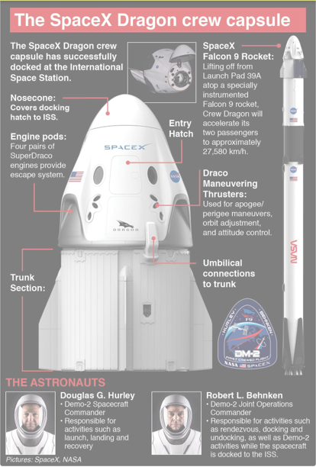
Science – Space
If you want to find out more about space
missions or space have a look on the
NASA website.
(National Aeronautics and Space Administration)

Explore Earth, the sun and other planets.
https://spaceplace.nasa.gov/menu/sun/

Activities to do at home
ww.nasa.gov/stem-at-home-for-students-k- 4.html

Remember to keep reading every day, for at least 10 minutes.
Continue to practice your times tables facts

