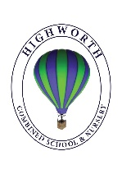
Home Learning Ideas for all
Friday 1st May 2020

Pyjamarama Day!
Wind in the Willows the Musical
It’s Pyjamarama Day! Go to

https://www.booktrust.org.uk/books-and-reading/have-some-fun/pyjamarama/

to find out more!

Time Tables Rock Stars
The site, Times Table Rock Stars is offering free use until later in June. Sign up for free and your child can have fun practising their times tables.

https://play.ttrockstars.com/

Yoghurt Art!
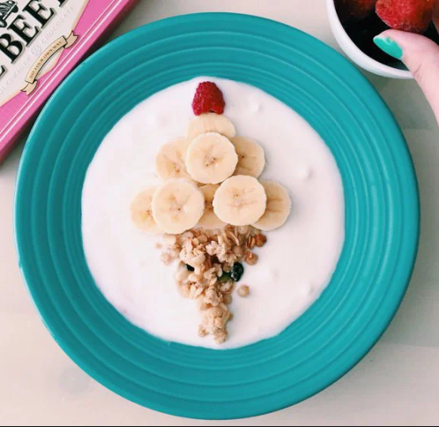
Did you know that in Japan, shallow bowls of yoghurt are used as a blank canvas for artists?

Let your child have a go at food art by giving them a bowl of yoghurt, a variety of fresh and dried fruits such as berries, banana, apricots and raisins. Please take a photo of their delicious art and send it into us before they enjoy eating it!

