Year 4 Home Learning – Friday 12th June 2020
Please email us your work to:
Year4@highworthcombined.co.uk
Fun Friday is back, with a dragon theme today!
REMARKABLE WRITING!

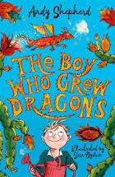
Looking at the book cover, can you answer these questions ….

Now you have thought about what you would like to grow, we would like
you to design a front cover for the book containing your story.

Challenge: you could, of course, start to write your story!

SUPER SCIENCE MEETS RESILIENT READERS!  Dragons are often used as fantasy characters in stories, but there is a real animal called a Bearded Dragon.  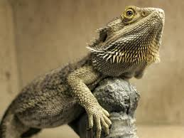  Attached below is a reading comprehension that will help you to learn all about these interesting creatures. | DRAGONS MEET ART!  In the UK, we have four different seasons:  Spring, Summer, Autumn and Winter.  Each season brings changes in the weather, changes in the world around us and different celebrations.  We would like you to think about each of the seasons and then decorate the sheet of dragons found on the pdf document with the home learning matrices, with one for each season. See how creative you can be to make them all look different, and not just with the colours you use!
MARVELLOUS MATHS MEETS SPLENDID SPAG!

Today you are going to try some data handling. Data is a mathematical (and scientific word) for information. We use tally charts and tables to collect data, and we can then use a bar graph or venn diagram to represent the data.

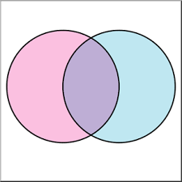
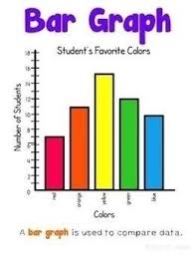
You are going to carry out a vowel investigation (the SPaG link!), using a piece of text about dragons to collect your data.

First you will tally the number of each vowels in a table.
Next you can create a bar graph from this data.
Then you can sort the words into a Venn diagram.

Everything you need is on the Word document that you will find with the home learning matrix for today.

Challenge: there are two additional word documents. One has some more challenging dragon themed Venn diagram puzzles and the other (word sort) has a mixture of Venn diagrams and Carroll diagrams (you can choose which to try!). Keep an eye open for great vocabulary too!

WONDERFUL WELLBEING!
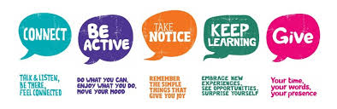

Use this link to try some yoga. Perhaps you can encourage someone in your family to join you!

https://www.youtube.com/watch?v=X655B4ISakg

