Home Learning Ideas for all
Monday 4th May 2020

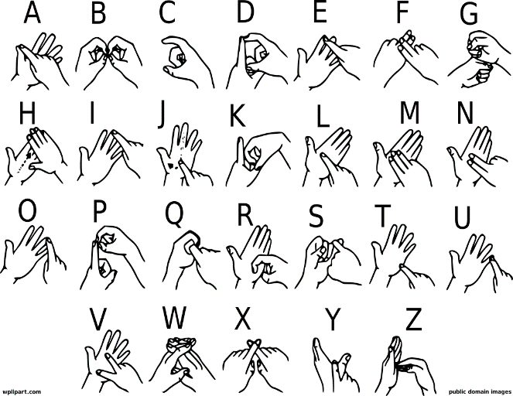
It’s Deaf Awareness Week this week and with this in mind it would be a great opportunity to watch the story ‘What the Jackdaw Saw’ by Julia Donaldson. The story is read with signing included in a window throughout the story and children can practice some signs at the end. Have fun. Please use the link below: https://www.youtube.com/watch?v=XbQTEz1M480

Also here is the signing alphabet. You can see if you can teach each other how to sign the names in your family. Perhaps you can sign some of your spelling words. Have fun!

Have a birthday party for your favourite toy!
Why don’t you pretend that it is your child’s favourite toys birthday today? Plan some party games, bake a cake or some biscuits and dance to some music.

Daily Challenge
And finally, go into Espresso (log on details on the Home Learning Ideas) https://www.discoveryeducation.co.uk/what-we-offer/discovery-education-espresso and select the correct Key Stage for you and complete the daily challenge.

