Home Learning Ideas for all
Monday 20th April 2020

Free online English and Maths lessons with the BBC
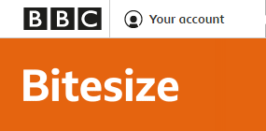
From 20th April, you’ll be able to access regular daily lessons in English and Maths, as well as other core subjects, in an expanded version of the BBC Bitesize website and also on special programmes broadcast on BBC iPlayer and BBC Red Button. https://www.bbc.co.uk/bitesize/articles/zn9447h

Read Write Inc Phonics update
From Monday 20th April, RWI are providing more online lessons than they previously have on their YouTube channel https://www.youtube.com/channel/UCo7fbLgY2oA_cFCIg9GdxtQ. See the schedule below.
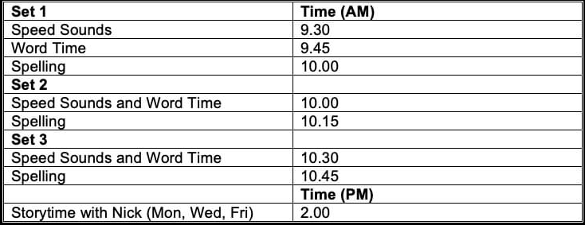

Milk Bottle Elmer Elephant!
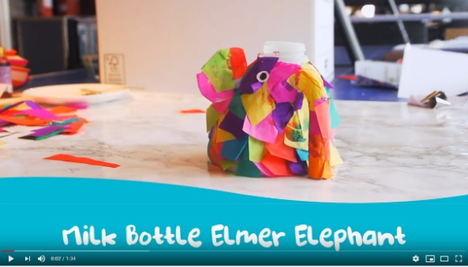
https://www.youtube.com/watch?v=eub7Pe6DZIc&safe=active
Have a go making your own Elmer using an empty milk bottle as a base! We would love to see any photos of your creations.

