**Year 2 Home Learning**

**Week Commencing 22 June 2020- Wednesday**

**Please send your work to-** [**year2@highworthcombined.co.uk**](mailto:year2@highworthcombined.co.uk)

**We always look forward to seeing your work. Please let us know if you need any help or have any questions.**

|  |  |
| --- | --- |
| **English Task**  Today, you are going to become an author.  Use your story mountain to write your own story. Remember to use capital letters and a range of punctuation. It is also important to include powerful descriptive language to create a vivid picture for your reader.  Here is an example of how the story might begin:  ***For the last few days, they had been falling from the sky. Nobody knew where they had come from and nobody knew why they were there. The mysterious objects, most of them spherical in shape, lay there on the sandy beach. They lay there motionless, immovable, despite the tide’s best efforts to remove them from the shoreline. Then, a crack began to appear on the surface…***  Can you continue the story? Or you can start it in your own way.  It might take you a couple of days to write each section of your story and that is fine. Remember to keep reading through your work and editing it as you go along. All the best!  **Please use the check list below when writing and editing your story.** | **Maths**  **Mental Maths warm up:**  **1. __ - 45 = 23**  **2. 47 + 55 =**  **3. 9 x 5 = ___**  **4. 25 ÷ 5 = __**  **Multiplication:**   1. Complete the number sentences to describe the arrays.     **2.** Write two multiplications for this array.    **3.** Show all possible answers and how you have worked it out**.**    Challenge!  With 12 cubes, how many different arrays can you create? Draw your arrays to show us how you have worked it out. |
| **SPaG**    **Write 5 sentences using the similies below.** | **Reading comprehension.**  **Read the text about Mr Wonka attached below.** |
| **Geography**  ***Learn what the Earth can tell us about the weather with Sir David Attenborough***  <https://www.bbc.co.uk/bitesize/articles/zw7vtrd>   |  | | --- | |  |  |  | | --- | |  | | **Geography**  ***What do you think weather, environment and climate mean?***      ***What do pollution, deforestation and climate crisis mean?***    **Activity:**  *Research ways of how we can help our planet and improve the environment. Create a poster to present your facts. Here is an example:* |

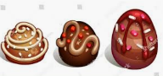

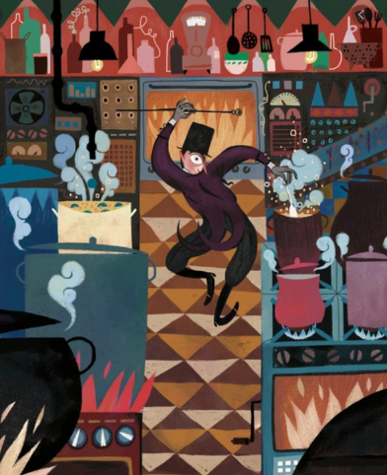

**Charlie Bucket stared around the gigantic room in which he now found himself. The place was like a witch’s kitchen! All about him black metal pots were boiling and bubbling on huge stoves, and kettles were hissing and pans were sizzling, and strange iron machines were clanking and spluttering, and there were pipes running all over the ceiling and walls, and the whole place was filled with smoke and steam and delicious rich smells. Mr Wonka himself had suddenly become even more excited than usual, and anyone could see that this was the room he loved best of all. He was hopping about among the saucepans and the machines like a child among his Christmas presents, not knowing which thing to look at first. He lifted the lid from a huge pot and took a sniff; then he rushed over and dipped a finger into a barrel of sticky yellow stuff and had a taste; then he skipped across to one of the machines and turned half a dozen knobs this way and that; then he peered anxiously through the glass door of a gigantic oven, rubbing his hands and cackling with delight at what he saw inside. Then he ran over to another machine, a small shiny affair that kept going phut-phut-phut-phut-phut, and every time it went phut, a large green marble dropped out of it into a basket on the floor.**

1. Underline the verbs or write them down in your book.
2. Highlight the similes or write them down in your book.
3. How did Charlie feel when he was looking around the room?

How do you know this?

_____________________________________________

1. What does *anxiously* mean?

_____________________________________________

1. Which words tell you that the machines were noisy?

_____________________________________________

1. How would you feel walking into that room? Explain your answer.

_____________________________________________

_____________________________________________

1. Use a dictionary to find the definition of these words

delicious ________________________________

dozen ________________________________

gigantic ________________________________

1. Using a thesaurus, could you find better words for

large _________________________

loved _________________________

1. Why do you think the author used the simile?

_____________________________________________

_____________________________________________

_____________________________________________

1. Could you change the simile?

‘He was hopping about among the saucepans and the machines like a _____________________________________________