Year 2 Home Learning
Week Commencing 1 June 2020- Friday
Please send your work to- year2@highworthcombined.co.uk

English Task  Look at our poem, ‘Don’t’ by Michael Rosen.  There are lots of different types of poems. Some poems use just one rhyme sound, some use repetition, some are more like conversation. Poems also have different feelings and purpose.  Today write a poem of ‘dos’ and ‘don’ts’ designed to help a friend in an unusual situation: - they are made of glass - they are wildly in love - their hat is on fire - they are turned into a fly - they are sad - they are a snowman - they are an elephant in a supermarket - they are about to stop a war - they are walking a tightrope.  • Can you think of any more imaginary situations that might need rules?  • Choose one of these situations and think about the advice you would give your friend. You could start by making a list of the advice you would give, and then turn this into a poem.  Think about the mood and tone of the poem before you start – will it be a jokey poem, an angry poem, a stern poem? Remember, not all poems have to rhyme.  In case you didn’t watch the link from Monday, I have attached it again.  https://www.youtube.com/watch?v=Oaq3gzswei0 | PSHE  Random Acts of Kindness  Why is it important to be kind?  Who should we be kind to?  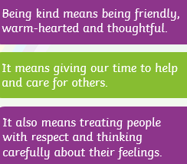  There are lots of different ways that we can show kindness to people. One way is to do random acts of kindness. This means being kind to someone without needing to or being asked. You could help someone, you could write a letter to someone with an encouraging message or you could give someone a hug.  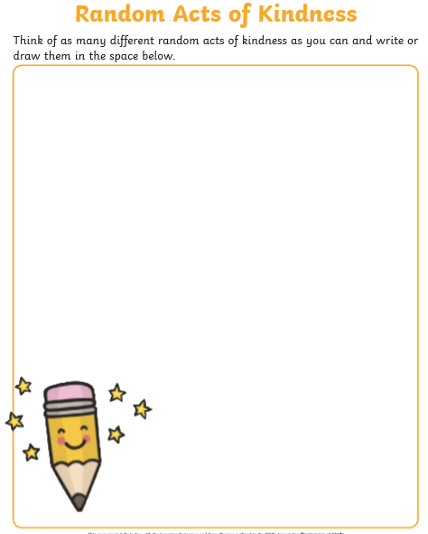  *Challenge- can you do one or more of the tasks on your list?
Maths  Mental Maths Warm Up  1. 56 + 67 = ___  2. 17- 9 = ___  3. __ x 2 = 14  4. __ ÷ 5 = 9  Fractions of a number- We have looked at fractions of a shape. Now we are looking at fractions of a number. Use anything around the house to make the total (Lego, raisins, anything) and then you can put them in to the right number of groups.  You will need to look at the denominator to find out how many groups there need to be. Then you will look at the numerator to find out how many groups you need to look at.  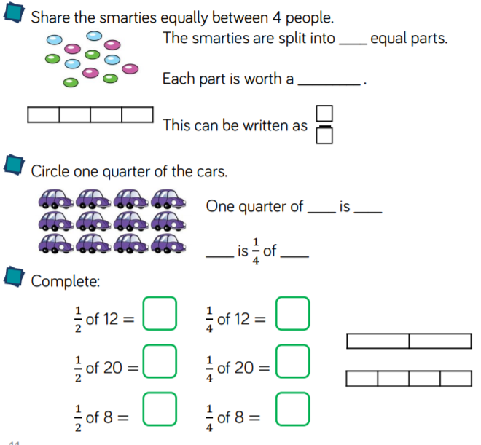 | RE  Judaism  I have attached a link to the Oak National Academy. It is one of the websites that provide online lessons. This particular lesson is the first in a new unit. Most of these lessons start with a quiz at the start and then students complete the quiz again at the end of the lesson. Don’t feel you need to take the quiz at the start. If you fancy a challenge, have a go at the quiz at the end.  Lesson 1- Judaism- What was the first covenant between Abraham and God?  --You will be making a map of Canaan during the lesson and a story map so make sure you have a pencil and paper ready. Please send us a picture of your work at the end of the lesson.  *At the start of the lesson the teacher reflects about a previous lesson, don’t worry, he quickly moves on.  https://www.thenational.academy/year-2/foundation/what-was-the-first-covenant-between-abraham-and-god-year-2-wk5-1#slide-3
Art  Journey Collage  This week we are going to make a collage. A collage is a work of art made from different materials such as paper, newsprint, photographs, fabric, and other found objects.  Have a go making a collage. You can use whatever materials you like. Watch the link below to get some ideas.  https://www.bbc.co.uk/teach/class-clips-video/art-and-design-using-textured-materials-landscape-collage/zfrfbdm | SPAG  How many different words can you make from the letters in this sentence, below? Grab a pencil and paper and write a list!  ‘Learning from home is fun.’

