Summer 2 Week 2 Home Activities
Here are some suggested activities you could complete as a family. Have fun and keep well! Please do send us photos of what you have been doing at yearn@highworthcombined.co.uk

Literacy/Communication  Listen to the story of Goldilocks and The Three Bears.  https://www.youtube.com/watch?v=T84dax2MDPg  - Can you draw a picture of each of the characters? Goldilocks, Daddy bear, Mummy bear and Baby bear.  - Ask an adult to help you listen/say/write the first sound at the beginning of their name.  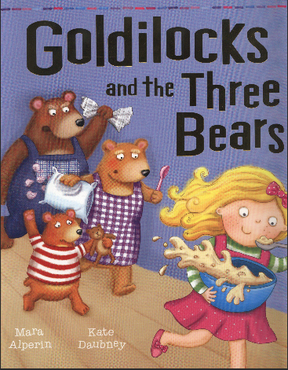 | Physical  How can you stay fit and healthy when the weather is hot?  What must you make sure you do when you go outside in the sun?  Draw a picture of three things you must remember to do when going outside in the sunshine.   | Personal and Social  It is important to have good manners.  Saying please and thank you are good manners.  When might you say please and thank you? Every time you say please and thank you to someone, I want you to record it on paper. At the end of the week count up how many times you have remembered to say please and thank you.  
Mathematics  https://whiterosemaths.com/homelearning/early-years/  Watch the lesson all about the days of the week.  Have a go at answering the questions. You will need to find out which day is missing in the pattern. | Knowledge and Understanding of the World  It has been really hot weather outside recently. The animals that live outside have been feeling very hot too.  What can we do to help them in hot weather?  Leave some water outside for the animals to drink. What animals might you see drinking the water?  Can you draw a picture of the different animals that live outside? | Expressive Art and Design  Using old boxes and materials make a home for an animal to shelter inside. What could you put inside the animal’s home to make it feel cosy?

