Year 1 Home Learning – Monday 15th June 2020

Below, you will find 6 home learning tasks. You may choose the tasks that you wish to complete and do them in any order. Please do not hesitate to contact us if you have any queries or to send us any of the work you have been doing.

year1@highworthcombined.co.uk
English  Watch the story read by Mrs Clarke ‘The way back home’ by Oliver Jeffers from the ‘Story time with Highworth staff’ section of the school website. To help you complete todays task. See the link below https://www.highworth.bucks.sch.uk/web/story_time_with_highworth_staff/478292  Diary writing is a piece of writing that has the date on and typically tells us about the events of a day, and the thoughts and feelings that go with it.  See the example below of a diary entry.  Monday 15th June 2020  Dear diary ,  It is the second day of my space mission. I am missing earth a lot today, especially flowers and gravity. It is past midnight but I am still wide-awake because my day has been so exciting.  First, I woke up and put on my special space suit. It is a bit lonely on my spacecraft so next, I talked to my computer and some of the lovely people who help me on earth at ground control.  Then I tested some of the rocks I had collected the other day from the moon. They are very interesting, but I will have to wait a long time for the results.  After that, I drove the spacecraft to the telescope and looked around at the amazing view. It is fantastic seeing the Earth from space it looks so small like a tiny bright blue and green marble surrounded by cotton wool clouds.  Later on, it was time for dinner, I ate some freeze-dried food. It does not look nice in its packet but it tastes delicious!  From,  Mrs Hawes the Astronaut  Today we want you to write a diary entry of a character from the story ‘The Way back home’ either the boy or the alien. The diary entry has to sound as if one of the characters has written it so it needs to be from their point of view. It also needs to be exciting and interesting to read. These steps will help you:  - Include the date the diary was written.  - Write in the past tense.  - Use the words ‘I, my, we, our or mine’  - Write as if you (the character) were there.  - Write about the events in the order they happened.  - Describe your (the characters) feelings.  - Use time words to link your events e.g. first, then, next, afterwards, finally.  - Include detailed descriptions and try and use adjectives  Make sure you have you used full stops, capital letters, finger spaces, pre-cursive writing and your phonics knowledge. You can write your own entry or use the template below for support.  Date  Dear diary,  First I woke up and  I felt  Then, I  Next , I  I felt  After that , I  I felt  At the end of the day , I  Today has been  I hope tomorrow  From,  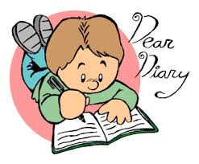 | Maths  Today you will be recapping your knowledge of 2D shapes and their properties. 2D shapes are flat shapes.  - First look at the picture below and tell an adult the names of the shapes and any properties of the shapes that you can remember.  - Now copy and complete this table about the properties of 2D shapes.  - Copy and complete the table below and see if you can guess what each shape is from the description.  Challenge  - Go on a 2D shape hunt around your house and record the shapes you find. Alternatively, take photographs of the 2D shapes that you find and make a 2D shape book.  - Use lolly pop sticks or strips of paper to make as many 2D shapes as you can.  - Make a 2D shape picture, can you use as many 2D shapes as possible? Can you make a rocket picture? What other pictures can you make only using 2D shapes?
Design and Technology
Astronauts use lots of special vehicles and equipment to support them in their roles. We would like you to choose one thing an astronaut might use, this could be the equipment, vehicles or outfits they have to wear and see if you can make them using resources you have at home.

E.g. a spacesuit, rockets, clothing, food pouches, cameras, parachutes, Luna rover, space station, satellites, computers.

- Make your equipment or vehicle.
- Write a sentence to evaluate your model - What is good about your model and why? What would you do differently next time and why? Write a few sentences at the end of your original design as an evaluation.

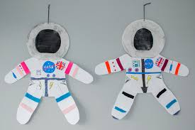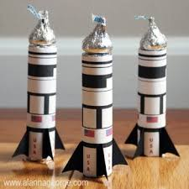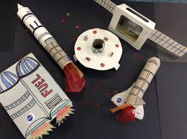

Please don’t forget to send us a photo of what you have made!
Science  Never look directly at the sun as it can damage your eyes.  Today we are thinking about shadows. Light can only travel in straight lines. A shadow is formed when something blocks the light. The closer to the light source (torch, sun etc.) an object is the bigger the shadow will be because the object blocks more of the light. When a light source moves the shadow will change. The length and direction of a shadow changes over a day due to the changing position of the sun over the planet.  On a sunny day, go outside, if you have chalks draw around a family member’s shadow (also mark where they were standing). If you do not have chalks place a toy on a piece of white paper and draw around the shadow. Write the time next to the shadow outline you have drawn. Do not move the paper or toy as it will need to be in the same place at a later time.  Repeat this at different times of the day and measure the length of the shadow. Always make sure they are in the same place to make it a fair test.  - What happened to the shadow at different times of the day?  - Why do you think this has happened?  - Can you name the light source you used to create your shadow?  - When was your shadow the shortest? Why do you think it is shortest at that time?  - When was your shadow the longest?  - Can you present your results in a table, or make a bar chart showing the length of your shadow at different times of the day.  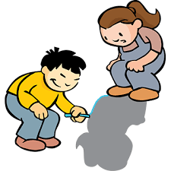 | Wellbeing  It is important for our wellbeing that we take notice of our own feelings and the people and things around us.  Today we are going to make a time capsule about what happened today and the times that we are in so that you can look back at it later. Many of the activities that you could put in your time capsule are going to ask you to take notice of a moment in time on this day.  First, find a box that you can put your time capsule objects in, label, and decorate the box and write on the front the date today and the date you want to open it. An old cereal box would be perfect. Then place a selection of things in your time capsule. Below is a list of ideas of things you could include:  - A drawing of something you have seen today. This could be the view from your window or portraits of your family it is totally up to you.  - A journal of your day.  - Photographs of your family or house.  - Information about yourself e.g. how you feel, what you are most thankful for, things that you are most excited to do in the future, what you want to be when you grow up , your favourite toy, colour, animal , food.  - The things you are doing now to have fun.  - What hobbies /activities have you enjoyed doing recently?  - Your handprint.  - An interview of someone else you live with.  - Alternatively, you could ask other family members to write letters to you that you do not open until a set date in the future.  It is your time capsule so add anything you think represents you and others around you at this time then keep it somewhere safe.
History
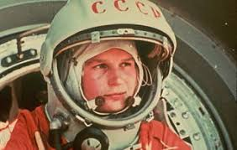
On the 16th June 1963 Valentina Tereshkova became the first woman in space she spent almost three days in space and orbited Earth 48 times in her space capsule, Vostok 6.
Other famous astronauts include Neil Armstrong the first man on the moon, Helen Sharman, Buzz Aldrin, John Glenn, Edward White, Yuri Gagarin and Tim Peake to name a few . Below are some links to help you find out more about famous astronauts from the past.
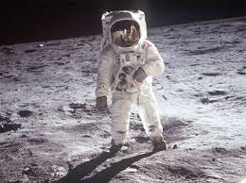
https://www.twinkl.co.uk/resource/t-tp-77-neil-armstrong-powerpoint
https://www.bbc.co.uk/bitesize/topics/zhpchbk/articles/z4w3mfr
https://www.twinkl.co.uk/resource/t-t-2549084-ks1-space-differentiated-reading-comprehension-activity-pack about a range of astronauts
Make a booklet to show all the information you know and have researched about famous astronauts. Don’t forget this will be a non-fiction booklet and so we will be looking for the key features of a non-fiction text e.g. facts and information, headings, pictures, labels, captions.

It has been fantastic to hear that so many of you have been accessing the Read, Write Inc phonics lessons at home. The RWI phonics lessons have made some changes and will have some extra sections from the 15th June. https://www.youtube.com/channel/UCo7fbLgY2oA_cFCIg9GdxtQ
All films will be available at 9.30 am. Set 1, 2 and 3 Speed Sounds lessons will restart. Set 2 and 3 Speed Sounds lessons will include new words for reading and spelling.
New daily films:
- Read longer words: for children who can read Set 3 sounds and words confidently.
- Read Red Words 1: for children who are reading Red, Green, Purple, Pink and Orange Read Write Inc. Storybooks. Many children are able to read these in Reception.
- Read Red Words 2: for children who are reading Yellow, Blue and Grey Read Write Inc. Storybooks. Many children are able to read these in Y1.
- Read and Hold a Sentence 1 (from 15th June): reading and writing practice for children reading Green, Purple, Pink and Orange Read Write Inc. Storybooks. (For children reading and writing with Set 1 sounds confidently and learning Set 2 sounds.)
- Read and Hold a Sentence 2 (from 15th June): reading and writing practice for children reading Yellow, Blue and Grey Read Write Inc. Storybooks. (For children reading and writing words with Set 2 sounds confidently and learning Set 3 sounds.)

