Year 1 Home Learning – Friday 3rd April

As this is the last day of our spring term, we will have a spring focus for our home learning activities before we fully embrace the start of the summer, which we hope will be a brighter and sunnier time for us all, in many ways.

Please do not hesitate to contact us if you have any queries.

year1@highworthcombined.co.uk
English  At the start of the spring term we looked at some different types of poetry. We focused on shape poems. Today we are going to write a different type of poetry called acrostic poems where usually the first letter of each line spells a word.  You are going to write a spring poem.  Write the word SPRING down vertically. Think of words, sentences and phrases that describe spring that start with each letter. Fill in the rest of the lines to make a poem. Now decorate your poem.  Challenge  - Can you make your poem rhyme?  - Can you make an acrostic poem for other words?  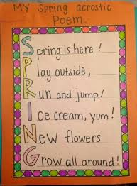 | Maths  The days are starting to get longer and lighter in the spring. So now is a good time for us to think about what we do throughout our day.  Draw 8 circles. Make those circles into clocks by writing the numerals 1-12 around the edge of each one.  Next to each clock write these activities: wake up, breakfast, play, lunch, dinner, watch tv, bath, bed. These can be in any order as everyone will have a different routine.  Now on each clock face draw the hands to represent what time you do these activities.  Challenge  - Can you tell the time, to the hour and half past the hour?  - Can you draw more clock faces to show us other activities that you do in the day?  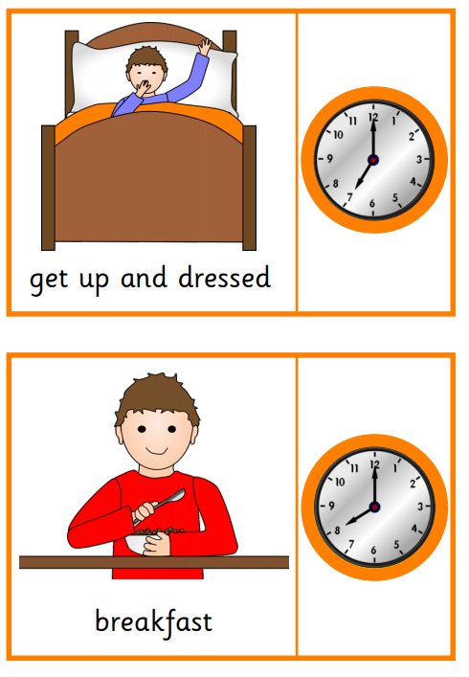
Art
Cherry blossom famously blooms in spring. Below is a selection of Cherry blossom paintings made by other children.
Make your own cherry blossom picture using one of the ideas below or any other ideas you have yourself.
Made using cotton wool balls dipped in paint | Made using finger-painting | Made by dipping the bottom of a bottle in paint | Made by sticking tissue paper onto a twig
We would love to see some photographs of your work!
PE  Being indoors can help us lose the spring in our step so let's get it back! Please try some of these activities to help keep your body and mind active:  - Walk like a crab  - Hop like a bunny  - Run like an ostrich  - Walk on your tip toes like a giraffe  - Flap your arms like a butterfly  - Stand as long as you can on one leg like a flamingo  - Gallop like a horse  - Skip  - Play with a ball  - Dance to different types of music  Keep a journal of the physical activities that you try at home this week, maybe take a photograph and try and think of as many creative physical (and safe) activities that you can do at home with the resources that you have in your house. | Geography and RE  During the spring a lot of countries and religions celebrate a range of festivals e.g. Holi-India, Songkran- Thailand, Cherry Blossom Festival-Japan, Floriade – Australia.  Choose one Spring festival or celebration from around the world and find out more about it.  Make a fact sheet to show us what you have learnt about the festival and the country it takes place in.  Don’t forget to name the festival, how they celebrate, where in the world it takes place, the name of the continent it takes place in, what happens at that festival, the flag of where it takes place and some drawings or pictures.  These links will help you:  https://www.bbc.co.uk/cbeebies/watch/lets-celebrate  https://www.bbc.co.uk/cbeebies/watch/lets-celebrate-norouz  https://www.twinkl.co.uk/resource/t-t-10000014-eyfs-all-about-holi-powerpoint  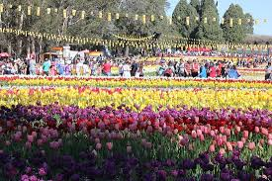
Design and Technology

Today design and make a spring basket. Outside in your garden you can see lots of flowers and so today we are going to make a basket to carry flowers in (or Easter eggs!)

Design what you want your basket to look like. Think about the materials you will use, the size of your basket and how much weight it will need to carry. Use materials from around your home to make a basket.

Below are some links and images of ideas to help you.

https://www.twinkl.co.uk/resource/easter-basket-weaving-craft-instructions-t-tp-7003
https://www.twinkl.co.uk/resource/ui-t-52820-basket-weaving-craft-activity
https://www.twinkl.co.uk/resource/t-c-254499-easter-themed-basket-craft

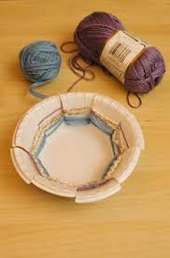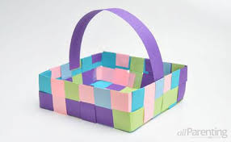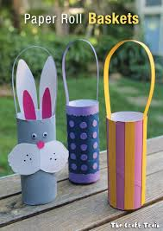
Challenge
- When you have made your basket, please write a sentence to evaluate your design.
- What is good about your basket? What would you do differently next time to improve your design?

