Home Learning Ideas for all
Thursday 23rd April 2020
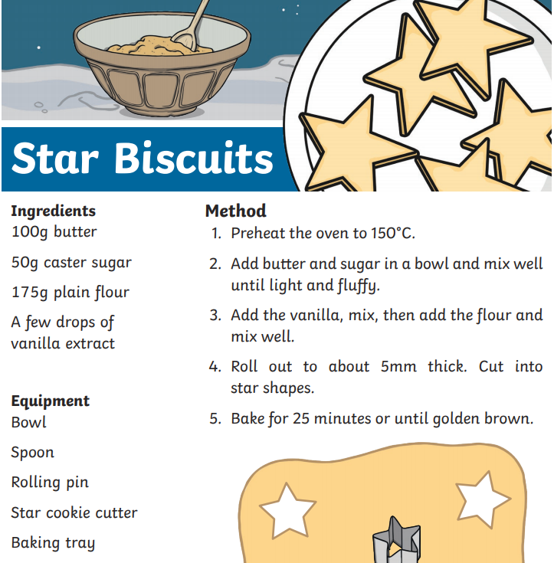
Baking – Star Biscuits

Have a go baking some yummy cookies today – if you don’t have star cutters, be creative… what shape biscuits can you make?

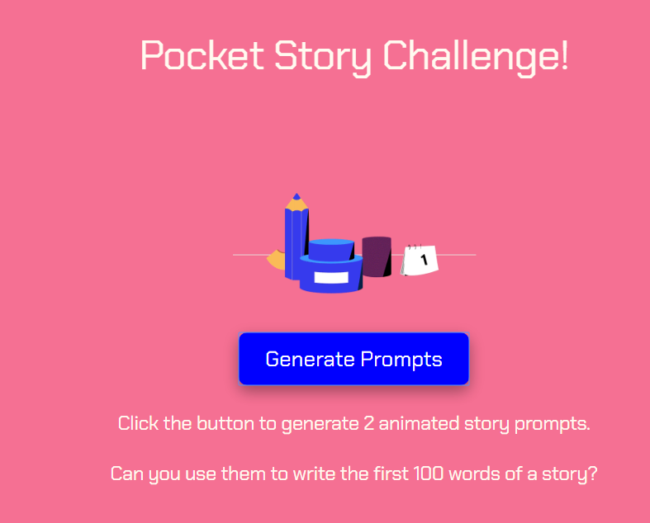
Pocket Story Challenge
Can you write the first 100 words of a story with two random prompts? Click on the link and click ‘Generate Prompts’. Good luck and be creative!
https://www.researchify.co.uk/storychallenge/

Learn more about nature!
http://www.treetoolsforschools.org.uk/categorymenu/?cat=activities
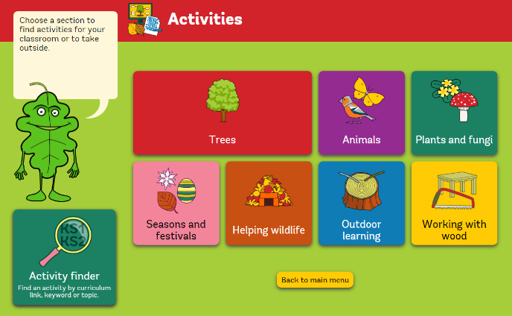
The Woodland Trust have a great site for helping you learn more about nature. Challenge yourself to learn the name of a new plant or tree – can you spot any new plants or trees on your daily exercise outside today?

