Year 2 Home Learning
Week Commencing 27 April 2020 - Wednesday

English task  Retell the story about Hermit crab using your story map or the one that is saved in our Year 2 folder for this week.  Remember to include all the exacting vocabulary and interesting sentence openers that you put on your story map. (carefully, gently, swayed, creaky)  Now you know the story well. Can you have a go at writing what happened to Hermit crab during spring months?  Do you remember which ones belong to Spring? Yes, that’s right – March, April, May.  Who did he meet during those months? What happened? Remember to use capital letters and full stops. Can you include other punctuation – question marks, exclamation marks, contractions?  Now you have finished your writing, please draw a picture to go with it. | 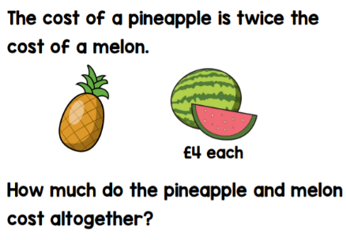  Maths task Problem solving challenge!  1.  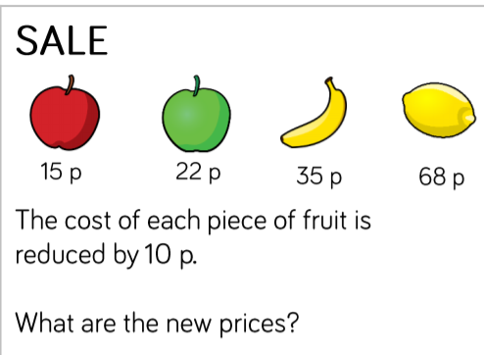  2.  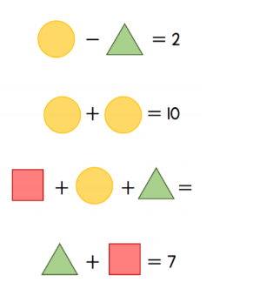  3. Complete the calculations.
SPaG  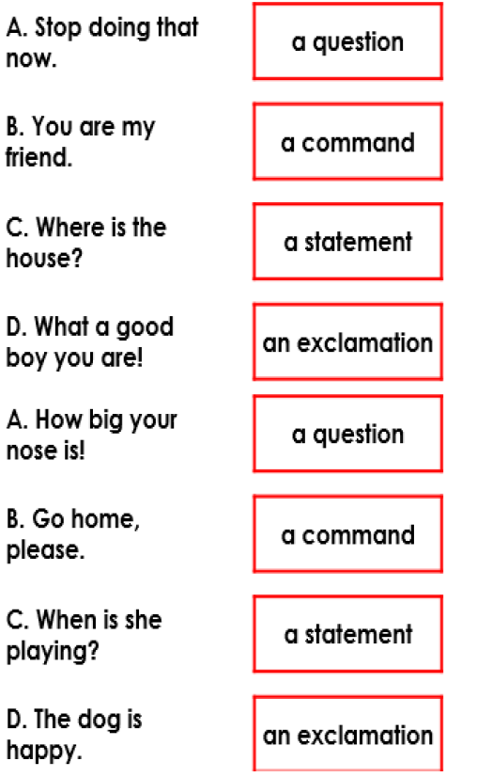  Match the following sentence to the correct sentence type: | Art:  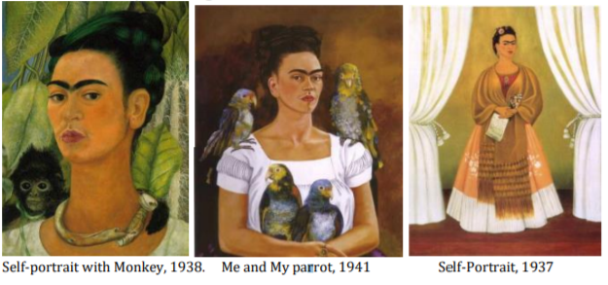  We will start looking at some famouse artists around the world. Today I would like to tell you about Frida Kahlo. Frida Kahlo was a Mexican artist who was known for her self-portrait paintings. She was severely injured from a bus accident and some of the artwork she made was from her bed! Frida Kahlo was friends with the artist, Pablo Picasso, who was also known for his interesting style of self-portraits. Below are some pictures of Frida Kahlo’s paintings  Which painting do you like? Why? Which animal or objects would you include in your own painting or drawing like Frida Kahlo? Can you practise drawing your favourite animals/objects? Happy sketching!
History  Neil Armstrong  https://www.bbc.co.uk/bitesize/articles/zj93bdm | Science  In February we learnt some interesting facts about different types of materials. Here is some more fun information and activities.  https://www.bbc.co.uk/bitesize/articles/z6kdwty  