Year 2 Home Learning
Week Commencing 27 April 2020 - Wednesday

English task A House for Hermit crab  Read ‘A house for Hermit crab’ on the Power point document (see our year 2 Matrices folder for this week). Or listen to it. https://www.youtube.com/watch?v=7cYgxknuDmc  Now draw a story map like we did for ‘The Angry Alligator’.  Remember that drawings don’t need to be detailed – a stickman for a person or wavy line to show the sea would do.  To show each month of the year you can just use a capital letter ( J for January, F for February ).  If you find it a bit tricky, have a look at my story map which is saved separately in our Year 2 matrices folder for this week.  Once you have completed a story map, write in any important key words or sentence openers. (carefully, swayed, creaky)  Now you are ready to tell the story using your story map.  At the bottom of this document I have attached a shorter version of the story that you can refer to.  Practise telling the story a few times.  Can you now do it without looking at the text? | Maths task  You have done an amazing job solving the word problems on Monday. Well done! Now have a go at these ones. Remember to read the word problems carefully and underline important words and numbers first.  - An octopus has 37 pairs of socks. He throws 10 of them away. How many pairs of socks has he got left?  - Hermit crab needs to find 50 pebbles for his house. So far he found 23. How many pebbles does he still need to find?  - Hermit crab had a dance party with 35 sea urchins. 17 sea urchins had to leave the party at 4 o’clock in the afternoon. How many sea urchins were still dancing at the party at 7 o’clock in the evening?  - An octopus found 23 corals. He gives 6 corals to a hermit crab and another 3 to a sea urchin. How many corals does he have left?
Spellings  From now on, every week you will be given a list of words to learn. You can do it in the same way as we did at school every day after lunch time.  You can write these words on cards.  Practise reading them, writing them.  Have a go at putting them in order from easiest to the most difficult to spell.  Practise using these words in your own sentences.  Play a memory game or ‘Snap’.  It would be great if you could send some examples of your practice to your teachers.  Here are the words for this week.  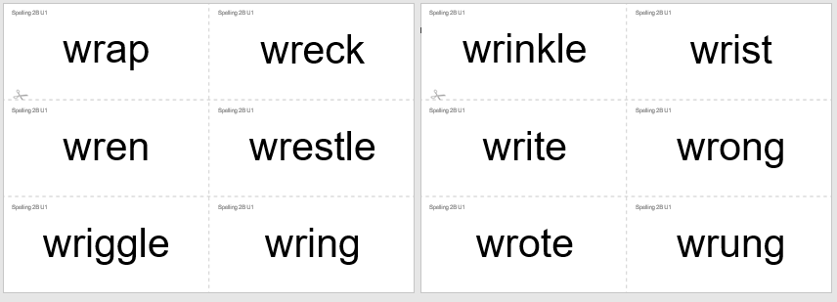  If you have access to the computer, then visit Oxford Owl website for more activities.  For guidance of how to access the Oxford Owl website go our school website click on coronavirus closure/home learning ideas/scroll down to parent guide for extra spelling zone/scroll down to  For log in details look in your yellow booklet you have been given at the end of March. | Science:  I have put a Power point together about the sea creatures from ‘A house for Hermit Crab’ book.  Read through power point in our Year 2 matrices folder.  Choose one creature that you really liked and create a poster about it.  Your poster can include a picture of that sea creature and the following heading: habitat, diet, special features and interesting facts.  Here are examples of a posters:  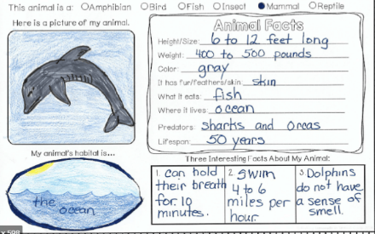  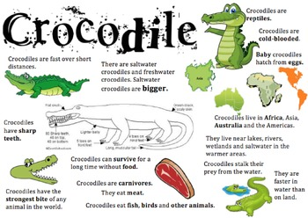
Geography/Science  Learn interesting facts about the sea animals.  https://www.youtube.com/watch?v=JOJkvhSpBiQ  And another one. Top 10 facts about the deep sea.  Lots to find out. Enjoy!  https://www.youtube.com/watch?v=o0QhPx5YYLI | Wellbeing:  BBC bitesize (Lesson on Wellbeing from 24th April)  https://www.bbc.co.uk/bitesize/articles/zmmgrj6  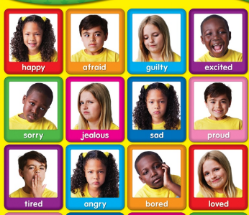  Watch the videos and complete Activity 1 or Activity 2.

A House for Hermit Crab
In January, Hermit Crab decided to move. He had grown too big for his shell. He stepped out onto the ocean floor but he was frightened. “What if a big fish comes along and attacks me?” He thought. In February, Hermit Crab found a new shell. But it was so plain! In March, Hermit Crab met some sea anemones who swayed gently in the water. “Would you be willing to come and live on my house?” “I would” whispered a sea anemone. Gently, Hermit Crab picked it up with his claw and put it on his shell. In April, Hermit Crab met a flock of starfish moving slowly along the sea floor. “Would you be willing to decorate my house?” “I would” signalled a starfish. Hermit Crab picked it up with his claw and put it on his shell. In May, Hermit Crab discovered some crusty coral. “Would you be willing to help make my house beautiful?” “I would” creaked a crusty coral. Carefully, Hermit Crab picked it up with his claw and put it on his shell. In June, Hermit Crab came upon some snails crawling over a rock. They grazed as they went, picking up bits of debris. “Would you be willing to help clean my house?” “I would” offered a snail. Happily, Hermit Crab picked it up and put it on his shell. In July, Hermit Crab came upon some fierce sea urchins. “Would you be willing to protect my house?” “I would” answered a sea urchin. Gratefully, Hermit crab picked it up and placed it near his shell. In August, Hermit Crab and his friends wandered into a forest of seaweed. “It’s so murky and dim and gloomy in here,” they thought. In September, Hermit Crab spotted a school of Lanternfish darting through the water. “Would you be willing to light up our house?” “I would” replied a Lanternfish and it swam over near the shell. In October, Hermit Crab approached a pile of smooth pebbles. “Would you mind if I rearranged you?” “Not at all” answered the pebbles. Hermit Crab picked them up and build a wall around his house. In November, Hermit Crab felt a bit small for his shell. Soon he would have to find another bigger home. But he had come to love his friends, the sea anemone, the starfish, the coral, the sea urchin, the snail, the Lanternfish and even the smooth pebbles. In December, a smaller hermit crab passed by. “I have grown too big for my shell, do you know of a place for me?” “I have outgrown my house too. You are welcome to live here but you must be good to my friends!”
The following January, Hermit Crab moved out and the little crab moved in. Soon Hermit Crab spied the perfect house. It looked a little plain, but…“So many possibilities! I can’t wait to get started!”

