Year 4 Home Learning – Wed 13th May 2020
Please email us your work to:

Year4@highworthcombined.co.uk
Remarkable Writing!  Look at the representations of rainbows (you can see a bigger version below the matrix).  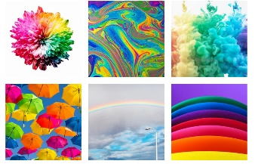  You are going to think of lots of different ways you can look at or explore a rainbow. To begin with, make a mindmap of any ideas or vocabulary that pop into your head as you look at the pictures. Now try and write a sentence, all rainbow related, using each of these:  - A simile.  - An instruction (given to the rainbow).  - Ask the rainbow a question.  - A wish.  - A short rhyming couplet.  - Alliteration.  - Onomatopoeia  - A lie (about a rainbow).  - A metaphor.  - Personification (giving the rainbow a human quality).  See how far down the list you can get. You could write more than one of each!  Write them out in your best handwriting and you will find you have a rather interesting poem. Poems do not always rhyme and often have lines of different lengths!  Challenge: There is an example of another type of rainbow themed poem below that you could have a go at for each colour of the rainbow. | Sensible SPaG!  QUESTIONS, EXCLAMATIONS,  STATEMENTS AND COMMANDS.  The difference between these can be quite tricky!  So today you are going to remind yourself about these different types of sentences.  There is a poster below or use this link to help you:  https://www.twinkl.co.uk/resource/t-l-1102-types-of-sentences-powerpoint  Some of you will have seen this sent with the Home Learning Matrix on Monday, so if you have had a go then your challenge is to write one of each type of sentence about, or to, a rainbow. How creative can you be?  There is an activity sheet attached below for you to have a go at deciding what each type of sentence will look and sound like.  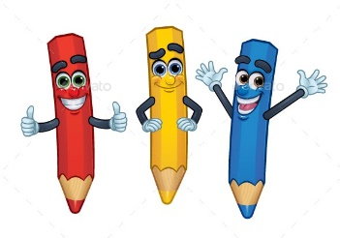  Challenge: There is a challenge included at the bottom of the sheet!  Also remember to keep reading!
Marvellous Maths!  Times Tables and division practice for quick recall. You can use this link: https://www.topmarks.co.uk/maths-games/daily10  Without Internet: You could write them out, chant them walking around or up and down the stairs (exercise too!), ask someone to quiz you or create your own beat the clock grid (copy below to remind you). Can you create a rap / song / poem to help you practice any times tables you find more tricky?  Factor pairs  A factor is a number that divides equally into another number without leaving a remainder.  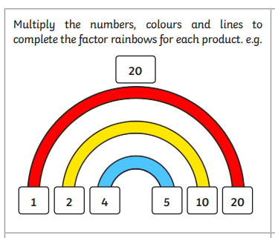  How to Find All Factors of a Number using the Rainbow Method  - Begin by dividing the number by 1. Your first factor pair will then be 1 and the number itself. Don’t be alarmed as this is always the case. You will then write the first two factors with enough space between them.  - Next, move on to the next number, which is 2, to test if you can also get a factor pair. If you can, write the new factor pairs inside the first factor pair giving it enough space in the middle as well. If the number is not divisible by 2, then leave it and move to the next chronological number, which is 3. Keep going in this way.  Try creating factor pair rainbows for the following numbers.  18 9 24 36  Now choose some of your own numbers.  Rainbow equivalent fractions.  Equivalent fractions are different fractions representing the same part of the whole.  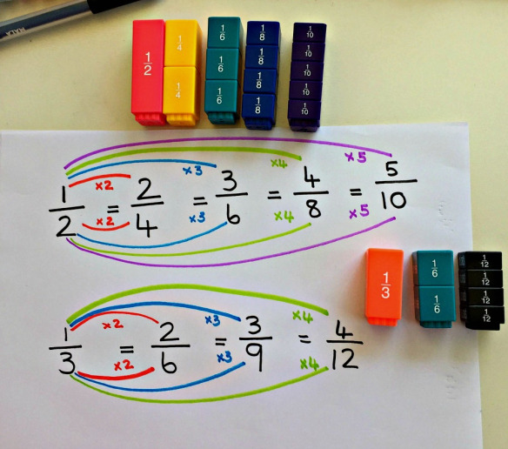  Recap what we did in class. Look carefully at the examples above. Can you explain to someone how these equivalent fraction rainbows were created. Think carefully about how we make sure that they are equivalent.  Choose your own starting fraction. Try to create your own equivalent fraction rainbow. | Super Science!  It’s hard to see a rainbow and not feel like a little special something is happening. Some of us may even stop in our tracks and swoon at the beauty of it, not to mention become elated at the promise of good fortune to follow. Rainbows are stunning, like shooting stars and Northern lights, they are total magic, Mother Nature style.  Today we are going to explore and make our own rainbow. Follow the instructions below.  While you are carrying out the experiment try to work out what factors cause the rainbow to be formed.  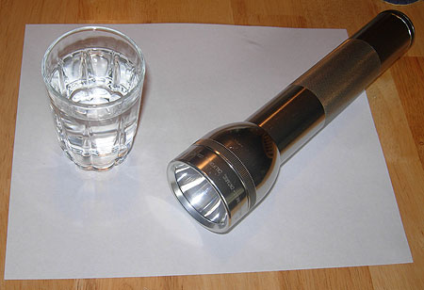  What You Need:  - A glass of water  - A sheet of white paper  - A sunny day or a flashlight  Instructions:  - Fill the glass almost to the top with water.  - If you are using sunlight, place the glass so that it is half on and half off the edge of a table, and so that the sun shines directly through the water, onto a sheet of white paper on the floor.  - Adjust the paper and the glass until a rainbow forms on the paper.  - If you are using a flashlight, place the glass of water on the white piece of paper, and move the flashlight around until you see a rainbow on the piece of paper.  - Try holding the glass of water at different heights and angles to see if it has a different effect.  If you have already tried this experiment, you could do the extension activity below.  Extension  If you have access to the internet, you could do some research on rainbows and create an interesting fact file on rainbows, including in it how rainbows are formed.  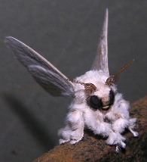  Venezuela Poodle Moth  This moth is only found in Venezuela in South America. Its name is derived from its appearance which closely resembles a poodle and moth. Its thick hair is used, not for warmth, but for smelling and defence.  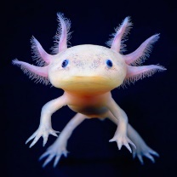  Axolotls  Otherwise known as the Mexican walk fish, which is found in Lake Xochimilco in Mexico. Whilst it is an amphibian that lives completely in water. It is related to the tiger salamander.
Wonderful Wellbeing!  Please continue to complete the Ramadan acts of kindness calendar you started  This week’s winning way to wellbeing is:  Rainbows are symbols associated with hopes and dreams.  We are sure you are all wishing for or hoping for something. Tell someone at home what’s at the end of your rainbow, what you are hoping for or aspiring to achieve?  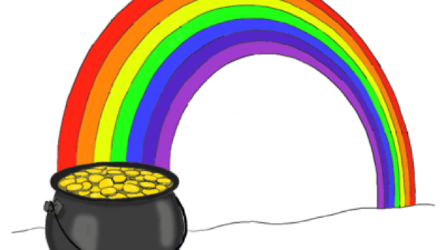  HOPE  We would be very interested to hear about your hopes and aspirations.  Attached below are mindfulness colouring sheet created by Sakeesh and Daniel. Enjoy colouring it in. | Terrific Topic!  Rainbow craft time!  How creative can you be? Using whatever you have at home, can you create a rainbow themed piece of art? Remember art can be a sculpture (3D piece of art) as well as any kind of picture. You could:  - Use different objects to create a colourful sculpture.  - Create a rainbow themed piece of art of your name.  - Think of something each colour of the rainbow reminds you of.  - Do an illustration to go with your writing.  - Create one of these …  