Year 2 Home Learning
Week Commencing 4 May 2020 - Monday

English task A House for Hermit crab  We are still using our story from last week. Have a look at your story map. Can you tell the whole story to someone just using your story map?  In English we group types of similar words. Two types we have looked at this year were nouns and adjectives.  Noun- person place or thing (Emma, London, bus)  Adjective- describes a noun (blue, big…)  To make our writing more interesting we use expanded noun phrases (that is where we have a noun and at least one adjective together).  Example of expanded noun phrase-  …an enormous carrot  enormous- adjective  carrot- noun  Read through the story again and see if you can find any examples of expanded noun phrases. I’ll start you off with one…  Crusty coral  Challenge- can you think of a few of your own? |  | Maths task  I’m impressed with your word problem skills so far. Can you see what skill will be needed in the word problems today? Remember to read the word problems carefully and underline important words and numbers first.  - I have made bunches of grapes with 10 grapes in each bunch. If I give one bunch to each of my 4 children, how many grapes will I need?  - I have three different recycling boxes. If I put two things in each box at lunch and then two more things in each box after dinner. How many things have I put in the recycling? Can you draw a picture of this problem to show your work?  - There are 3 round biscuits and 3 square biscuits in a pack. How many biscuits are in 5 packs?  - Your turn. Can you write a word problem that makes me do the same skill as these problems?
Spellings  Suffixes -er and -est  There are lots of root words that do not have to be changed before we add –er and –est.  tall…. taller….tallest  Sometimes when we add -er or -est, we might need to change the root word.  Remember our suffix rhyme:  Is there a letter I need to swap?  Is there a letter to double or drop?  If a word ends in e we must drop the e before adding -er or -est.  Drop the e before adding -er or -est.  brave…braver…bravest  Here are the words for this week. Think about the root word and how the suffix rhyme can help.  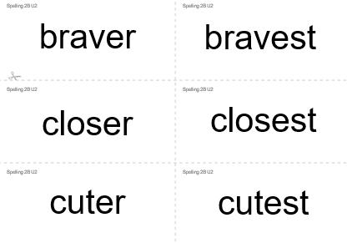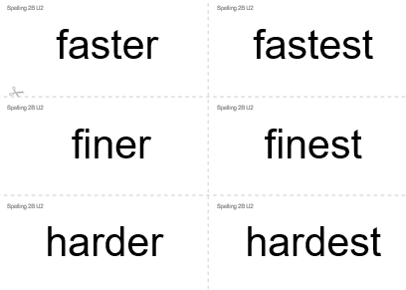  Try to do a daily spelling activity-  You can write these words on cards, Practise reading them, writing them. Have a go at putting them in order from easiest to the most difficult to spell. Practise using these words in your own sentences. Play a memory game or ‘Snap’.  If you have access to the computer, then visit Oxford Owl website for more activities.  For guidance of how to access the Oxford Owl website go our school website click on coronavirus closure/home learning ideas/scroll down to parent guide for extra spelling zone/scroll down to | PSHCE  The Environment- Recycling  In PSHCE we sometimes look at the world around us and think about how we live in the wider world. One thing that we all have in common in we all live on the same planet, and we have a responsibility to look after it.  https://www.bbc.co.uk/bitesize/clips/z8s87hv  Watch the following clip and start to think about recycling. Do you recycle things in your house? What do we recycle at school? Why is it important for us to recycle?  I have attached a link to a TV show on BBC called Maddie’s Do you know. She looks at recycling newspapers. If you want to look it up on iplayer it is series 1 episode 4.  https://www.bbc.co.uk/iplayer/episode/b07tzrt5/maddies-do-you-know-series-1-4-bin-lorry-and-newspaper
Design and Technology  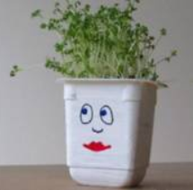  We have looked at recycling. Now you can have a go at recycling something yourself. Find something destined for the bin and turn it into something useful.  This person has used a yogurt pot as a plant pot.  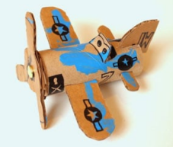  This person made a toy from some old cardboard. They even made the propeller move with a split pin.  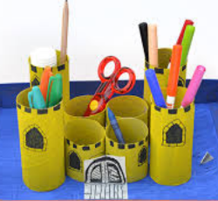  This one is a desk tidy. What do you think it is made from? | App reccomendation  On a phone or tablet go to the app store and download…  Cbeebies- Storytime  This app has lots of different stories the chidlren can read on their own. Read carefully cause ther are some challenges at the end!  Two stories I recommend-  -Peter Rabbit story- The Unguarded Garden  Andy and the Baby T-Rex

A House for Hermit Crab
In January, Hermit Crab decided to move. He had grown too big for his shell. He stepped out onto the ocean floor but he was frightened. “What if a big fish comes along and attacks me?” He thought. In February, Hermit Crab found a new shell. But it was so plain! In March, Hermit Crab met some sea anemones who swayed gently in the water. “Would you be willing to come and live on my house?” “I would” whispered a sea anemone. Gently, Hermit Crab picked it up with his claw and put it on his shell. In April, Hermit Crab met a flock of starfish moving slowly along the sea floor. “Would you be willing to decorate my house?” “I would” signalled a starfish. Hermit Crab picked it up with his claw and put it on his shell. In May, Hermit Crab discovered some crusty coral. “Would you be willing to help make my house beautiful?” “I would” creaked a crusty coral. Carefully, Hermit Crab picked it up with his claw and put it on his shell. In June, Hermit Crab came upon some snails crawling over a rock. They grazed as they went, picking up bits of debris. “Would you be willing to help clean my house?” “I would” offered a snail. Happily, Hermit Crab picked it up and put it on his shell. In July, Hermit Crab came upon some fierce sea urchins. “Would you be willing to protect my house?” “I would” answered a sea urchin. Gratefully, Hermit crab picked it up and placed it near his shell. In August, Hermit Crab and his friends wandered into a forest of seaweed. “It’s so murky and dim and gloomy in here,” they thought. In September, Hermit Crab spotted a school of Lanternfish darting through the water. “Would you be willing to light up our house?” “I would” replied a Lanternfish and it swam over near the shell. In October, Hermit Crab approached a pile of smooth pebbles. “Would you mind if I rearranged you?” “Not at all” answered the pebbles. Hermit Crab picked them up and build a wall around his house. In November, Hermit Crab felt a bit small for his shell. Soon he would have to find another bigger home. But he had come to love his friends, the sea anemone, the starfish, the coral, the sea urchin, the snail, the Lanternfish and even the smooth pebbles. In December, a smaller hermit crab passed by. “I have grown too big for my shell, do you know of a place for me?” “I have outgrown my house too. You are welcome to live here but you must be good to my friends!”
The following January, Hermit Crab moved out and the little crab moved in. Soon Hermit Crab spied the perfect house. It looked a little plain, but…“So many possibilities! I can’t wait to get started!”

