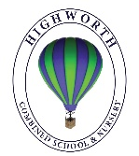
Year 1 Home Learning – Monday 22nd June 2020

Below, you will find 6 home learning tasks. You may choose the tasks that you wish to complete and do them in any order. Please do not hesitate to contact us if you have any queries or would like to share the work you have been doing.
year1@highworthcombined.co.uk
Today we are thinking about Poems and your challenge is to see how many of the poems in the home learning matrix you can learn by heart and perform to another person. If you know any other poems or have any poetry books maybe you could send us some poems to learn!
Maths  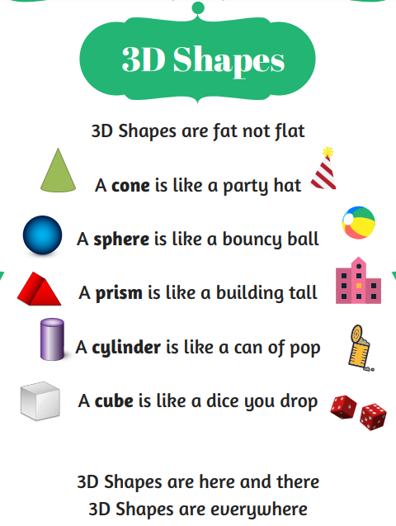  - Learn this poem to help you remember 3D shape names.  - Make a label and picture for each of the 3D shapes in the poem cone, sphere, triangular prism, cylinder, and cube. Collect as many examples of the 3D shapes as you can.  Challenge  - Now go on a shape hunt both inside and outside your house and create a table to record the 3D shapes that you find.  Look at the properties of 3d shapes picture below and use it to talk about the properties of the shapes you have found. 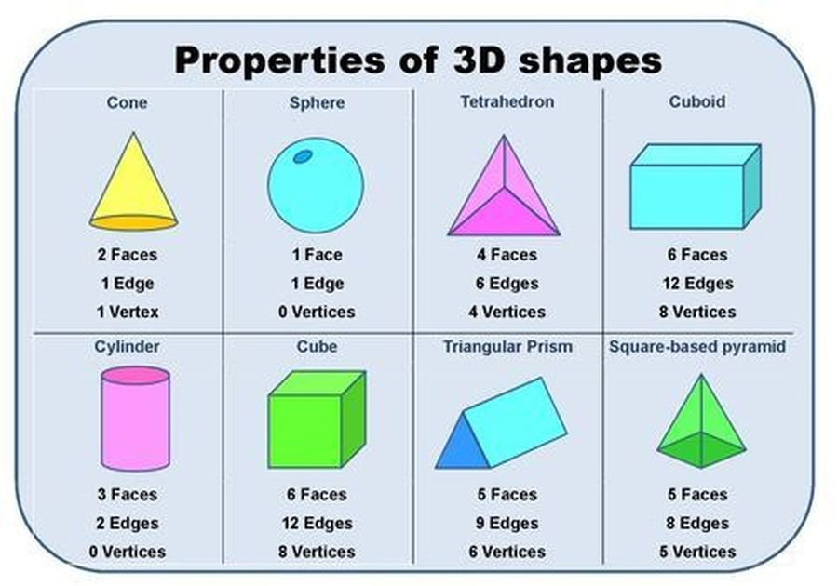 | Science  We are thinking about plants today. A plant is usually a living thing that grows from the ground. Over previous home learning matrix we have thought lots about the main parts of a plant, flowers, leaves, stems, roots.  Today we are going to identify some common plants and label them.  With an adult go for a walk either in your garden or in your local area.  Take with you a pen and paper or camera and record the plants and flowers that you see.  Below are some pictures to help you identify some of the plants that you might see. Please remember that we never pick wild flowers or flowers from a garden without permission.  When you return from your walk, please draw your favourite plant and label it with the parts of a plant.  Challenge  - Can you plant and grow your own flower.
English
We are thinking about rhyming words and rhyming poems today. This is a speaking task, and we will be learning to appreciate rhymes and poems, and to recite some by heart and to write our own.

- Write out the poem from the picture above changing the pictures for words.
- Write the words that rhyme in the same colour e.g. the last two lines would look like this:
- I like ice cream, I like stew,
I like eating next to you.
- Now learn this poem and perform it to another member of your family.
- Next you are going to change this poem to your own poem change the words: pears and stairs, cake and lake, peas and trees, bread and bed ( you will need to change it to anything you like but the words will need to rhyme and you may need to change the words I like eating by , I like eating on to make your poem make sense)
- Then write your poem out neatly and decorate it , try and learn your new poem and perform it to another family member.

Challenge
- Now write your own poem about what you like be as creative as you can and imaginative with your poem as you like. It can follow the pattern of the poems we have looked at or be completely different. Practise your poem lots, until you know it by heart and perform it to an audience.
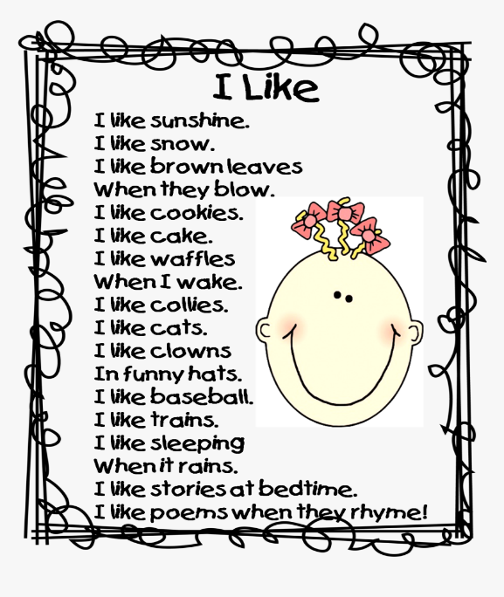
Design and Technology  Mrs Pankhania read a poem called ‘Chocolate cake’ by Michael Rosen on the story time with Highworth staff part of the website . Please watch her reading the poem, the link is below. https://www.highworth.bucks.sch.uk/web/story_time_with_highworth_staff/478292  In the poem, it uses lots of describing words to talk about the texture, look and taste of a delicious cake.  Today we would like you to prepare a delicious treat to share with your family, if you’re grown up says you are allowed!  Help a grown up to make a treat e.g. cake, biscuit, fruit ice-lolly etc. If you are not sure what to make you could have a look in a recipe book you have at home or ask someone in your family what their favourite treat is. This link has some ideas https://www.bbc.co.uk/cbeebies/curations/easy-cooking-with-kids-recipes “I would make a fruit ice lolly”, but it is totally up to you, your adult and the ingredients you have available. Write the list of ingredients you will use, the method and maybe photograph or draw what your final dish looks like. Don’t forget about food hygiene, and the importance of helping to clear and tidy away at the end of your cooking session.  - Wear a clean apron.  - Wear closed-in shoes to protect your feet, in case of hot spills or breakages.  - Wash your hands before and after handling food.  - Keep food preparation surfaces clean.  - Tie back long hair.  - Wash vegetables and fruit under cold water before use.  - Do not run around the room where food is being prepared.  - Wipe up food spills immediately.  - Don’t use any cooking equipment or appliances without adult supervision.  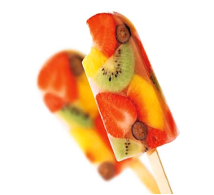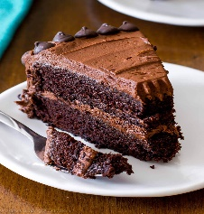  Challenge  - Can you make a list of as many describing words about your treat that you made to describe the, look, texture, smell, and taste of your food?  - Can you use some of the describing words to write your poem about the treat you made?  - This link has lots of other activities you can print off and try based on the poem ‘Chocolate cake’ by Michael Rosen that Mrs Pankhania read . https://www.puffinschools.co.uk/wp-content/uploads/2019/02/Puffin-Schools-KS1-Poetry-Resource-Pack-Michael-Rosens-Chocolate-Cake.pdf | Art and Wellbeing  The little things  The little things are most worthwhile-  A quite word, a look, a smile,  A listening ear that's quick to share  An others thoughts, an others care....  Though sometimes they may seem quite small,  These little things mean most of all.  By Margaret Lindsey  Read the poem above by Margaret Lindsey and think about the important things that you do for others. Make a list of all the little things you have done today that have been kind to someone else.  Lots of the things she mentions in the poem are about giving, not always a gift by your time, or smile or thoughts. Giving makes everyone feel special – make sure today that you give someone your time or just say thanks. It is also about taking notice of the little things others give you.  Today we would like you to draw a picture to show all the Little things that are important to you. Give the picture you make the title Little things that make me happy.  You can use any materials that you have at home and it’s up to you how you do it and what’s in your picture.  Please take a photograph and share your Little things artwork with us.  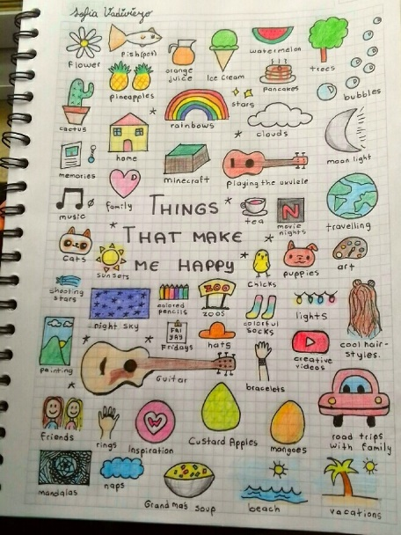  Challenge  - Make a picture to be kind to someone else and give it to someone in your family. Alternatively, send it to someone who has helped you as a way of saying thank you.
History
Schools has changed over time in Britain, both what they look like, what children learn and how teachers teach. Look at the pictures below of a Victorian classroom, and a classroom from 2020.

What looks the same? , what is different? Write a few sentences to compare schools from the past to schools today. I have also included a little summary of information to help you when looking at the pictures and writing your sentences about similarities and differences.

Victorian classroom

Modern –Day classroom

Until the Victorian era, not all children were able to attend school. For a long time, only children from rich families were able to go to school. In 1870, a law was passed which stated that all children aged between 5 and 10 must attend school. Victorian schools were very different to the schools we have today. In very poor areas, some Victorian classrooms would have up 80 children or more. Now schools usually have 30 children in each class. The classroom has also changed due to progress in technology. Victorian children would have mainly used slate to do their work on. Now children use paper or different types of technology, such as computers or tablets to do their work on.

Challenge
- Below is a poem about a teacher do you think it is about a teacher in the past or a teacher in modern times? Why do you think this? Can you write a poem about your teachers or school or about a teacher or school from the Victorian times?
