Year 3 Home Learning – Friday 22nd May 2020
X means that no internet access is needed. Remember, you can do the activities over several days. Take a photograph of your work and send it to year3@highworthcombined.co.uk
x
Make a book about your favourite things.

Over the holiday week make a booklet about your favourite things. Think about all the different things you enjoy at school and out of school.
Make a page or two for each of your favourite things and include drawings or diagrams.

You could -

Write down your favourite poem or write a book review of your favourite book.

Write about your favourite animal or your pet.

Share a recipe to make your favourite meal or instructions on how to make your favourite sandwich.

Describe a hobby you enjoy
football, gymnastics, swimming, art, jigsaws, games, baking, singing. The list is endless!

Write down all your favourite jokes.
(Here is one of mine. I had a hen who could count her own eggs. She was a mathemachicken!)

Create a page about your friends. Describe why you like them and what games you like to play together.

Write a page about what you like to do for others.
For example - playing or reading stories to brothers or sisters. Helping Mum or Dad with chores.

Make a list of all the things that are important to you. Family, friends, playing, learning, reading, praying.

You might think of other things to include that are not on the list. Remember to design a cover for your book. Have fun!

Ancient Greece – Who were the ancient Greek gods and heroes?

Find out and learn about the Greek gods by clicking on the link below.

https://www.bbc.co.uk/bitesize/topics/z87tn39/articles/zgt7mp3

Who was your favourite Greek god or hero? Write down everything you remember about them including any special powers. Now draw a picture of them.

Challenge

Write about a hero you have created and draw a picture. What is their special power?

X
Scavenger Hunts.

Indoors

1. Find and write down the names of 10 objects beginning with the letter B.

Indoors 2. Find –

- A fork
- Something that is red
- A tissue box
- 3 things that have wheels
- An orange crayon
- Something that is soft
- A plaster
- A key
- Two socks that match
- Something round
- A sticker
- An elastic band
- A pair of glasses
- An envelope

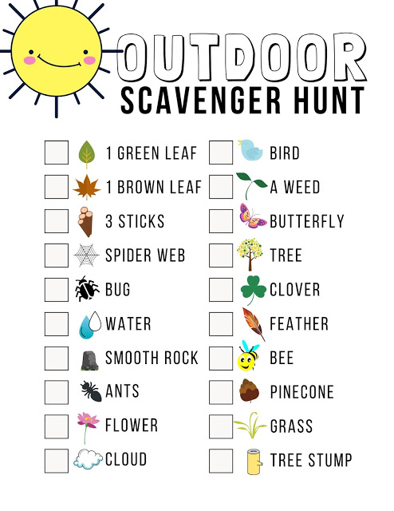

Have a go at designing your own Scavenger Hunt.

