Year 5 Home Learning – Monday 6th July 2020
We’d love to see your work! Please send it to: Year5@highworthcombined.co.uk
ENGLISH:  We are going to start a new text called  The Game  It’s a finding tale, which follows the same plot idea as a book called Jumanji. Have you heard of that title before?  Scroll down for the story and the activity sheets. There’s a link to a video too BUT please check with an adult first that it’s alright for you to view it.  There’s also a recording of the story but please use this link https://soundcloud.com/talkforwriting/game/s-7MBlxRcz8zL  because the one on the sheet isn’t working. If you do listen to it, make sure you stop the recording at 1:46 because you’re going to predict what happens next.  Don’t worry, you’re going to carry on reading the story on Wednesday so you will find out! |  | MATHS:  You are going to be using all of your knowledge about Number and Place Value to solve some problems.  We have also included some Rapid Reasoning questions.  Scroll down and try to answer as many questions as you can.  The answers are included so, when you have finished, you can mark your work.  If you have any incorrect answers, re-read carefully to make sure you’ve understood the question, check your work and see if you can spot your mistake.
WONDERFUL WORDS
Look at the Year 5 & 6 Words List. You can find it as a link on our Coronavirus Closure, Home Learning Matrix, Year 5 tab: https://www.highworth.bucks.sch.uk/web/year_5/460996
Choose 4 or 5 words to practise at a time.
- Look up the definition in a dictionary to check the meaning of each word.
- Learn the correct spelling by using: Look, Say, Cover, Write, Check.
- Write a sentence which includes the word to show that you understand its meaning.
4. Challenge yourself to include speech in each of your sentences. Scroll down for a reminder
about accurate punctuation using the KNOWLEDGE ORGANISER: Writing Dialogue.

ART and DESIGN  Use this link for a lesson in how to make a Wind Whirler.  https://classroom.thenational.academy/lessons/the-world-around-us-wind-whirlers-primary/activities/1  You will be able to create a very attractive, natural decoration for your garden.  We would really love to see a photograph of your finished decoration. | GEOGRAPHY:  City Life, Countryside Living  Scroll down to read the non-fiction text, which gives information about settlements. Then answer the questions, giving as much detail as you can.  If you’re not sure about the meaning of any of the vocabulary, find the definition in a dictionary.  Remember to read the text once in full, then scan for key words and re-read the section where you think you’ve found the answer to the question.  The answers are included so, when you have finished, you can mark your work. |  | FOOD TECHNOLOGY:  CHOCOLATE  WIZARD HAT  CUPCAKES  Scroll down to try out a great recipe to make some wizard cupcakes.  HAPPY BAKING  AND  BON APPETIT!
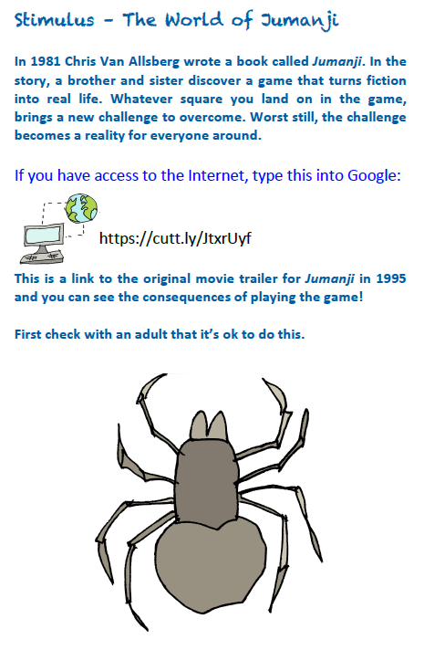
THE GAME

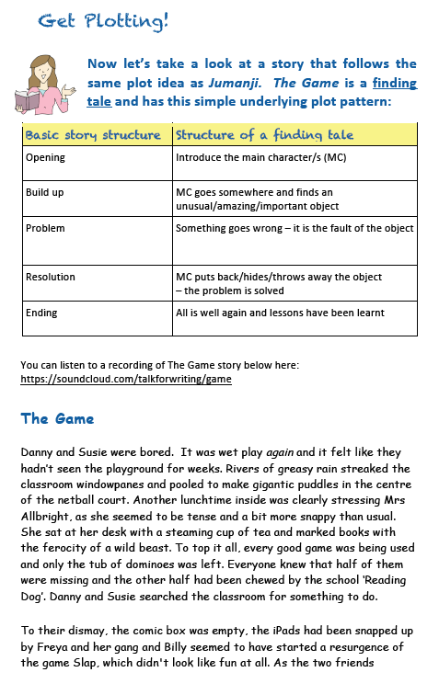

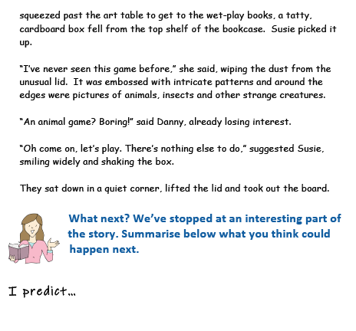

NUMBER AND PLACE VALUE
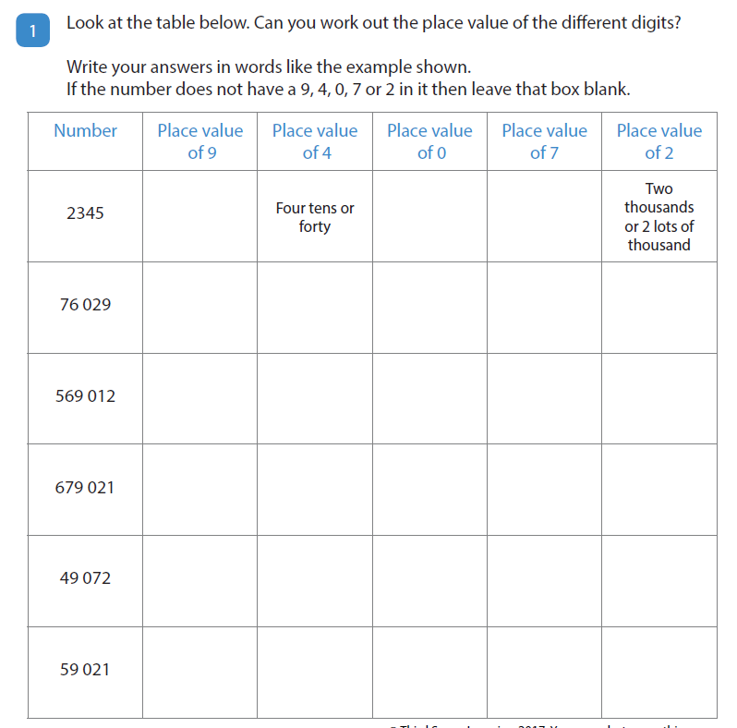

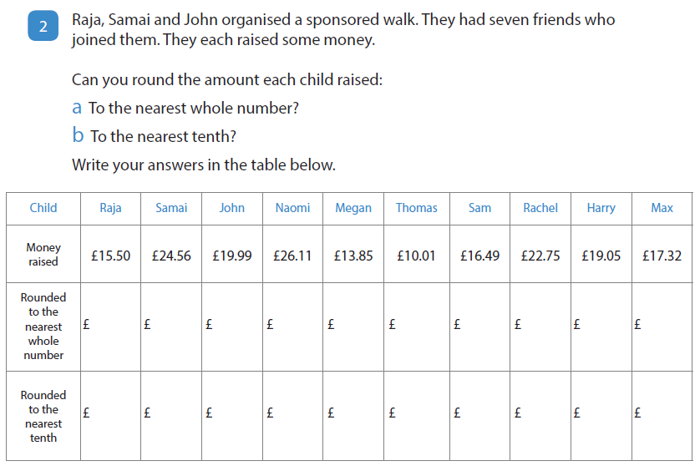

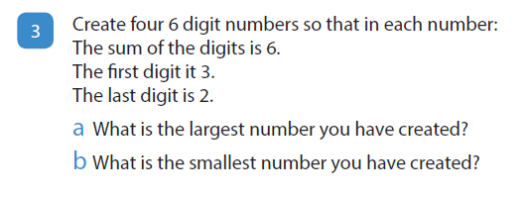

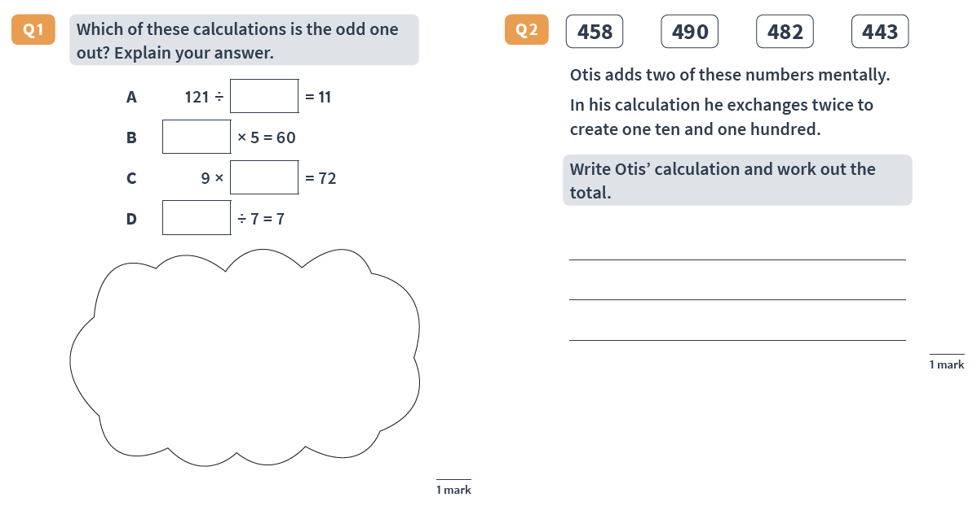
RAPID REASONING

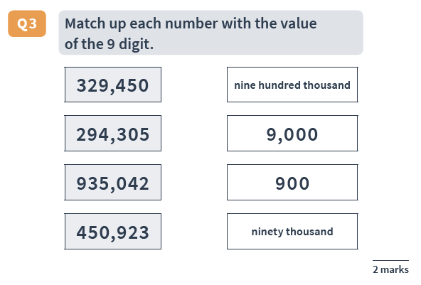

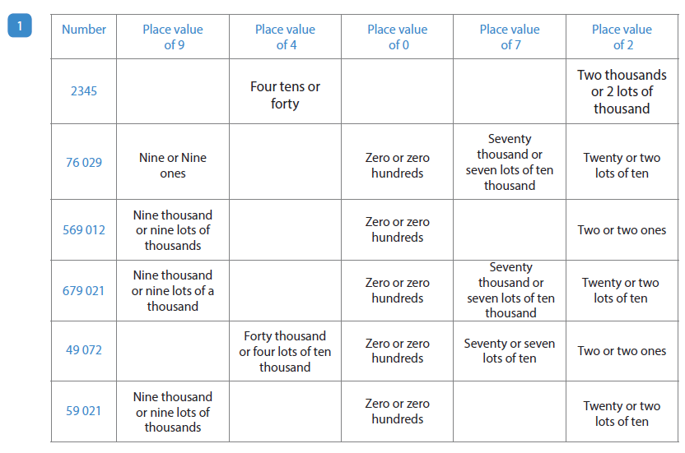
ANSWERS NUMBER AND PLACE VALUE

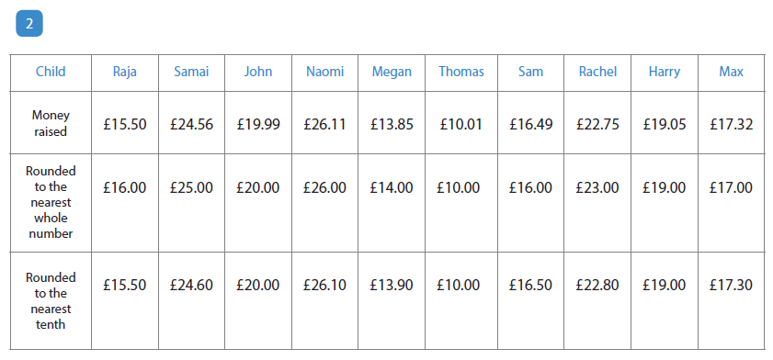

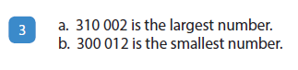

ANSWERS RAPID REASONING
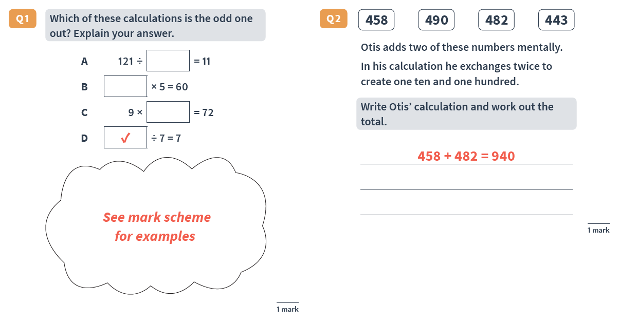

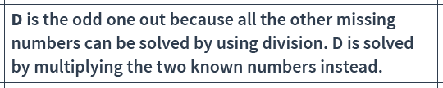

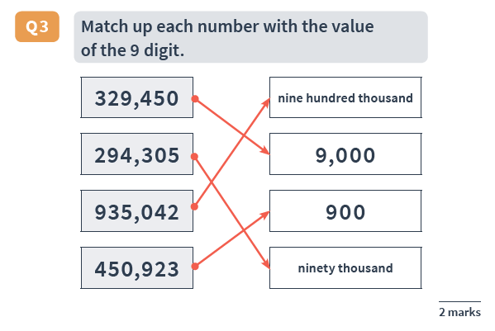

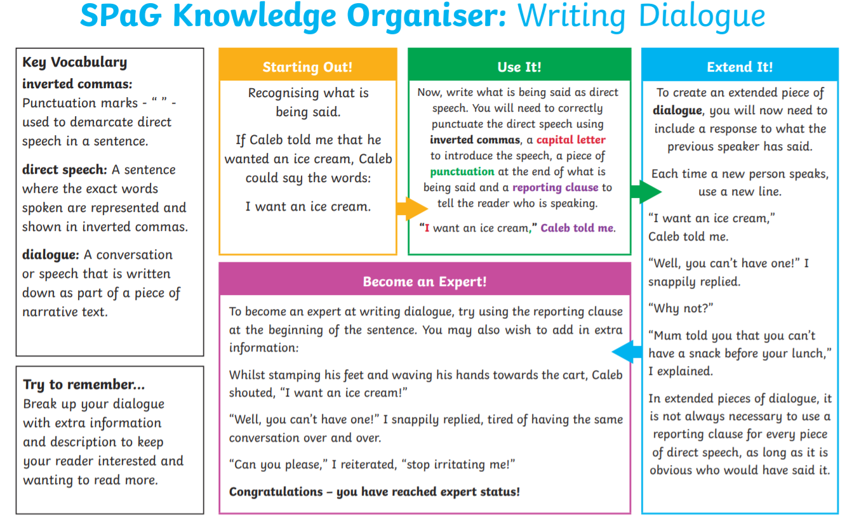

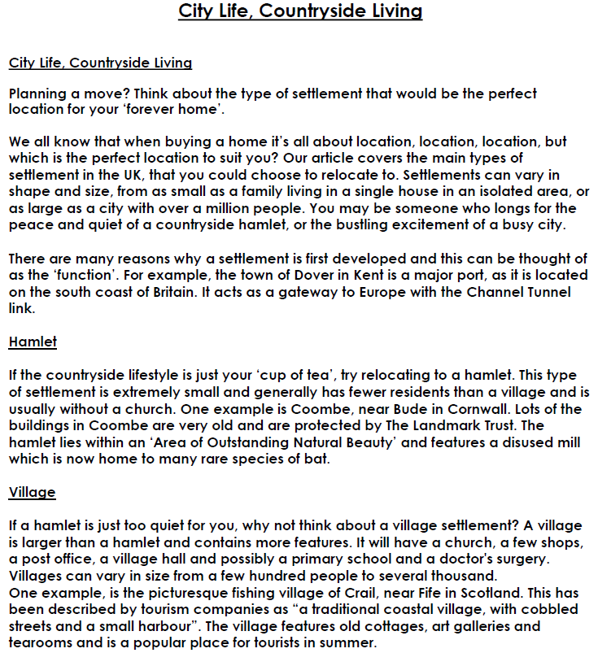

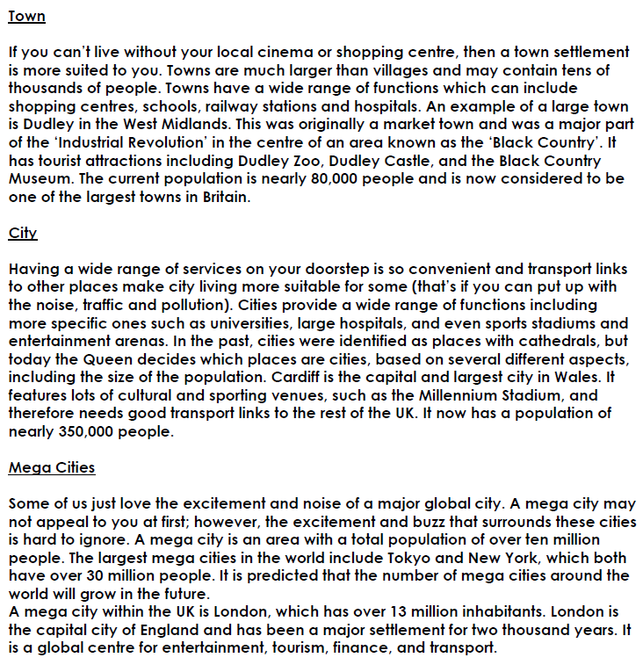

City Life, Countryside Living
Now answer these questions. Remember to re-read the text and think carefully about your answers:
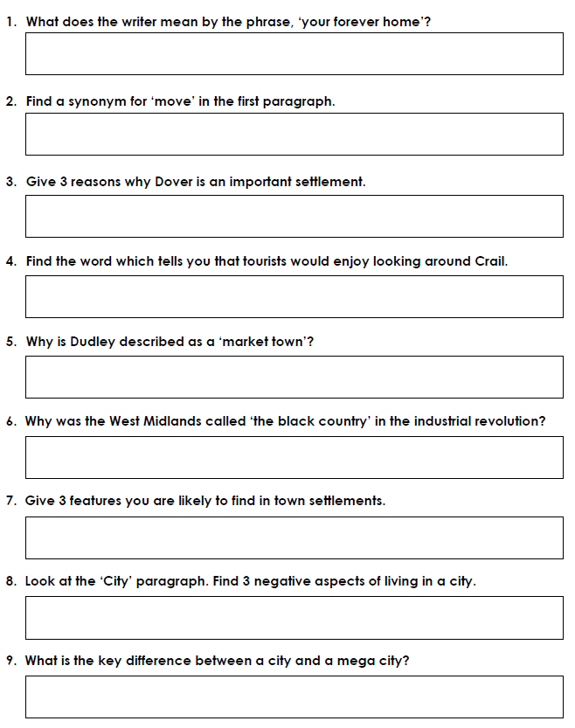

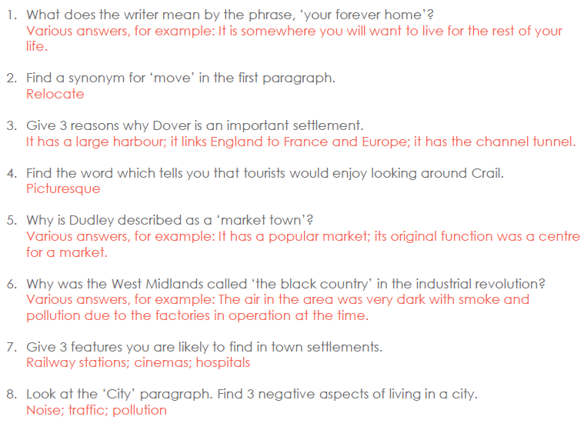
ANSWERS City Life, Countryside Living

